Ministry of High Education

Culture and Science City on 6 October City

The High Institute of Computer Science & Information Systems



المعهد العالي لعلوم الحاسب ونظم المعلومات

Graduation Project:

**Product Reviews Detection**

Supervised by

**Dr. Eng. Omaima Goher**

Assistant:

**L.A. Ahmed Tmam**

Project Code: N42316 Academic Year:2022/2023

Ministry of High Education

Culture and Science City on 6 October City

The High Institute of Computer Science & Information Systems



المعهد العالي لعلوم الحاسب و نظم المعلومات

Graduation Project:

**Product Reviews Detection**

Prepared by

(sorted by ID number & in Arabic)

20180779- عمر عادل فرغلي مهران 20190353- محمد أسامة إسماعيل ناجي

20191169- محمد طه شعبان طه حجاج 20193084- ميرنا فايز انور صمور

20193330- محمد حسن السيد حسن 20194212 – محمد حامد إبراهيم حامد

**Supervised by:**

**Dr. Eng. Omaima Goher**

**Assistant:**

**L.A. Ahmed Tmam**

Project Code: N42316 Academic Year:2022/2023

# Acknowledgment

We would like to offer our sincere thanks and appreciation to Allah, our institute, **Professor Dr. Mohamed El Sayed Waheed**, and project supervisor **Dr. Eng. Omaima Goher** for their guidance, encouragement and support in the course of this project. Working with them has been a rewarding experience each time.

Additionally, we extend our gratitude to **Eng. Ahmed Tmam** for her assistance throughout the project as well as providing us with vital information that contributed to its successful completion.

Finally, we thank every doctor, engineer and all other people who aided us in our endeavour; as well as the Computer Science and Information System Institution for giving us an education enabling us to serve society. We wish them all the best.

# Abstract

*“***Product Reviews Detection***”*

When people are buying a new product, they often face the challenge of not knowing if it is any good or not. Through reviews posted by other customers and opinions, many times the decision-making process can be confusing and time-consuming. We have developed a software package to address this problem and give people an easy way to get the information they need.

Our software package allows customers to search for a specific product online. Once a product is selected, the software then gathers data from various websites and reviews from actual customers who purchased said product. This provides an easy way for the customer to quickly see what other customers think about that specific product in order to make an informed decision about whether that product is right for them or not.

The software also provides additional features like highlighting negative feedback points which may be difficult to spot among numerous positive ones, as well as tools that allow users to filter certain items according to their own preferences such as price range and quality requirements. Thus, this makes it easier for customers to narrow down their search while still getting all the crucial information they need before making a purchase.

Overall, this software helps to solve the growing problem of inadequate knowledge when buying products by giving customers easy access to data gathered from multiple sources across the web. As such, it greatly reduces the time spent researching said item as well as confusion which may arise amidst mixed reviews from various parties and makes it easier for people to purchase with confidence knowing exactly what they are getting for their money.

Table of Contents

**Acknowledgment 3**

**Abstract 4**

**Chapter 1: Introduction 9**

**1.1 Introduction: 9**

**1.2 The project objectives: 9**

**1.3 Project Scope: 10**

**1.4 The Project Tools: 10**

**1.5 Definition, Acronyms, Abbreviation: 11**

**Chapter 2: Theoretical background and tools 12**

**2.1 Customer Purchase Decision-making process 12**

**2.2 History of online shopping 13**

**2.3 Platform (Previous Solution) 15**

**2.3.1 Yelp Platform Ratings and Reviews 16**

**Chapter 3: Analysis & Design 20**

**3.1 Functional Requirement 20**

**3.2 Project Function 21**

**3.3 Non-Functional Requirement 21**

**3.4 Requirement Analysis 22**

**Introduction 22**

**UML Diagrams: 23**

**3.4.1 Product Reviews Detection Use Case diagram: 24**

**3.4.2 Product Reviews Detection Activity diagram: 25**

**3.4.3 Product Reviews Detection Sequence diagram: 27**

**3.4.4 Product Reviews Detection Flow Chart Diagram: 28**

**3.4.5 Product Reviews Detection ERD Diagram: 29**

**Chapter 4: Implementation 30**

**4.1 Onboarding Screen 31**

**4.2 Login Screen 33**

**4.3 Registration Screen 34**

**4.4 Home Screen 35**

**4.5 Item Details Screen 37**

**4.6 Favorite screen 38**

**4.7 Cart Screen 39**

**4.8 Search Screen 40**

**4.9 Categories Screen 41**

**4.10 Admin Setting Screen 42**

**4.11 Add Product Screen 43**

**4.12 Edit Product Screen 44**

**4.13 Dark Mode Screen 45**

**5. Conclusion 47**

**6. Appendix 48**

**6.1 Onboarding Screen Code 49**

**6.2 Login Code 52**

**6.3 Registration Code 55**

**6.4 Home Code 57**

**6.5 Item Details Code 61**

**6.6 Favorite Code 69**

**6.7 Cart Code 71**

**6.8 Search Code 73**

**6.9 Categories Screen Code 75**

**6.10 Setting (User - Admin) Code 77**

**6.11 Add – Edit Product Screen Code 79**

**6.12 Database Backend Code 84**

**6.13 API Connection 91**

**6.14 NLP and Scripting IPYNB 98**

**6.14.1 Amazone Reviews IPYNB: 98**

**6.14.2 Scraping IPYNB: 108**

**7. References 114**

**Table of Figures**

**Figure 1: Data Collection and Filteration process 16**

**Figure 2: Filtration Process 18**

**Figure 3: Scraping Process 19**

**Figure 4: Main use case for Product Reviews Detection 24**

**Figure 5: User activity diagram 25**

**Figure 6: Admin Activity diagram 26**

**Figure 7: Sequence diagram for Product Reviews Detection 27**

**Figure 8: Product Reviews Detection Flow Chart diagram 28**

**Figure 9: Product Reviews Detection ERD Diagram 29**

**Figure 10: Onboarding First Screen 31**

**Figure 11: Onboarding Second Screen 32**

**Figure 12: Login Screen 33**

**Figure 13: Registration Screen 34**

**Figure 14: Main Home Screen 35**

**Figure 15: Home Screen Special Offer 36**

**Figure 16: Item Details Screen 37**

**Figure 17: Favorite Screen 38**

**Figure 18: Cart Screen 39**

**Figure 19: Search Screen 40**

**Figure 20: Categories Screen 41**

**Figure 21: Admin Setting Screen 42**

**Figure 22: Add Product Screen 43**

**Figure 23: Edit Product Screen 44**

**Figure 24: Dark Mode Screen 46**

**Figure 25: Onboarding Screen Code 51**

**Figure 26: Login Screen Code 54**

**Figure 27: Registration Screen Code 57**

**Figure 28: Home Screen Code 61**

**Figure 29: Item Details Screen Code 68**

**Figure 30: Favorite Screen Code 70**

**Figure 31: Cart Screen Code 73**

**Figure 32: Search Screen Code 75**

**Figure 33: Categories Screen Code 77**

**Figure 34: Setting Screen Code 78**

**Figure 35: Add - Edit Product Screen Code 83**

**Figure 36: Tables of Database 84**

**Figure 37: Database Code 88**

**Figure 38: PHP Connection with Database and Push 1 88**

**Figure 39: PHP Connection with Database and Push 2 90**

**Figure 40: All Categories 91**

**Figure 41: Categories Names 92**

**Figure 42: Categories Insertion 92**

**Figure 43: Categories Update 93**

**Figure 44: Categories Delete 93**

**Figure 45: Categories Search 94**

**Figure 46: Register 94**

**Figure 47: Login 95**

**Figure 48: User Profile 95**

**Figure 49: Refresh 96**

**Figure 50: Wish List insertion 96**

**Figure 51: Wishlist Delete 97**

**Figure 52: Log Out 97**

**Figure 53: Importing the Libraries 98**

**Figure 54: Loading The Data 99**

**Figure 55: Data Inspection 100**

**Figure 56: Preprocessing The Data 103**

**Figure 57: Roberta Model 105**

**Figure 58: Building NLP System 107**

**Figure 59: Importing the Dependencies 108**

**Figure 60: Required Functions 112**

**Figure 61: System Interface 113**

# Chapter 1: Introduction

## Introduction:

Online shopping has rapidly become an essential part of many people’s lives, and yet it can also be an intimidating prospect. Choosing the right product to suit your individual needs can be daunting, especially when unlimited options are available with a few clicks of a mouse. With so many websites, brands, models, and products offering similar services, buyers can often find themselves confused and uncertain when making decisions about their next purchase.

Our team has developed a solution to this problem – an application designed to help alleviate some of the ‘buying burden’ experienced by online shoppers. By viewing reviews of products in the category being searched for and highlighting best-selling items based on market trends, our application will provide customers with confidence that they are choosing the right product for them; one that won't break the bank or require hours of research. This allows customers to quickly navigate through the vast selection of choices and identify the optimal purchase more swiftly than ever before.

## The project objectives:

To help customers to find bestselling.

To prevent customers confusion about products reviews.

## **Project Scope:**

1. The user decides the target whether seeing the trending page or searching for a product.
2. In the case of visiting the trending page the user will see an appropriate chart that will help him to choose which product is suitable.
3. In the case of visiting the search line for writing the product name, the user will get some result from different website with the name of product, the website name and the product.
4. In the case of visiting the product information page the user will see the product name, photo, price and the positive, negative, neutral ratio.
5. In the case of there are some products the user wants to buy them later or complete checking them later, the user can use add to favorite list feature.
6. In the case of the user wants to sign out for a special purpose, the user must press sign out.
7. In the next time if the defined user wants to visit the application, just the user must login. for undefined users they should create an account for registering.

## The Project Tools:

1. Scraping Data

2. Natural Language Processing (NLP)

3. PHP

4.Database (MYSQL)

5. Flutter

6. UX/UI

7. Dart - RX Dart

8. Laravel

9. Provider

10. Postman

## Definition, Acronyms, Abbreviation:

* SQL : Structured query language
* NLP : Natural Language Processing
* Ipynb : Interactive Python Notebook
* PHP : Personal Home Page (Hypertext Preprocessor)
* UML : Unified Modeling Language

# Chapter 2: Theoretical background and tools

In today's digital age, online buying has become a popular trend among consumers. However, making the right decision when purchasing a product online can be challenging. Consumers need to be cautious when buying online, as they cannot physically inspect the product before making a purchase.

To make a sensible online buying decision, consumers should carry out thorough research on the product they intend to purchase. They should read product descriptions, reviews, and ratings from other customers who have already purchased the product. This will give them an idea of the product's features, quality, and performance. Consumers should also compare prices of the product from different online stores to ensure they get the best deal. Additionally, consumers should only purchase from reputable online retailers to avoid the risk of fraud or receiving a fake product. In summary, making a sensible online buying decision requires careful research, comparison, and consideration of customer reviews and ratings.

## **2.1** Customer Purchase Decision-making process

The customer purchase decision-making process is the series of steps that a consumer goes through when making a purchase. This process starts with recognizing a need or a problem that requires a solution. The consumer then begins to search for information about the product or service that can meet their needs. This information can be obtained through various sources such as online research, word-of-mouth recommendations, advertisements, and reviews.

Once the consumer has gathered enough information, they begin to evaluate the alternatives available to them. The evaluation process involves comparing the features, benefits, and prices of different products or services to determine the best fit for their needs. The consumer may also consider other factors such as brand reputation, availability, and convenience.

After evaluating the alternatives, the consumer then makes a purchase decision. At this stage, the consumer may decide to purchase the product or service immediately or delay the purchase.

The decision to delay the purchase may be due to factors such as budget constraints, uncertainty about the product's effectiveness, or a desire to wait for a better deal.

Finally, after making the purchase, the consumer evaluates their experience with the product or service. This evaluation can influence their future purchase decisions and also impact their willingness to recommend the product or service to others.

## 2.2 **History of online shopping**

The history of online shopping can be traced back to the 1970s when the first business-to-business online transaction took place. However, it was not until the 1990s that online shopping became widely popular among consumers. The development of the World Wide Web and the increasing availability of personal computers and internet access played a significant role in the growth of online shopping.

As online shopping became more popular, the need for customer reviews and ratings also increased. Reviews and ratings provide valuable information to consumers, allowing them to make informed decisions about the products they wish to purchase. In the early days of online shopping, customer reviews were limited to a few websites, and the quality of the reviews was often questionable. However, as the popularity of online shopping grew, so did the number of websites offering customer reviews and ratings.

Today, there are numerous websites and platforms that provide customer reviews and ratings for a wide range of products and services. These reviews are often accompanied by photos and videos, which give consumers a better understanding of the product's features and performance. In addition, some review websites use algorithms and machine learning to analyze customer reviews and provide a summary of the product's strengths and weaknesses.

To help users choose the best product, several solutions have been developed. For example, comparison websites allow users to compare the features, prices, and reviews of different products side-by-side. Some websites also provide personalized recommendations based on the user's browsing and purchase history.

In recent years, the development of artificial intelligence (AI) and machine learning has led to the development of more advanced solutions. For example, some AI-powered solutions use natural language processing to analyze customer reviews and provide a summary of the product's pros and cons. Others use image recognition technology to identify products in photos and provide information about them.

The history of online shopping and reviews has seen significant growth and development over the years. Today, there are numerous solutions that help users choose the best product, including comparison websites, personalized recommendations, and AI-powered solutions. These solutions provide valuable information to consumers and help them make informed decisions about the products they wish to purchase.

## 2.3 Platform (Previous Solution)

After searching for a platform that can help you make informed decisions about online shopping, Yelp can be a powerful solution. Yelp allows customers to search for specific products or product categories and read detailed reviews of businesses that sell those products. By doing so, customers can get valuable insights into the quality of the products, customer service, and overall experience of other customers, ultimately leading to increased satisfaction with their purchases. Moreover, Yelp's rating system indicates the overall satisfaction of customers with the product or service. With Yelp's feature that allows customers to filter reviews by the reviewer's purchase history, customers can identify reviews from verified purchasers, making their purchasing decisions even more informed. Overall, Yelp can be a valuable resource for e-commerce customers looking to find reviews and ratings of online products, helping them make more informed purchasing decisions and ultimately leading to increased satisfaction with their purchases.

## 2.3.1 Yelp Platform Ratings and Reviews

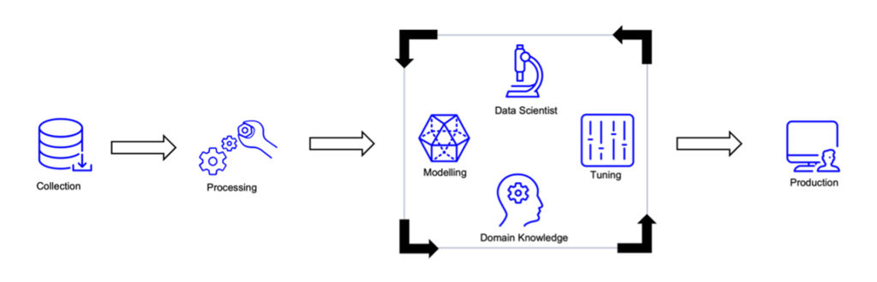Yelp is a platform that can be a powerful solution for customers looking to show reviews and ratings of online products. Yelp's primary focus is on local businesses, but it can also be a valuable resource for e-commerce customers. Yelp allows customers to search for specific products or product categories and read detailed reviews of businesses that sell those products. These reviews can provide valuable insights into the quality of the products, customer service, and overall experience of other customers. Yelp also has a rating system that indicates the overall satisfaction of customers with the product or service. Additionally, Yelp has a feature that allows customers to filter reviews by the reviewer's purchase history, which can help customers identify reviews from verified purchasers. By using Yelp to find reviews and ratings of online products, customers can make more informed purchasing decisions based on real reviews and ratings from other customers through the following process **as shown in figure (1),** ultimately leading to increased satisfaction with their purchases.

Figure : Data Collection and Filteration process

Yelp website uses several mechanisms to collect and display reviews and ratings of businesses. While AI is not the primary mechanism used by Yelp, it does play a role in some of the platform's features.

Here are some key mechanisms used by Yelp:

1. Review collection: Yelp relies on user-generated content to collect reviews of businesses. When a customer leaves a review, Yelp's system automatically detects key information such as the star rating, text review, and date of the review. This process is not dependent on AI, but rather on Yelp's proprietary algorithms.
2. Review filtering: Yelp uses a filtering system to remove reviews that violate its content policy or are suspected of being fake. This filtering system uses a combination of automated and manual processes to identify and remove problematic reviews. The automated process uses AI to detect suspicious patterns in the reviews, such as a high number of reviews from a single IP address **as shown in figure (2).**

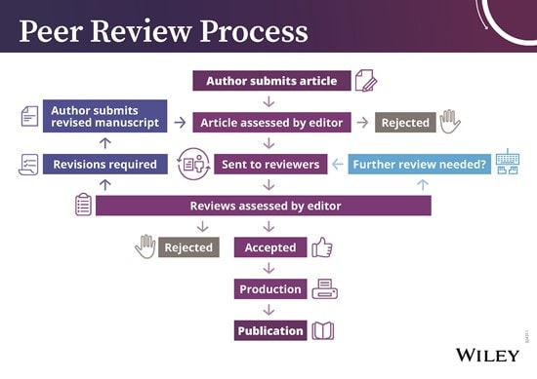

Figure : Filtration Process

1. Personalization: Yelp uses AI to personalize the content that users see on its platform. By analyzing user behavior and preferences, Yelp's AI algorithms can recommend businesses and products that are likely to be of interest to the user.
2. Search ranking: Yelp's search ranking algorithm uses AI to determine the order in which businesses are displayed in search results. The algorithm takes into account factors such as the relevance of the business to the search query, the quality of the reviews, and the user's location.

Yelp relies on user-generated content to collect reviews of businesses on its platform. This means that users voluntarily share their experience with businesses and services on Yelp by leaving reviews. Yelp's system automatically detects key information such as the review text, the star rating, and the date of the review, but this is not done through a scraping process. Instead, Yelp uses proprietary algorithms to manage and curate the reviews on its platform.

Some other platforms may use a scraping process to collect data. Web scraping involves using software to extract information from websites. While scraping can be a useful way to collect data, it can also be illegal and unethical if done without permission or in violation of a website's terms of service.

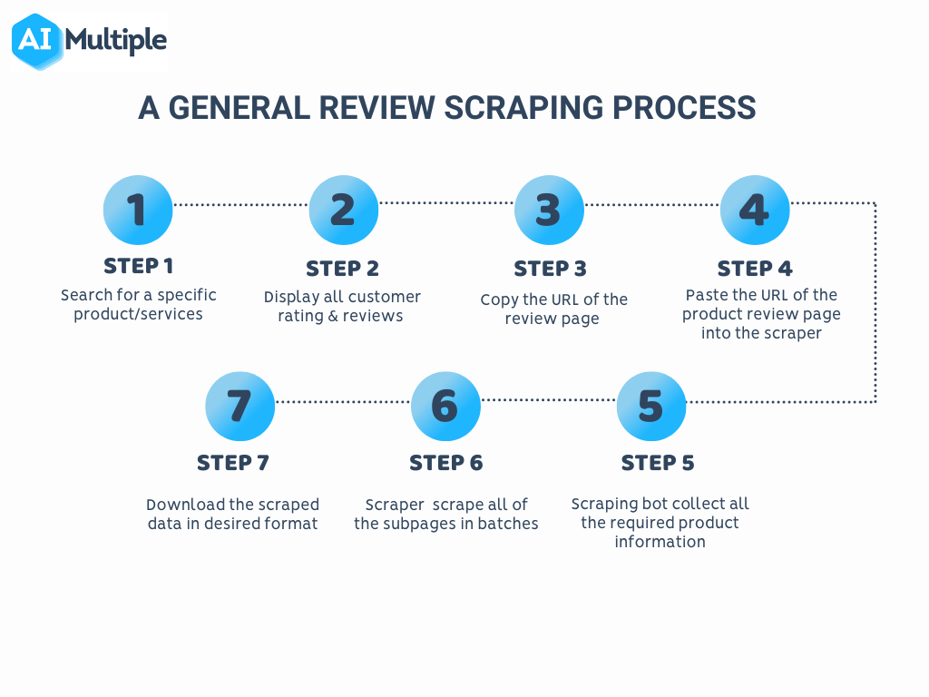The process of scraping involves using software to extract data from a website's HTML code. The scraper sends a request to the website, retrieves the data, and then extracts the relevant information **as shown Figure (3).** This can be done either manually or through automated means.

Figure : Scraping Process

# Chapter 3: Analysis & Design

System analysis is a systematic approach used to examine a system or its components to identify its objectives. This process allows for a more practical engagement with a project, as it enables us to focus on the prepared module and ensure its flawless execution and accurate estimation.

In the realm of data analysis, we conduct a thorough examination of the data and construct a representation of the system in the form of a data model. A conceptual data model defines the structure of the data and the processes that utilize it.

## 3.1 Functional Requirement

The primary purpose of requirements is to outline what a system or its components should accomplish. These requirements describe the desired behavior of a software system and its various elements. Functions represent specific capabilities of the system and encompass its inputs, behavior, and outputs. These capabilities can range from data manipulation and calculations to user interactions and other specialized functionalities that define the system's intended operations.

1. Registration Management:

The system allows Agents or admins to sign and login into the application. The system must validate the data for each agent to login into his/her screen. The system must validate the agent’s/admin’s login.

1. Admin management:

The system allows the admin to Add and delete and update a product details and description.

## 3.2 Project Function

In the following we will describe the function and essential tasks of the project and Detailed Screens Functionality:

Our System is to extract and analyze product reviews and ratings from the Amazon website using Artificial Intelligence (AI) and Natural Language Processing (NLP) techniques. This process involves retrieving data from Amazon's website and using advanced algorithms to interpret the sentiment of the reviews and ratings. The analyzed data is then displayed in an application where an admin can view various products and their ratings. The AI and algorithms are used to provide accurate and reliable ratings for each product, which can be used to make informed decisions when purchasing products. Ultimately, the goal of the project is to streamline the process of obtaining and evaluating product reviews, making it easier for users to make informed decisions when purchasing products online.

## Non-Functional Requirement

Non-functional requirements refer to the more abstract aspects of a software system, including its environment and operational characteristics, and address its quality attributes. These requirements assess the software system based on critical non-functional standards such as responsiveness, usability, security, and portability. In the context of our project, the non-functional requirements include the following:

* Availability: Ensuring that the system is always accessible.
* Safety: The database is hosted on a dedicated server to ensure data safety and security.
* Ease of use: The user interface is designed to be familiar to users, allowing them to easily perform tasks without requiring assistance.
* Speed: The system should process data and provide results swiftly.
* Reliability: The software system should function consistently and predictably.
* Recoverability: The system should have mechanisms in place to recover from errors or failures.
* Capacity: The system must be able to handle large amounts of data and traffic without performance degradation.

## Requirement Analysis

In this section, we use the modeling system “UML diagrams”, based on requirements analysis, to describe the functions and processes that the system must perform.

**Introduction to UML:**

UML is a standardized graphical display format for the visualization, specification, design, and documentation of (software) systems. It offers a set of standardized diagram types with which complex data, processes, and systems can easily be arranged in a clear, intuitive manner.

**UML** **Diagrams**:

In this section, we will introduce the UML diagrams of the project.

A **Use Case diagram** is used to represent the dynamic behavior of a system. It encapsulates the system’s functionality by incorporating use cases, actors, and their relationships. It models the tasks, services, and functions required by a system of an application. The following list shows the project goals’ categories.

1. Agents’ goals:

Search, View Product, View Rating, Favorite list, create order, Load menu, categories.

1. Admin goals:

Check, update, add and remove data.

### **3.4.1 Product Reviews Detection Use Case diagram:**

**Figure 4** presents the use case of the proposed Product Reviews Detection.

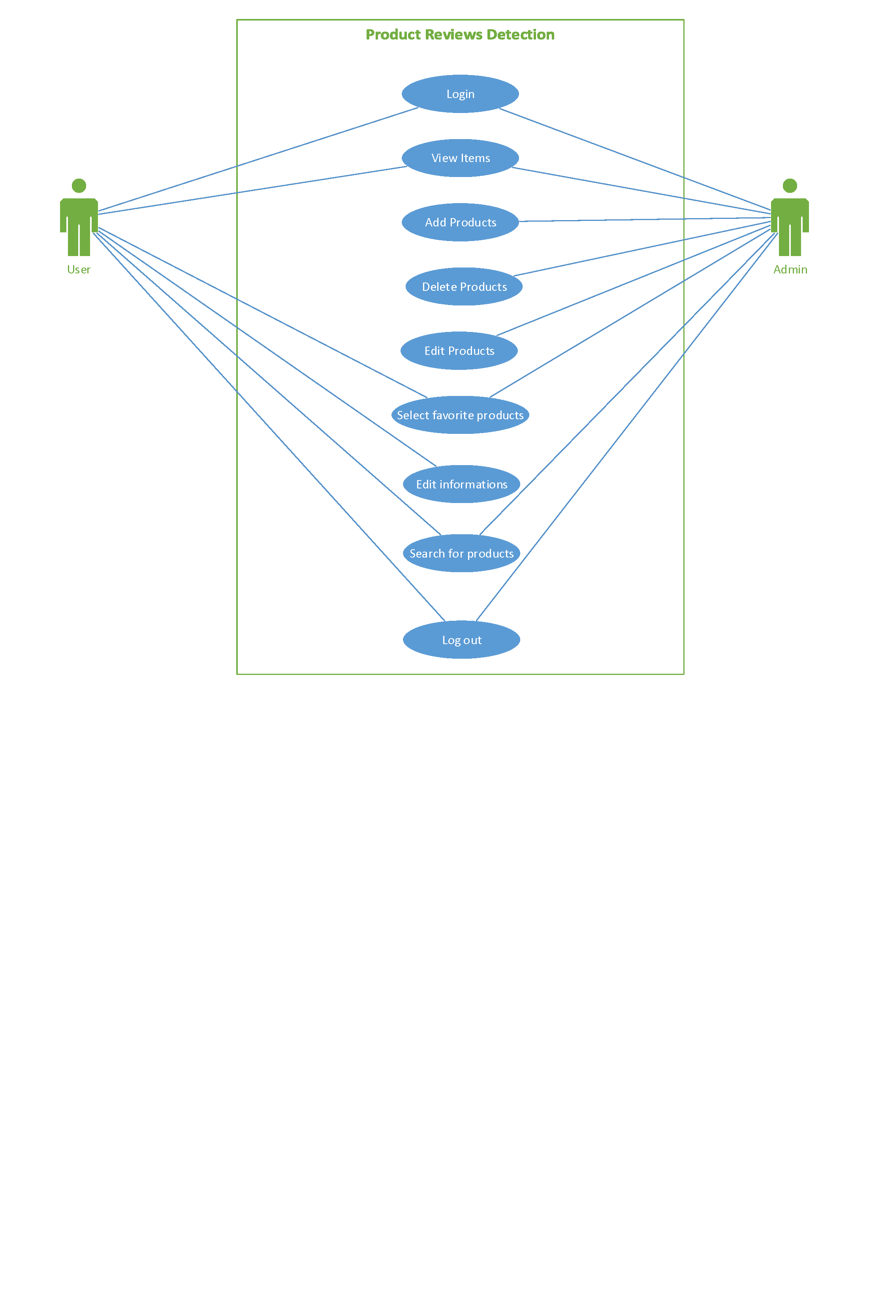

Figure : Main use case for Product Reviews Detection

### **3.4.2 Product Reviews Detection Activity diagram:**

An activity diagram is a chart that captures the dynamic behavior of the system and shows the message flow from one activity to another. **Figure 5 and 6** presents User System Process activity diagram Admin System Process activity diagram.

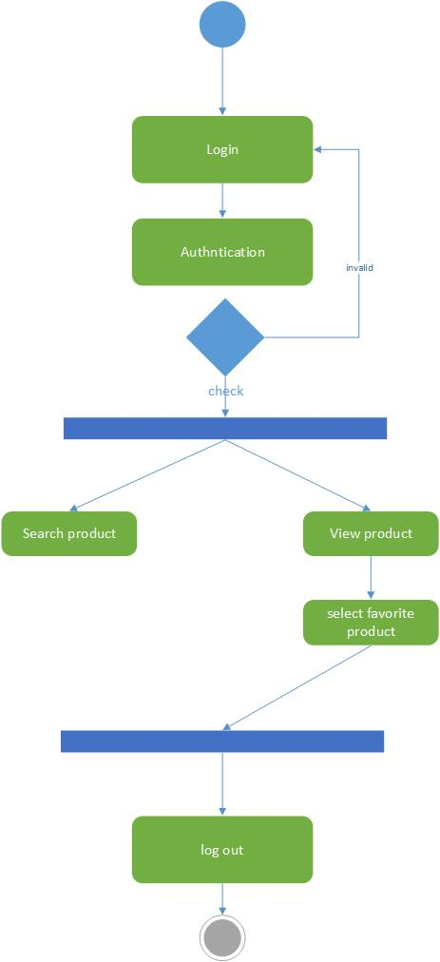

Figure : User activity diagram

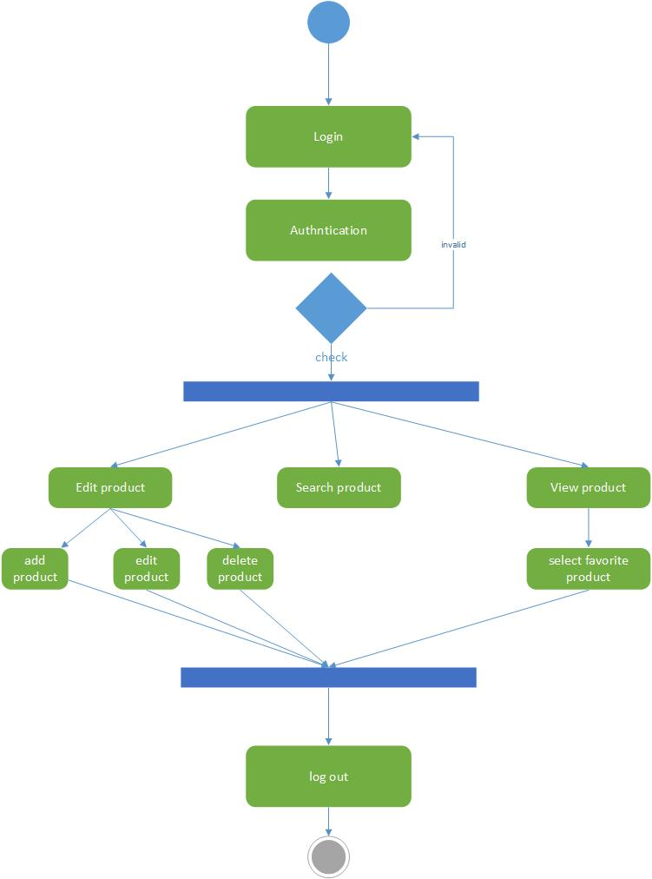

Figure : Admin Activity diagram

### **3.4.3 Product Reviews Detection Sequence diagram:**

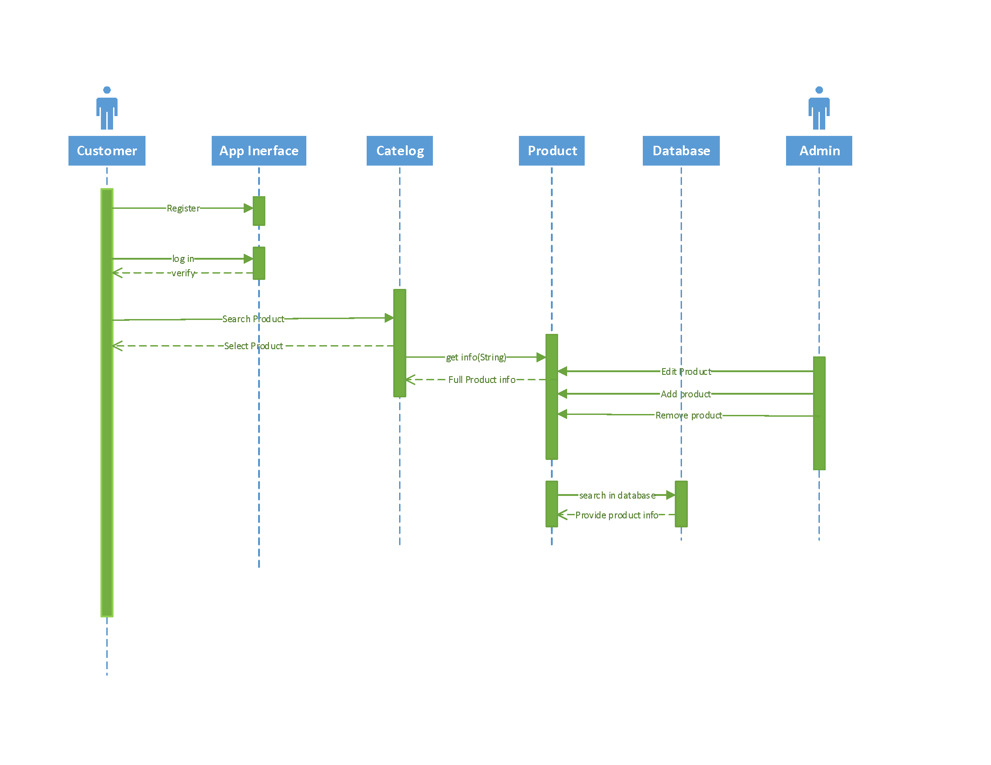The sequence diagram is an interaction diagram that shows how processes operate with one another and in what order. A sequence diagram shows object interactions arranged in a time sequence. It depicts the objects and classes involved in the scenario and the sequence of messages exchanged between the objects needed to carry out the functionality of the scenario. **Figure 7** presents Product Reviews Detection sequence diagram.

Figure : Sequence diagram for Product Reviews Detection

### **3.4.4 Product Reviews Detection Flow Chart Diagram:**

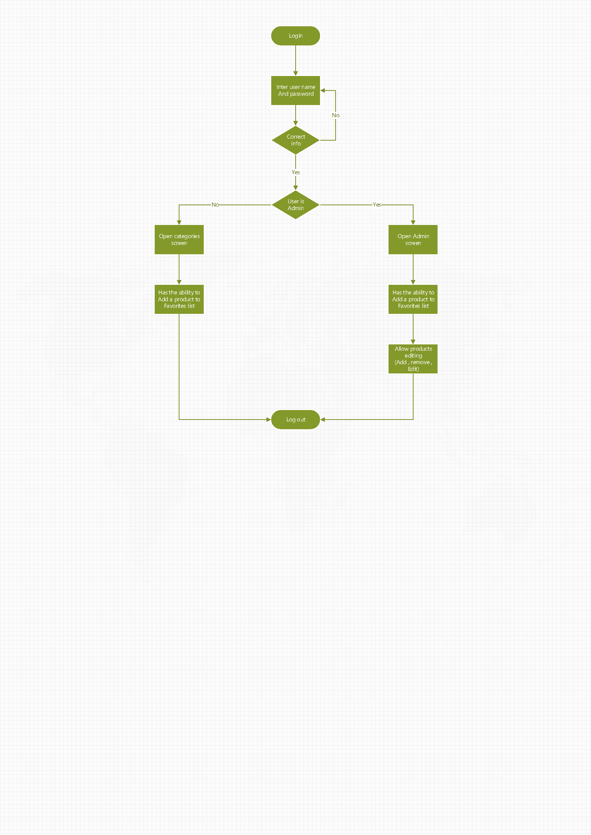A flowchart diagram is a visual representation of a process or algorithm that uses symbols and arrows to illustrate the sequence of steps or actions involved in completing a task or solving a problem **as shown in figure (8).**

Figure : Product Reviews Detection Flow Chart diagram

### **3.4.5 Product Reviews Detection ERD Diagram:**

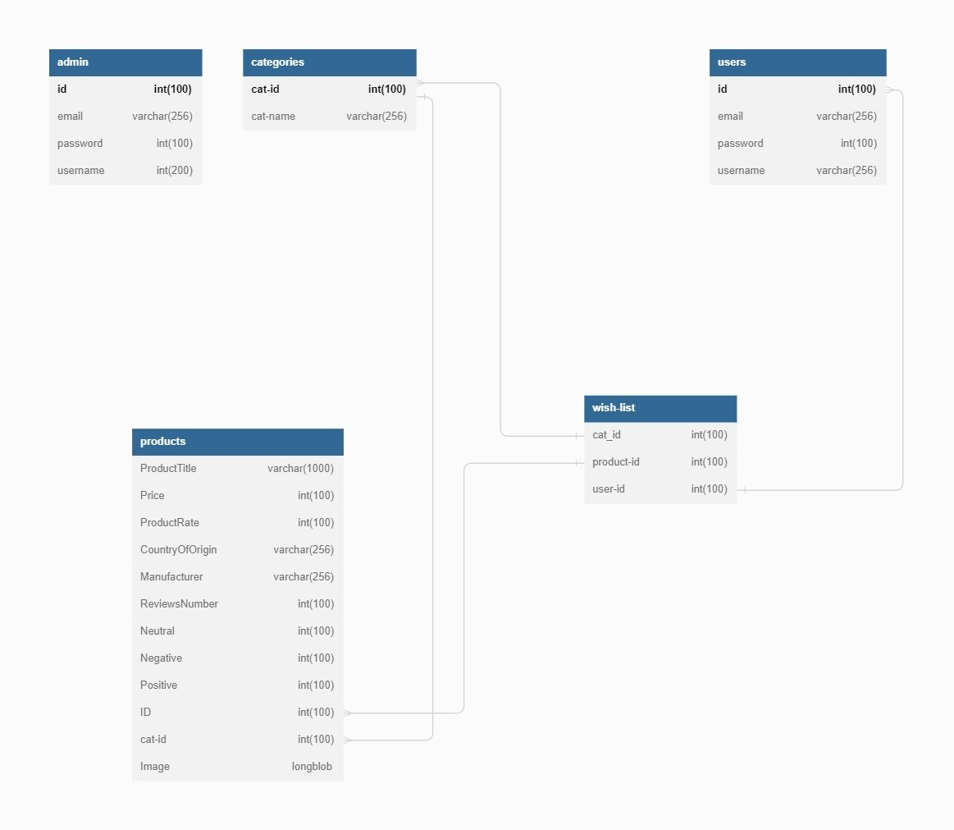An ERD (Entity-Relationship Diagram) is a graphical representation of entities or objects that are relevant to a particular domain and the relationships between them. ERD diagrams are commonly used in database design to model and visualize the relationships among different entities or tables. In an ERD diagram, entities are represented as rectangles, relationships between entities are represented as lines, and attributes of entities are represented as ovals or ellipses. ERD diagrams help to identify the key entities, attributes, and relationships in a domain, and serve as a blueprint for designing a database schema **as shown in Figure (9).**

Figure : Product Reviews Detection ERD Diagram

# Chapter 4: Implementation

**Project overview:**

Our product reviews detection app is a user-friendly tool designed to help customers make more informed purchasing decisions when shopping online. The app utilizes Amazon reviews and AI algorithms to analyze the sentiment and relevance of each review, creating a chart that shows the status of the product based on real customer experiences.

the app uses natural language processing (NLP) algorithms to identify the sentiment and relevance of each review from Amazon, including the positive and negative aspects of the product. The app then aggregates the data and creates a chart that shows the overall status of the product, based on the experiences of real customers who have already purchased and used the product.

The app is designed to be easy to use, with a simple interface that allows customers to view the status of the product quickly and easily. Customers can also customize the chart to show specific aspects of the product that are most relevant to their needs, such as price, quality, or performance.

In addition to the review data, the app also incorporates other data sources, such as product specifications and pricing information. This helps customers make more informed decisions based on their specific needs and budget.

Overall, the product reviews detection app provides a valuable service to customers by providing a comprehensive view of the product based on real customer experiences. By making it easier for customers to make informed purchasing decisions, the app can lead to increased customer satisfaction and loyalty.

## Onboarding Screen

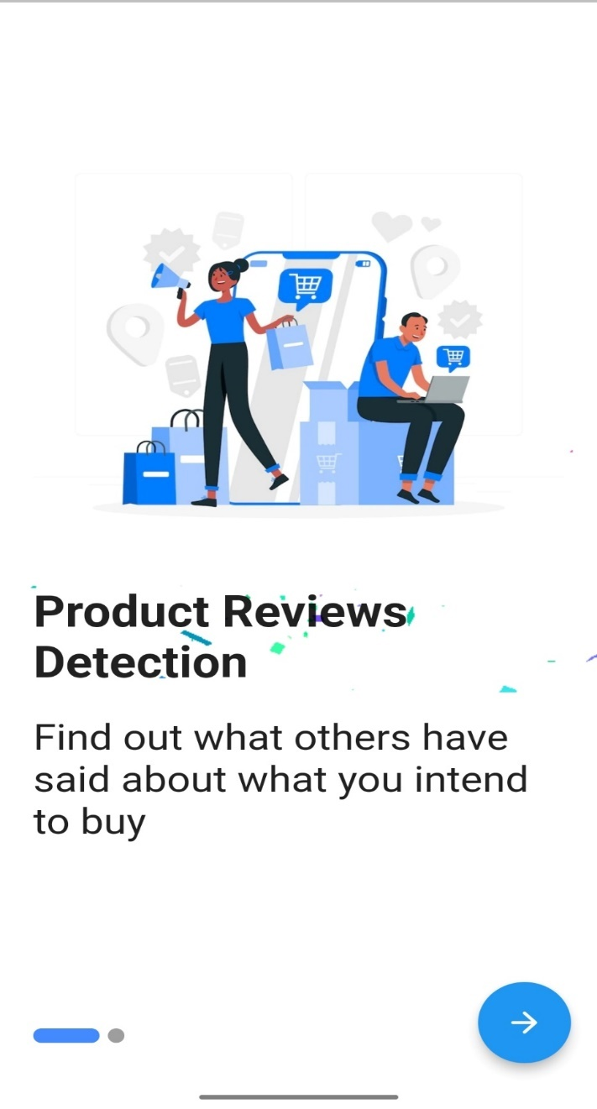The boarding screen is the first thing users see when they open an app. It helps users set up their account and learn about the app's features. The screen can also collect personal information to make the experience better for the user **as shown in figure (10).** It's important because it helps users feel more comfortable using the app.

Figure : Onboarding First Screen

The second screen of the boarding process is the next thing you see after opening the app. It helps you set up your account or profile and may ask for some personal information to improve your experience. It's important because it helps you use the app better and have a better time **as shown in figure (11).**

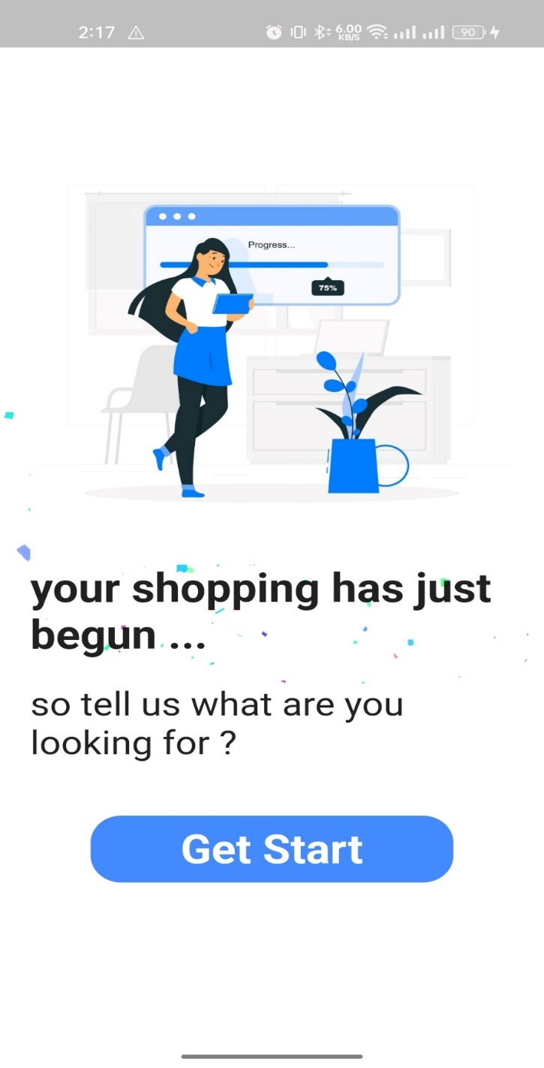

Figure : Onboarding Second Screen

## Login Screen

The login screen is the first step to verify a user's identity and prevent unauthorized access to an app or website. It should be easy to use and provide a positive experience. It can also collect important information for communication or marketing purposes. Overall, the login screen is important for security and a good user experience **as shown in Figure (12).**

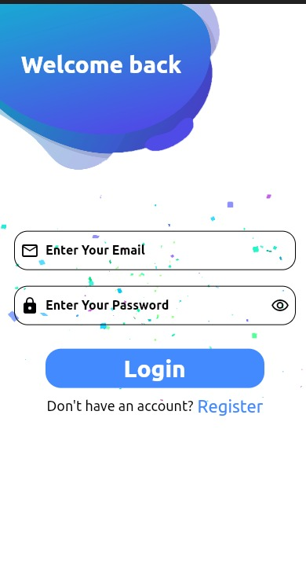

Figure : Login Screen

## 4.3 Registration Screen

The registration screen is where users create a new account in an app or website. It's important because it allows users to access the app's content and personalize their experience. The screen typically asks for basic user information, such as name, email, and password. It may also ask for more information about users' interests or preferences **as shown in figure (13).**

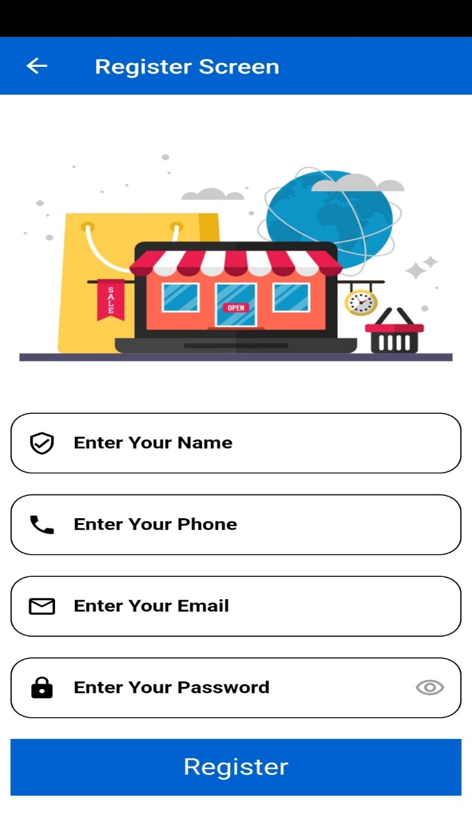

Figure : Registration Screen

## Home Screen

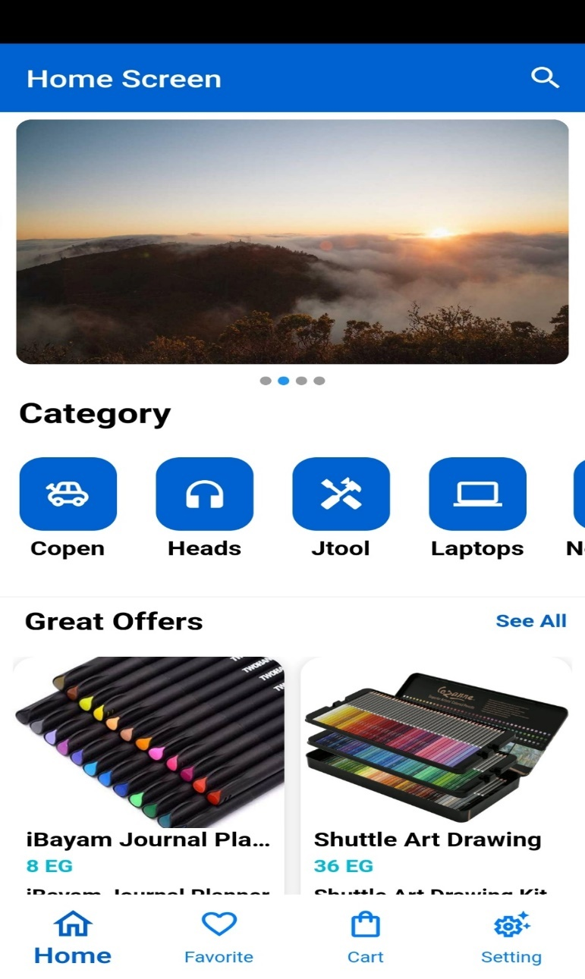The home screen is the main screen of an app or website. Its job is to give users quick access to the most important and frequently used features and content within the app. It usually shows a menu that lets users navigate to different parts of the app or website. The home screen can also be personalized to show content that is relevant to the user. Overall, the home screen is an essential part of any app or website, making it easy for users to access the app's content and features **as shown in figure (14).**

Figure : Main Home Screen

The home screen is the main screen of an app or website, displaying important and frequently used features and content. Sometimes, it may include "great offers" in the form of ads or banners to capture users' attention and encourage them to use special deals or discounts. This helps to increase user engagement and drive conversions **as shown in figure (15).**

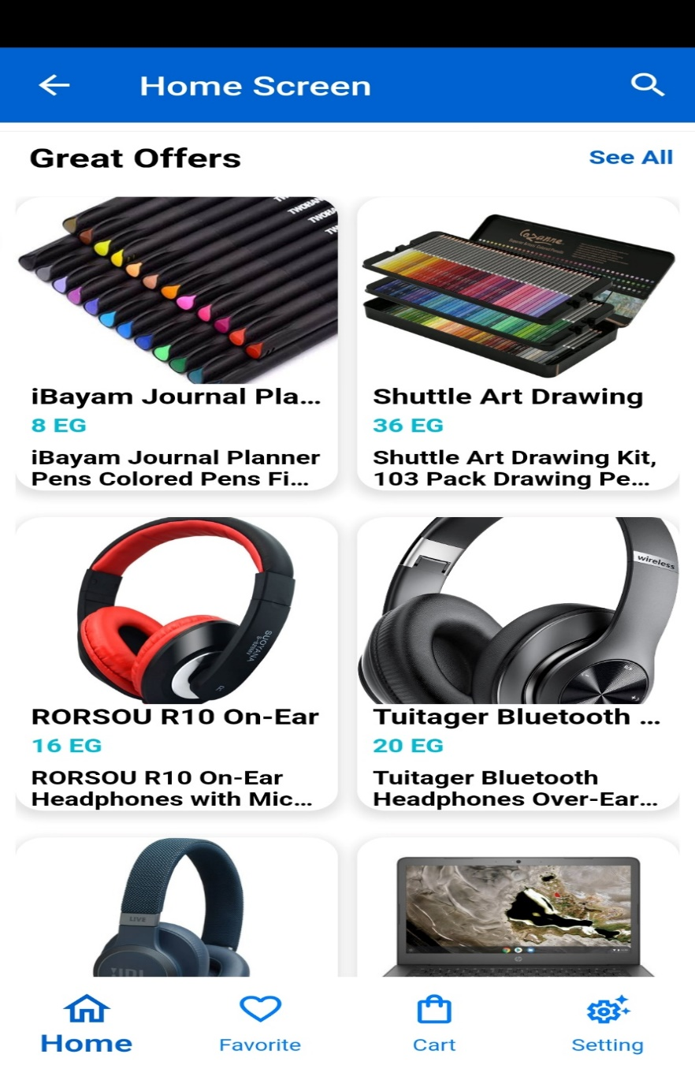

Figure : Home Screen Special Offer

## Item Details Screen

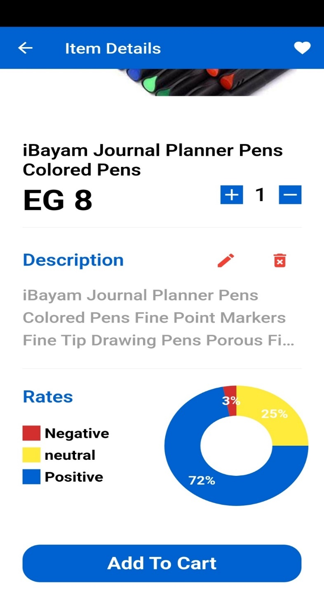This screen displays the details of an item and allows the user to interact with it using reactive programing, such as adding it to favorites or cart. It also includes a pie chart to display the rates of the item. Also, if this user is admin, he has 2 options first to edit this item details and second is deleting this item **as shown in figure (16).**

Figure : Item Details Screen

## Favorite screen

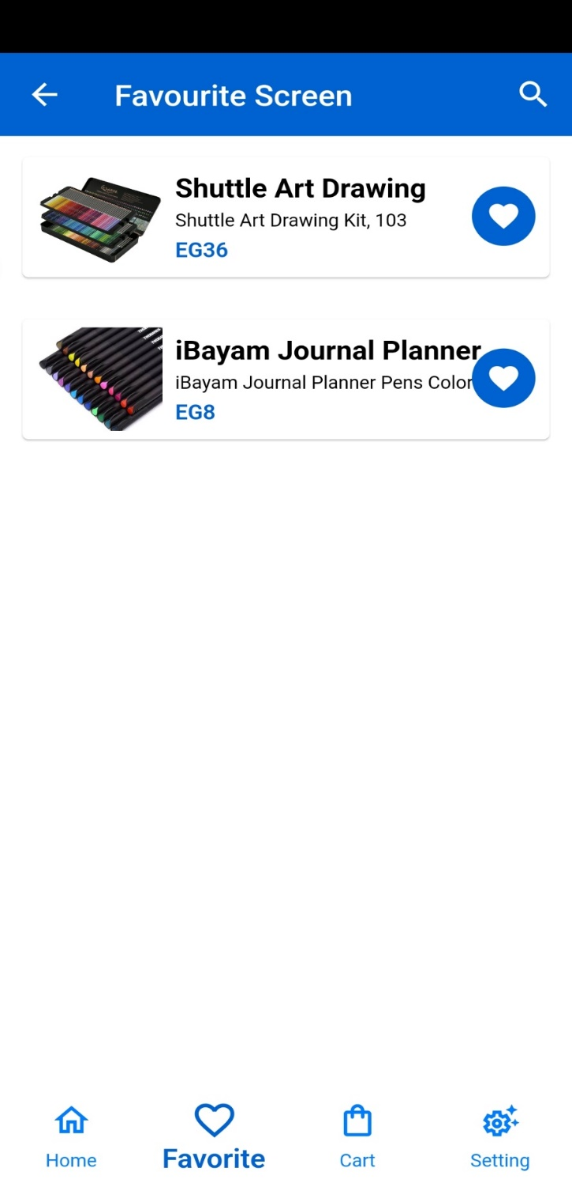On this screen, If the user added a product to his favorites, it would appear here, then if he wants to delete this product, he must click on the favorite’s icon, then he will send the new status to the controller and emitting the new state and the product will be deleted **as shown in figure (17).**

Figure : Favorite Screen

## Cart Screen

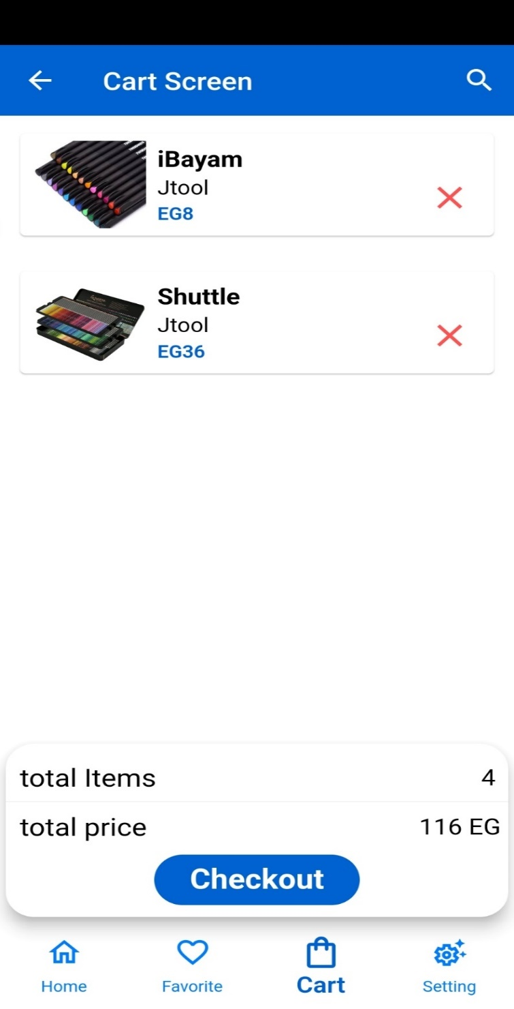If the user added a product to his cart, it would appear here, then if he wants to delete this product, he must click on the cancel icon, then he will send the new status and the product will be deleted, the bottom section counting items count and sum its price to inform the user the total cost **as shown in figure (18).**

Figure : Cart Screen

## Search Screen

This screen is used for displaying a search screen where users can enter a search query and view the search results **as shown in Figure (19).**

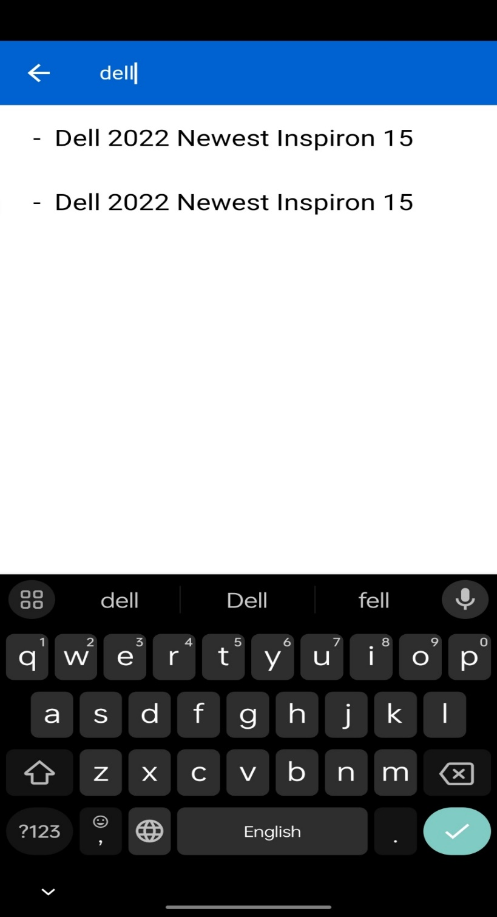

Figure : Search Screen

## Categories Screen

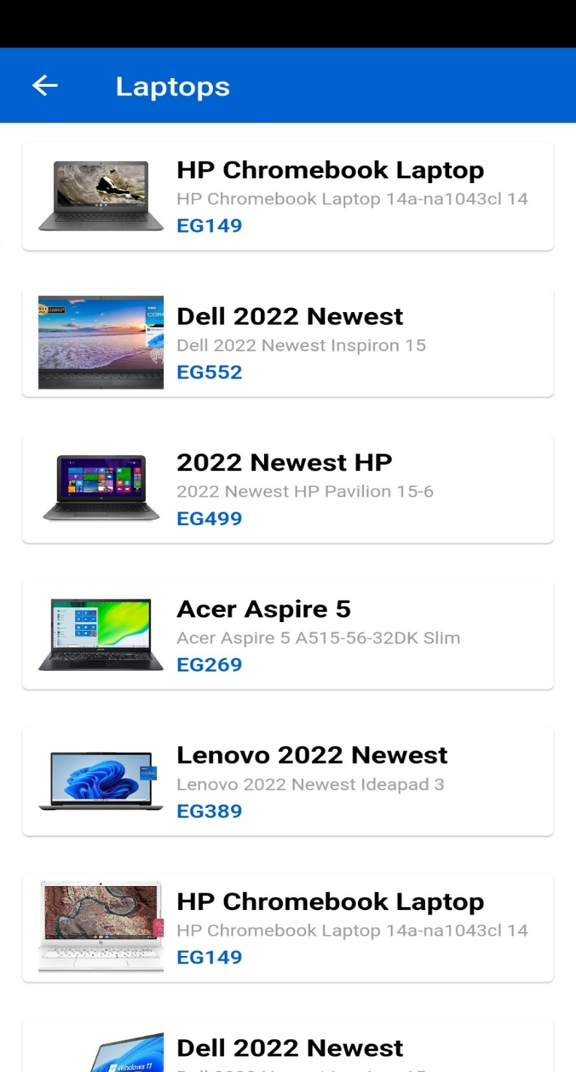Category screens are screens in an app or website that group similar content or features into categories. They help users find what they need more easily by showing a list of categories that users can select to view more specific content or features. Category screens are important because they provide a structured and organized way for users to explore and discover the app's content or features **as shown in Figure (20).**

Figure : Categories Screen

## Admin Setting Screen

On this page, setting screen from admin view, has additional option to add new product **as shown in figure (21).**

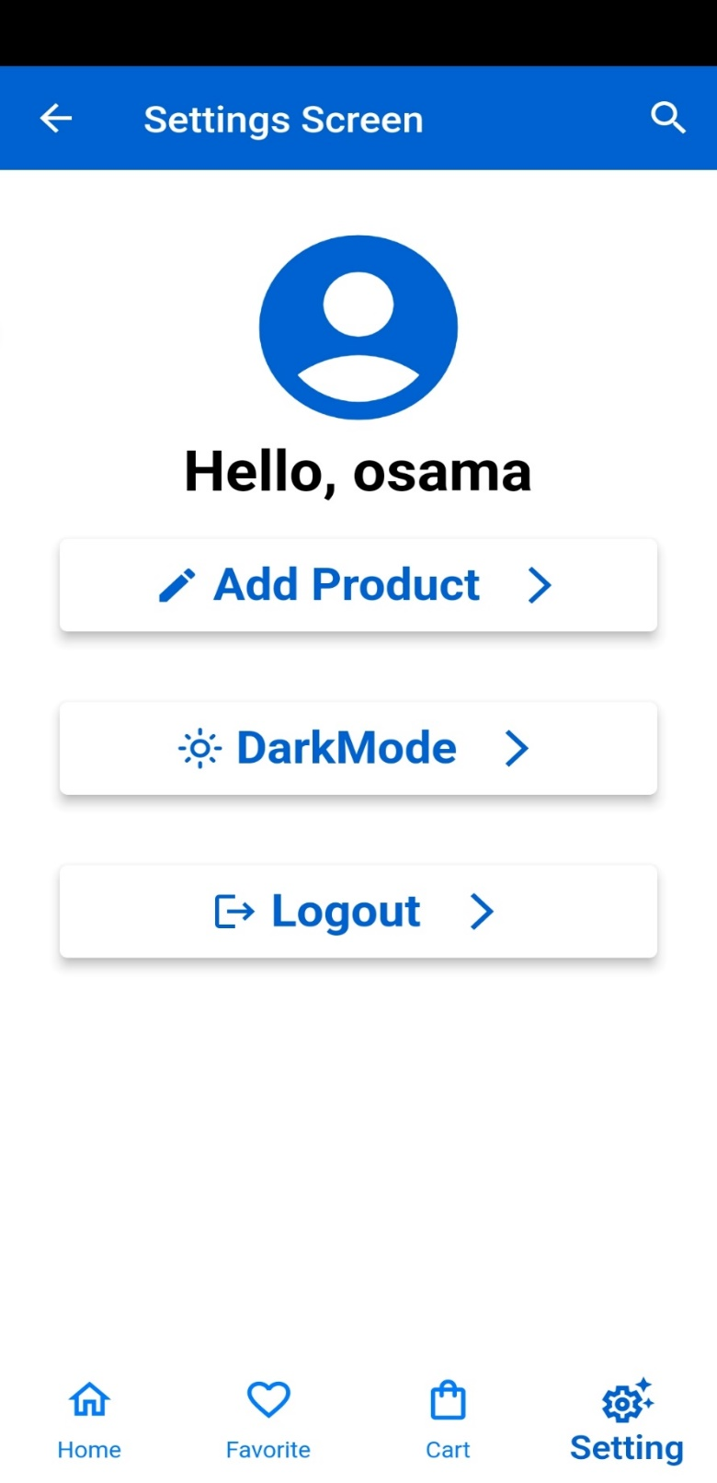

Figure : Admin Setting Screen

## Add Product Screen

This screen is used for adding a product. It includes form fields for entering the product details such as title, price, description, image URL, ratings, and category **as shown in figure (22).**

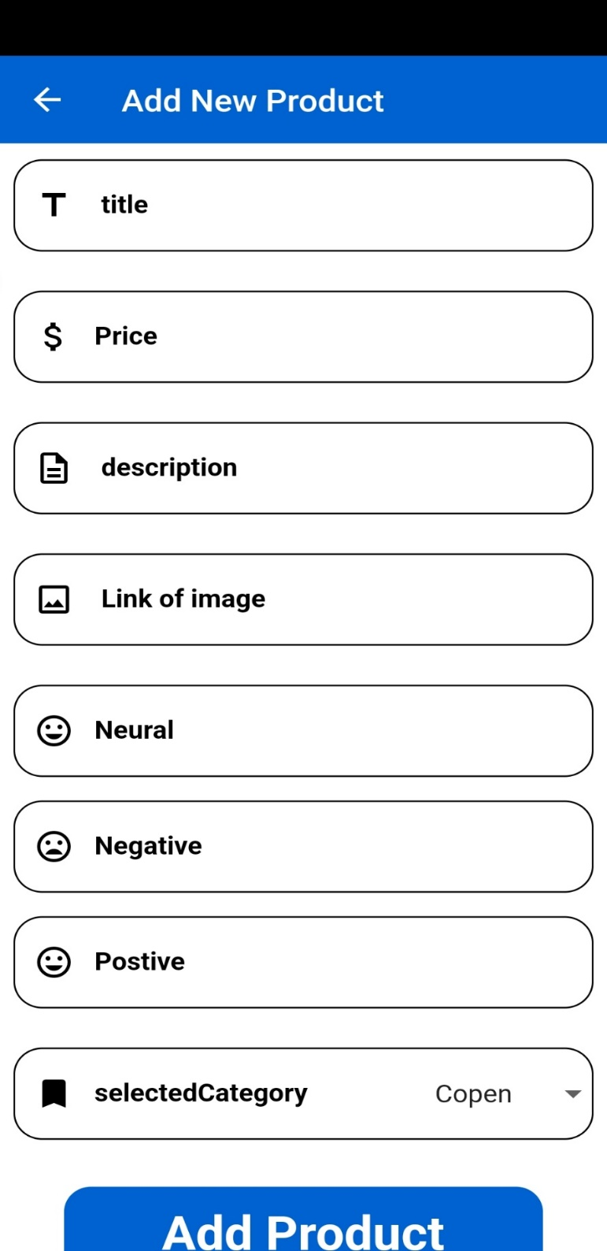

Figure : Add Product Screen

## Edit Product Screen

This screen is used for editing a product. It includes form fields for entering the product details such as title, price, description, image URL, ratings, and category **as shown in figure (23).**

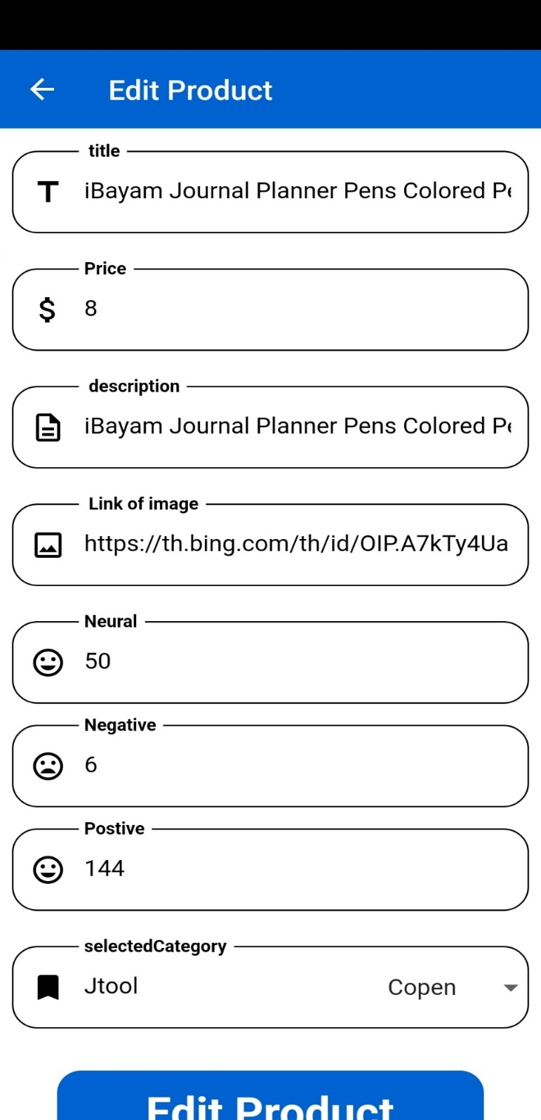

Figure : Edit Product Screen

## Dark Mode Screen

A screen that shows dark mode in an app is a user interface that displays content with a dark background and light foreground. This screen is commonly used in mobile applications to provide a more comfortable viewing experience for users, especially in low-light environments **as shown in Figure (24).**

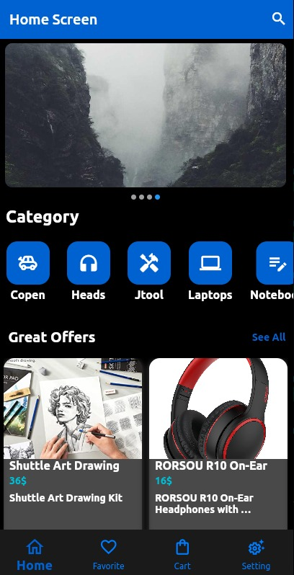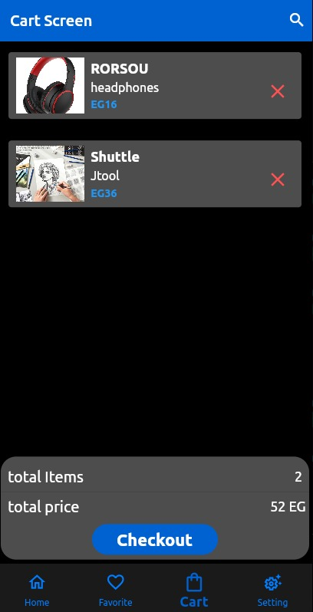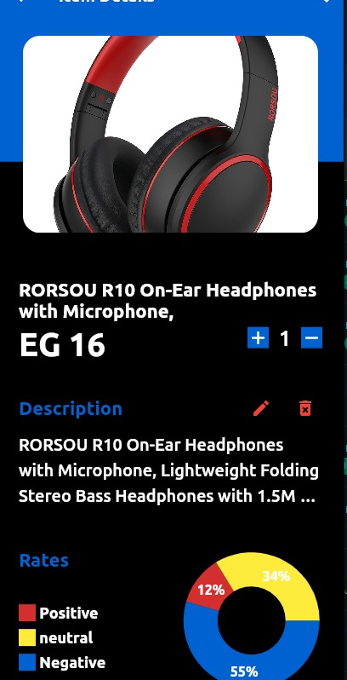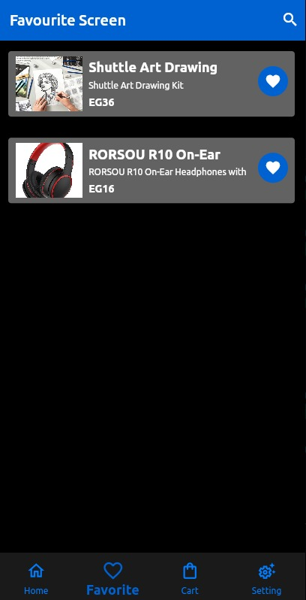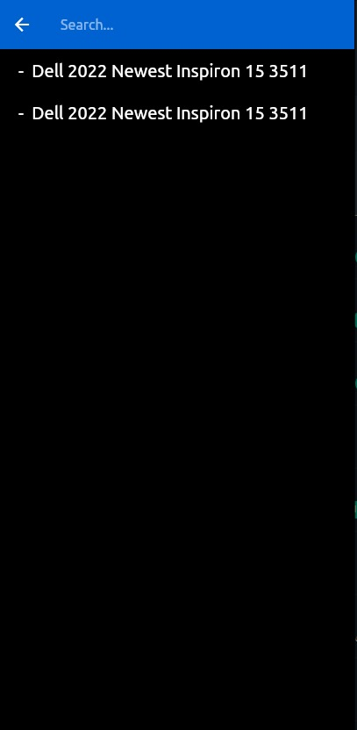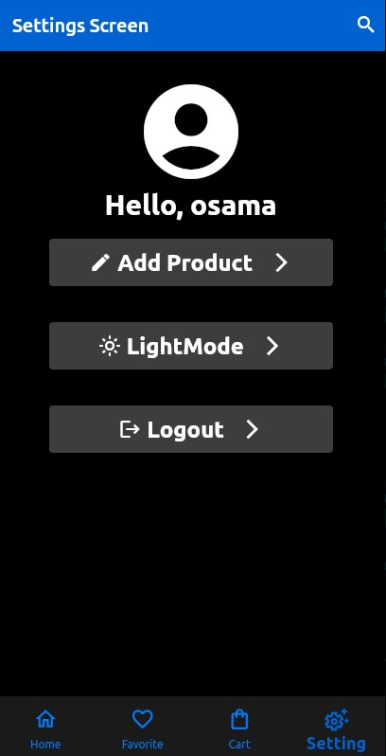

Figure : Dark Mode Screen

# Conclusion

In conclusion, this project has presented a comprehensive solution for helping customers make informed decisions about online shopping. By leveraging the power of AI and web scraping techniques, this project has developed a mobile application that provides access to reviews of products sourced from Amazon. The application filters the reviews and uses natural language processing techniques to identify the most relevant and helpful reviews for the customer. Additionally, the project has utilized programming languages such as Flutter and Dart for the mobile application, and Laravel for the backend, along with Postman as the API tool and MySQL as the database.

The project has implemented a user-friendly interface that allows customers to easily access and browse reviews of products, giving them the necessary information to make an informed purchase decision. The application provides a seamless shopping experience for customers, while also providing sellers with valuable insights into the preferences and needs of their customers.

Overall, this project has demonstrated the potential of technology in improving the online shopping experience for customers. By providing access to reviews and filtering them for relevance and helpfulness, this project has addressed one of the key challenges of online shopping. The project has also showcased the importance of using a combination of programming languages and tools to create a complete solution that meets the needs of both customers and sellers. The success of this project highlights the potential for further advancements in technology to revolutionize the e-commerce industry and provide an enhanced shopping experience for customers.

# Appendix

In this section, we will delve into the code implementation of our application's backend. The backend is responsible for handling the server-side logic and database operations that power the application's functionalities. We will discuss how the code is structured, the technologies and frameworks used, and the different modules that make up the backend.

The code implementation of our application's backend, which is built using PHP, Dart, Laravel, and API. These technologies are commonly used in web development and provide a powerful stack for building robust and scalable applications.

The backend modules are organized based on their specific functions, such as user authentication, data management, or API integration. Each module contains a set of functions that perform specific tasks, and they interact with each other to provide the desired outcome. For instance, the user authentication module handles user login and registration, while the data management module deals with database operations like creating, reading, updating, and deleting data.

## Onboarding Screen Code

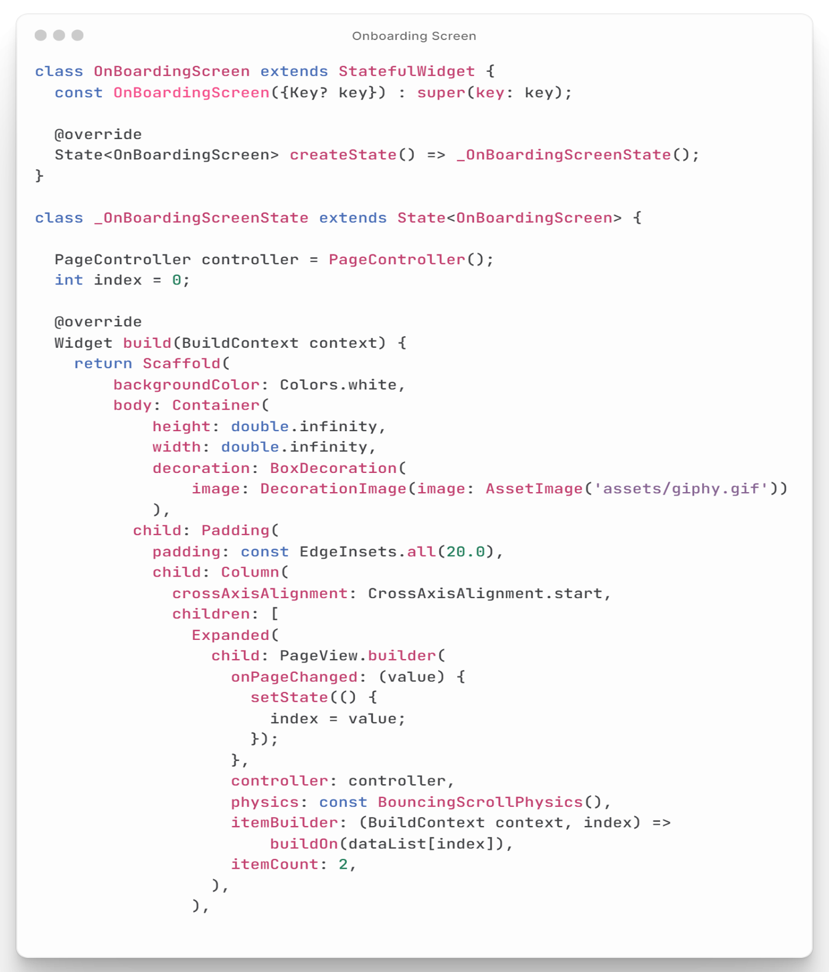This code is for an introduction screen in a mobile app, which is the first screen that users see when they open the app. It includes two pages, each with an image, title, and text description. There is a button that allows users to move to the next screen once they have finished with the introduction **as shown in figure (25).**

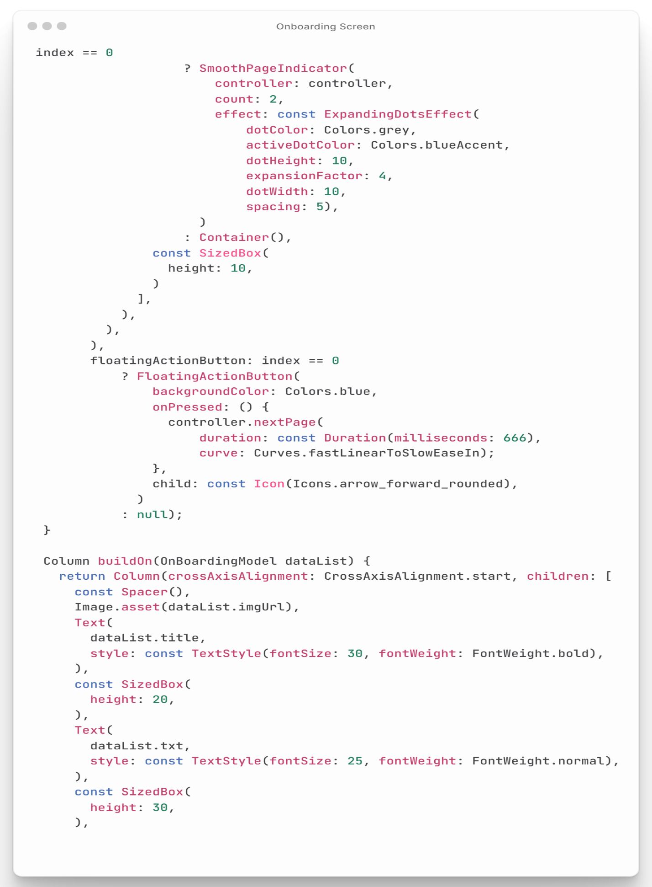

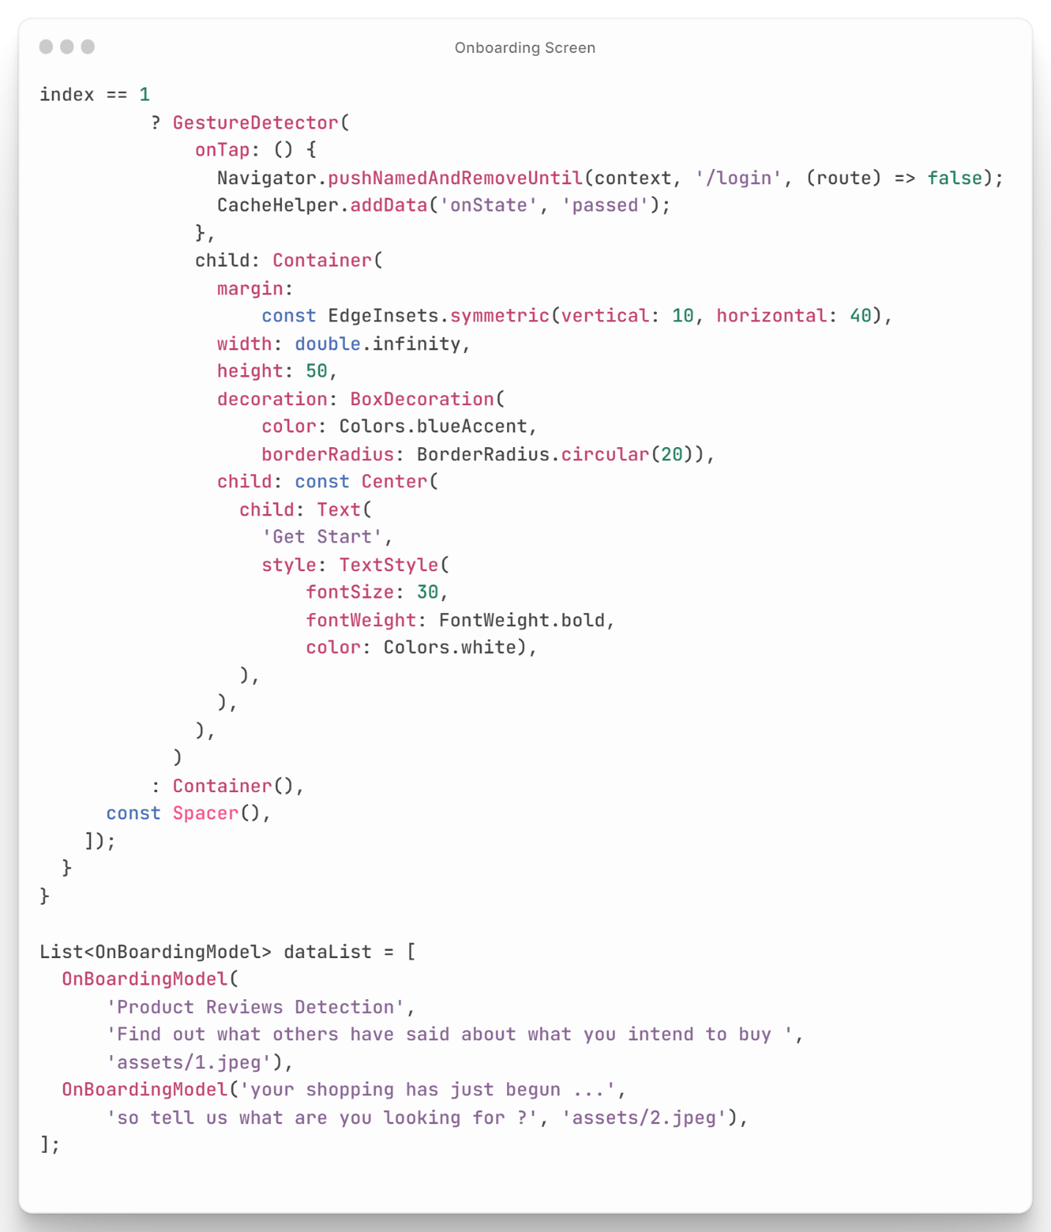

Figure : Onboarding Screen Code

## Login Code

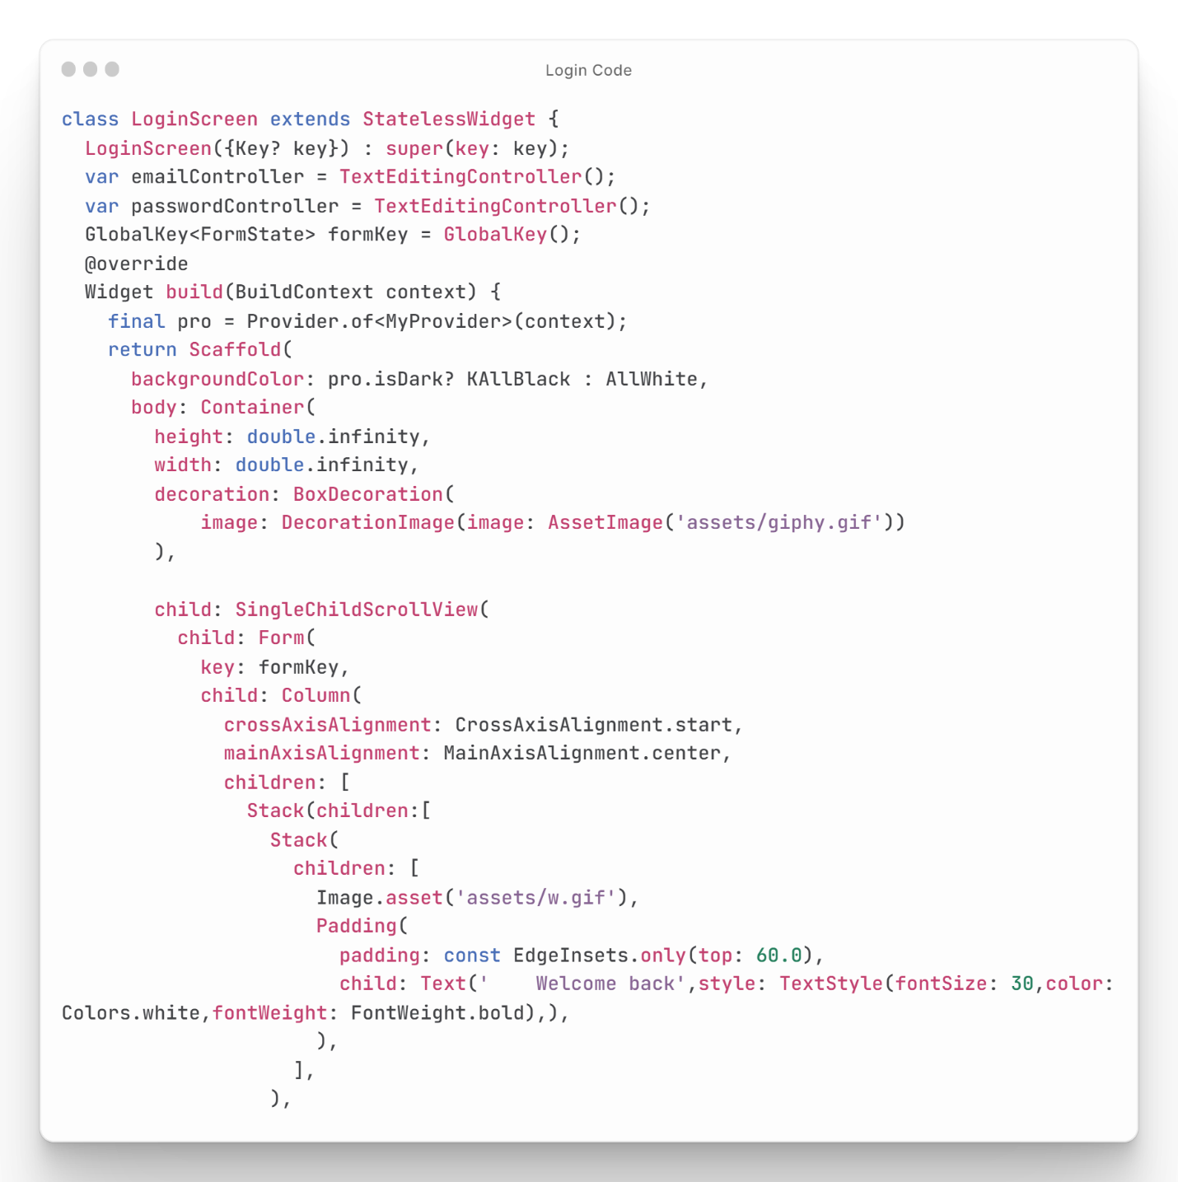This code presents a basic login screen for a mobile app, which consists of an image, a form with email and password text fields, a "Login" button for validating user input and authenticating their credentials, and a "Register" button that navigates to the registration screen. The code provides a simple and functional login screen for mobile app users **as shown in Figure (26).**

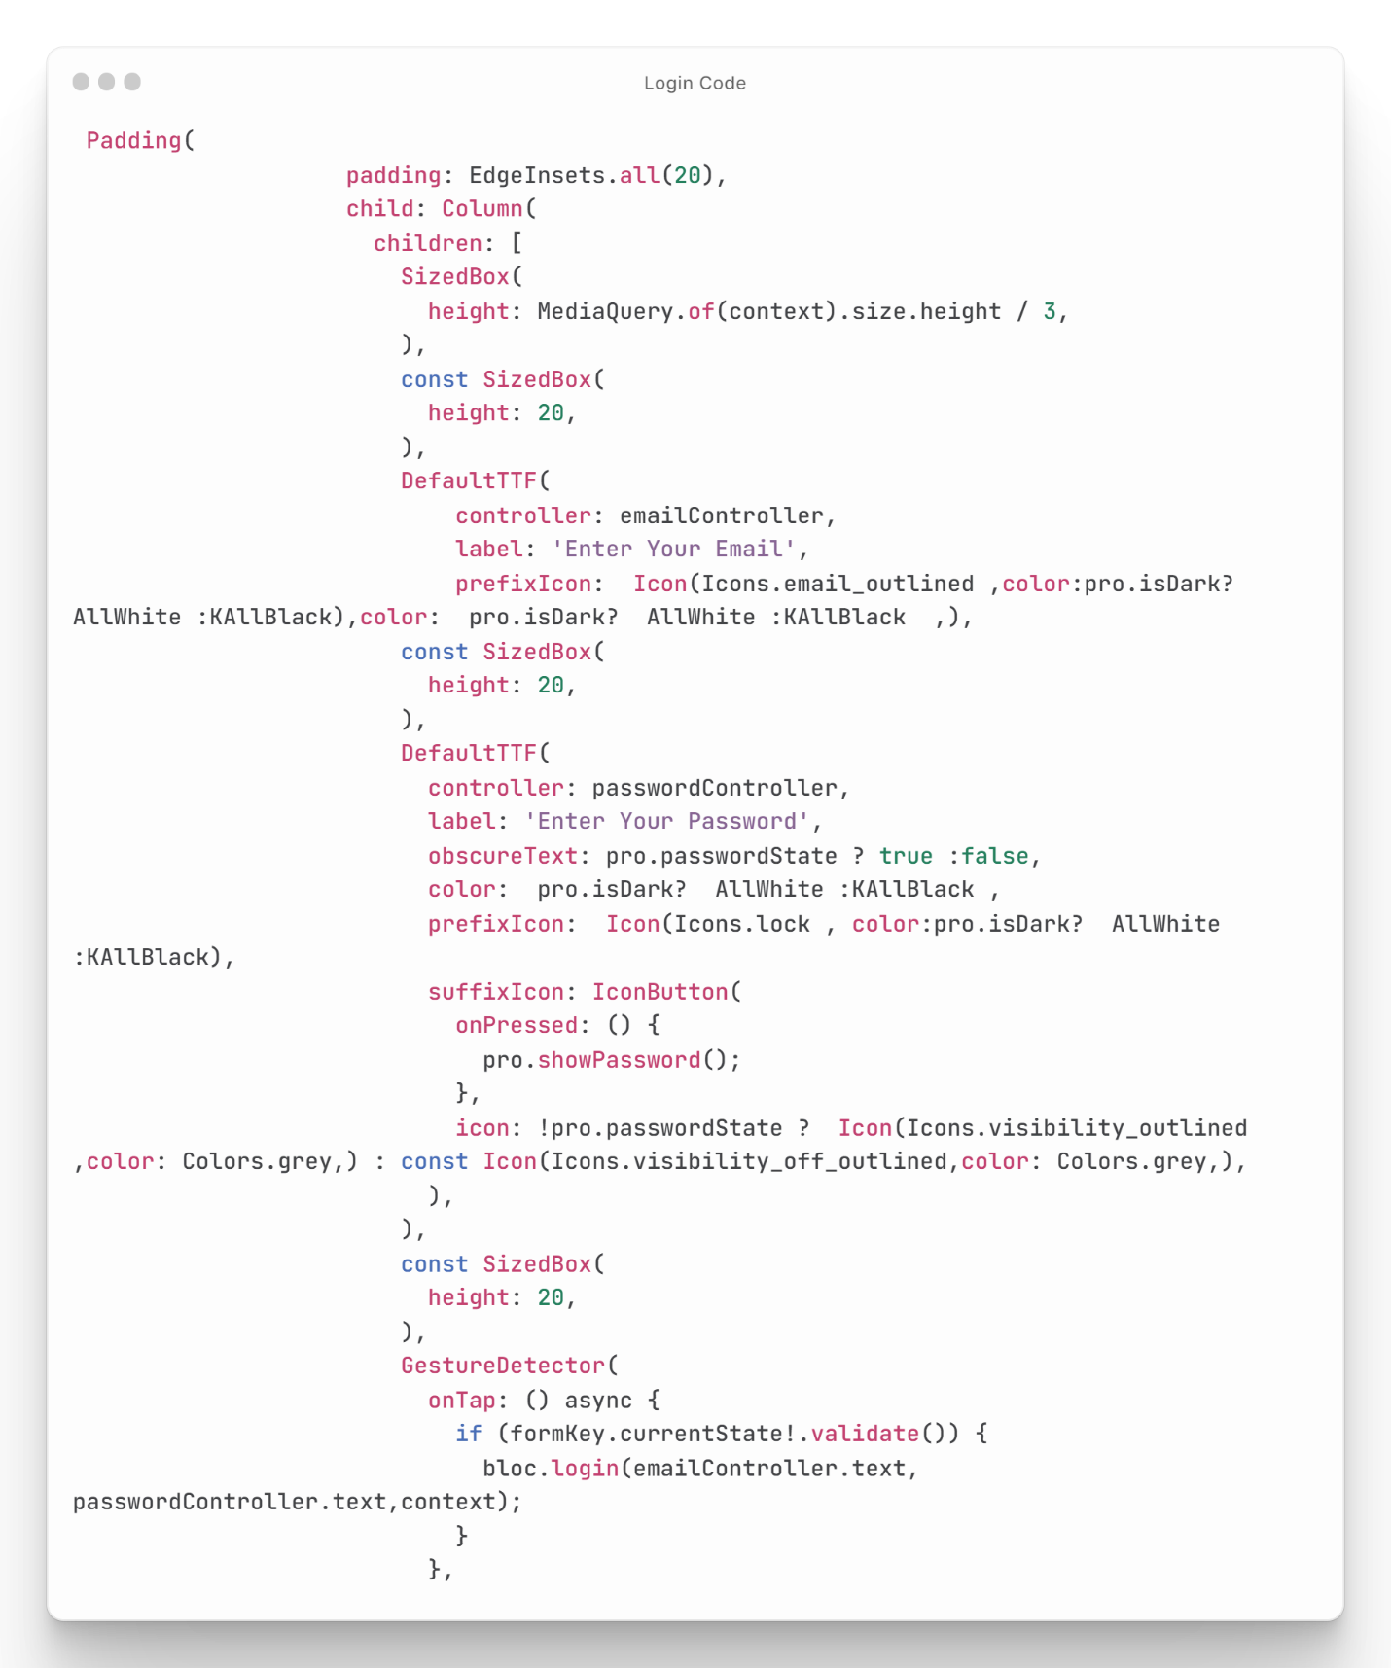

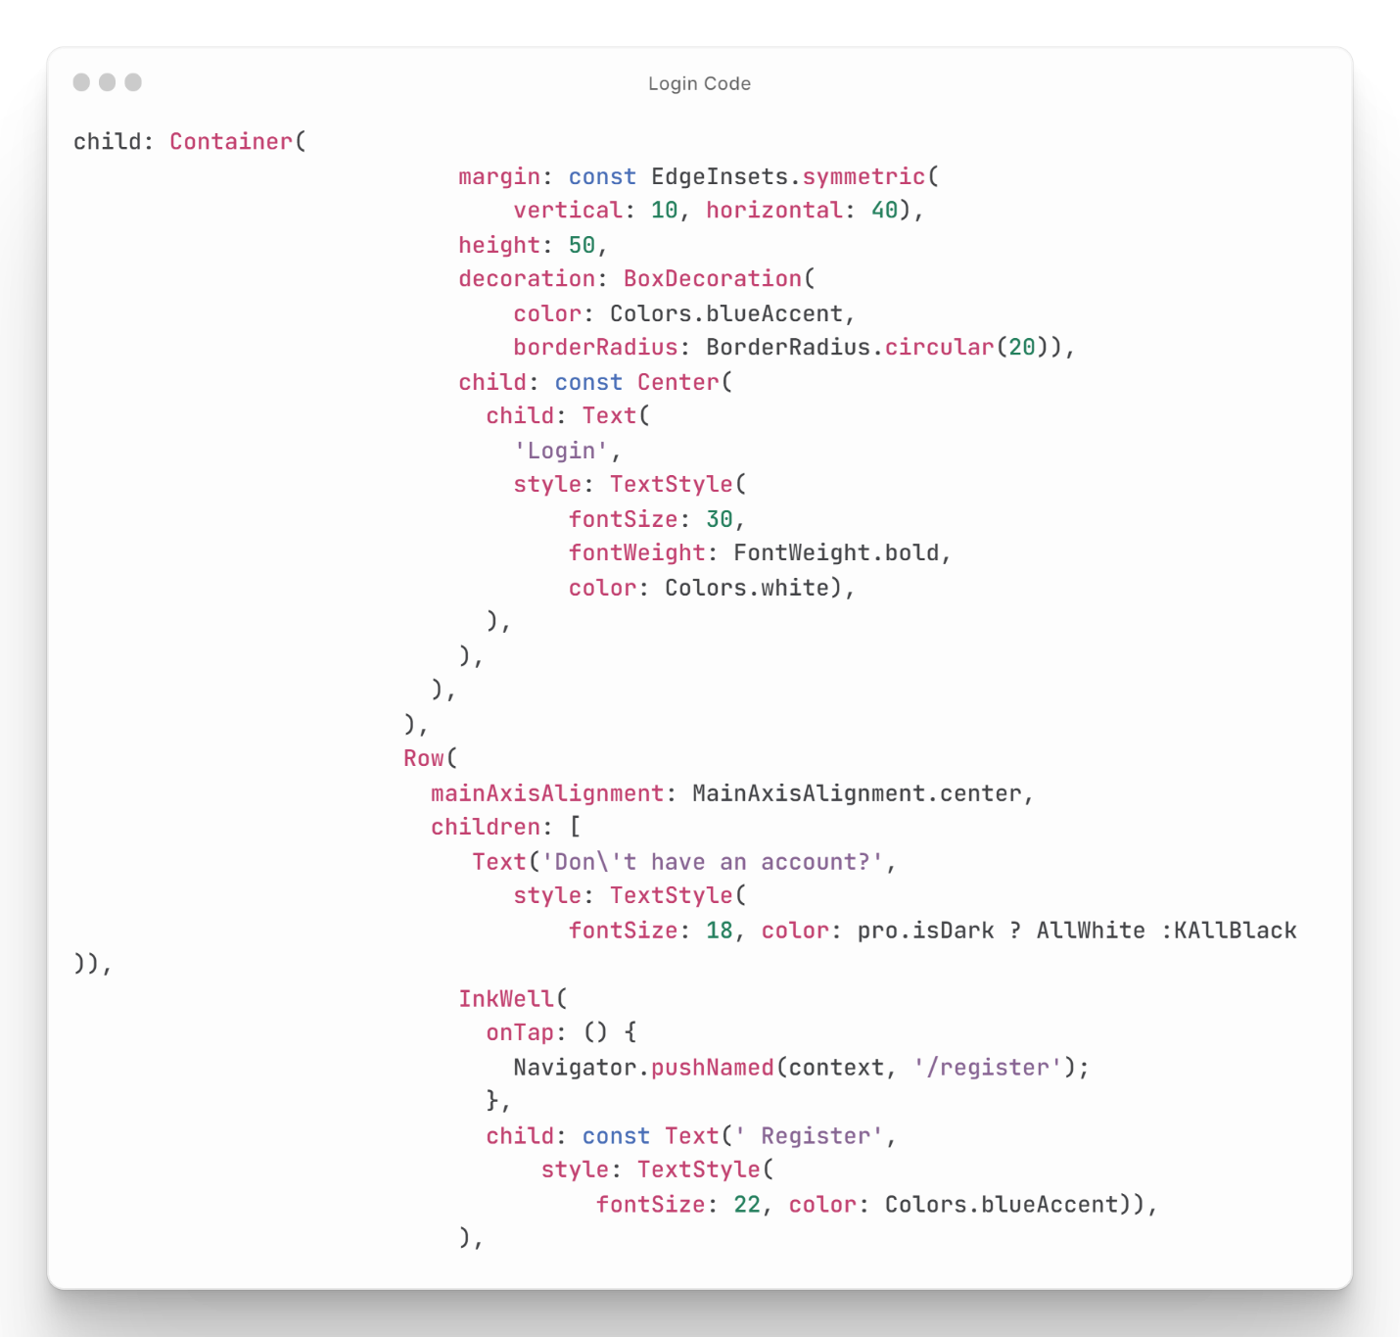

Figure : Login Screen Code

## Registration Code

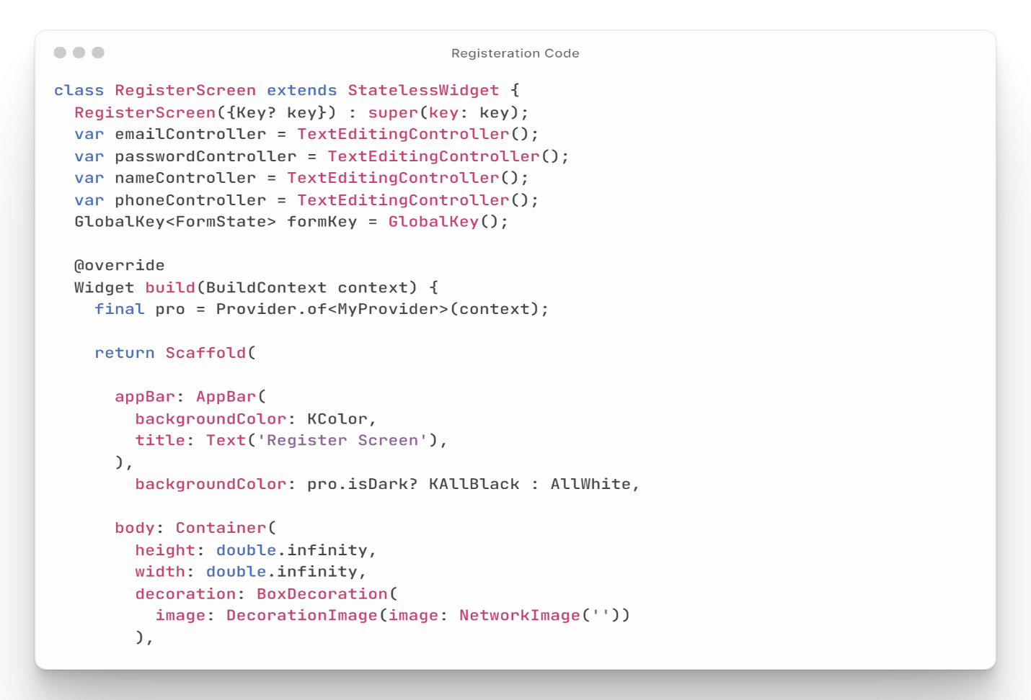The presented code is for a registration screen in a mobile app that provides users the ability to create an account. The code imports several classes, including the My Provider class, ex_file.dart file, a custom Default TTF widget, and a custom Default Button widget. The Register Screen widget is a stateless widget that builds a Scaffold with a custom app bar title and background color. The body of the screen is a Container that includes an image, a Form widget, and several Default TTF widgets for name, phone, email, and password inputs. The email and password fields use the Default TTF widget, while the "Register" button uses the Default Button widget to validate the inputs and call a register function from a bloc object to create a new user account. Overall, this code provides a simple and user-friendly registration screen in a mobile app, allowing users to create a new account by providing their necessary details **as shown in Figure (27).**

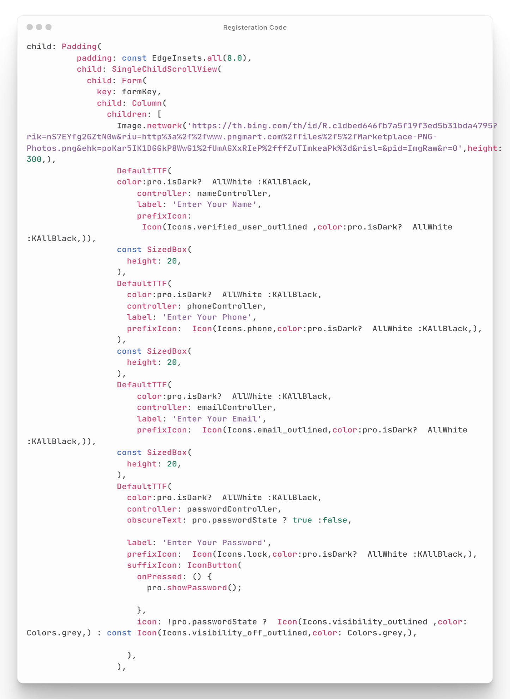

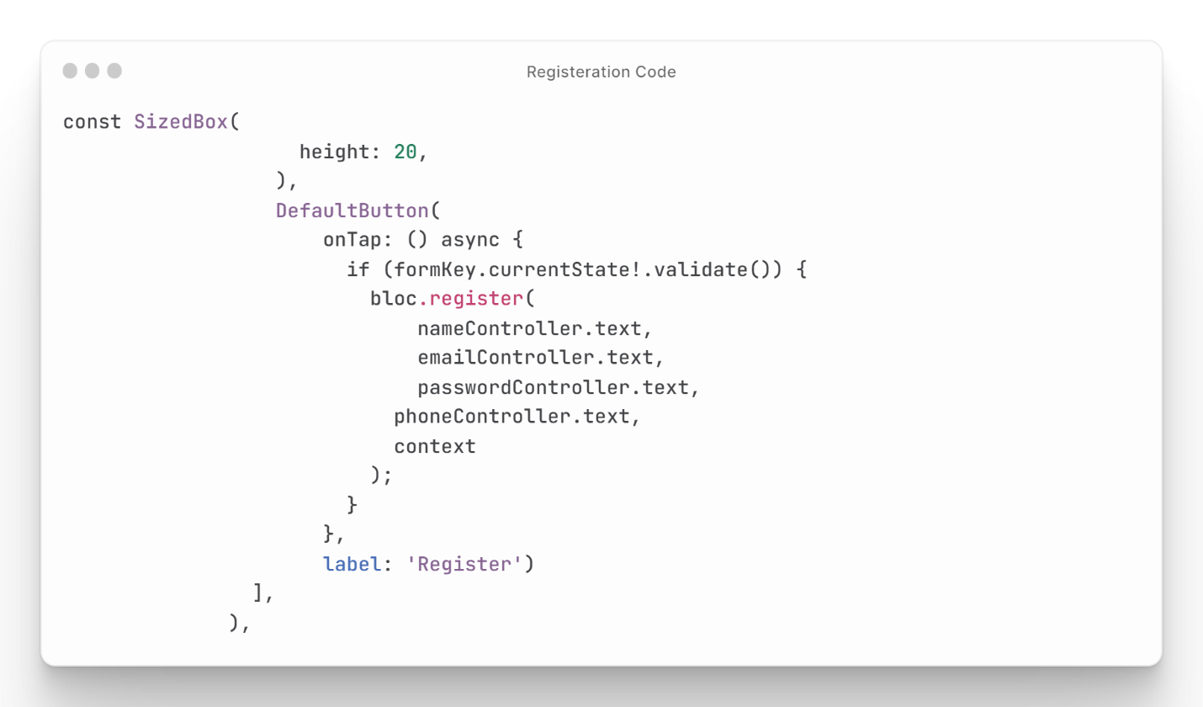

Figure : Registration Screen Code

## Home Code

This code is for the home screen of a mobile app. The screen displays a carousel slider with images, a list of categories, and a grid view of items. The code imports necessary packages and uses the `Provider` package to access and update data from the app's database, The carousel slider displays images from a list of URLs, while the list of categories displays icons and category names. The grid view of items displays the item's image, title, and price **as shown Figure (28).**

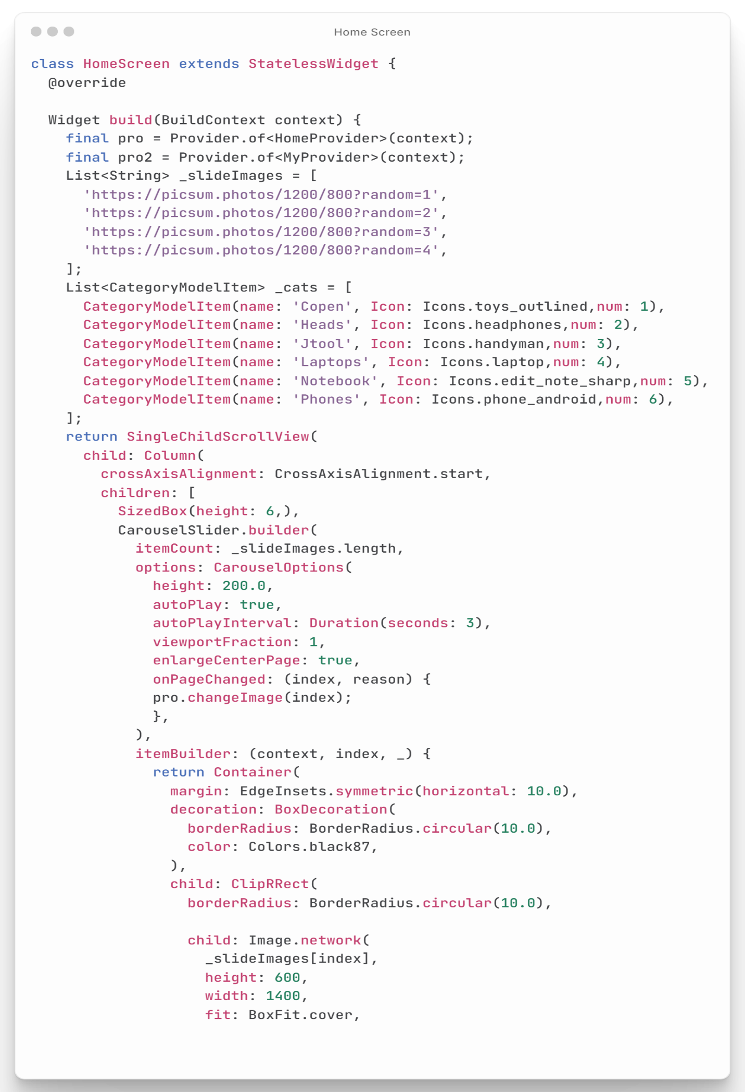

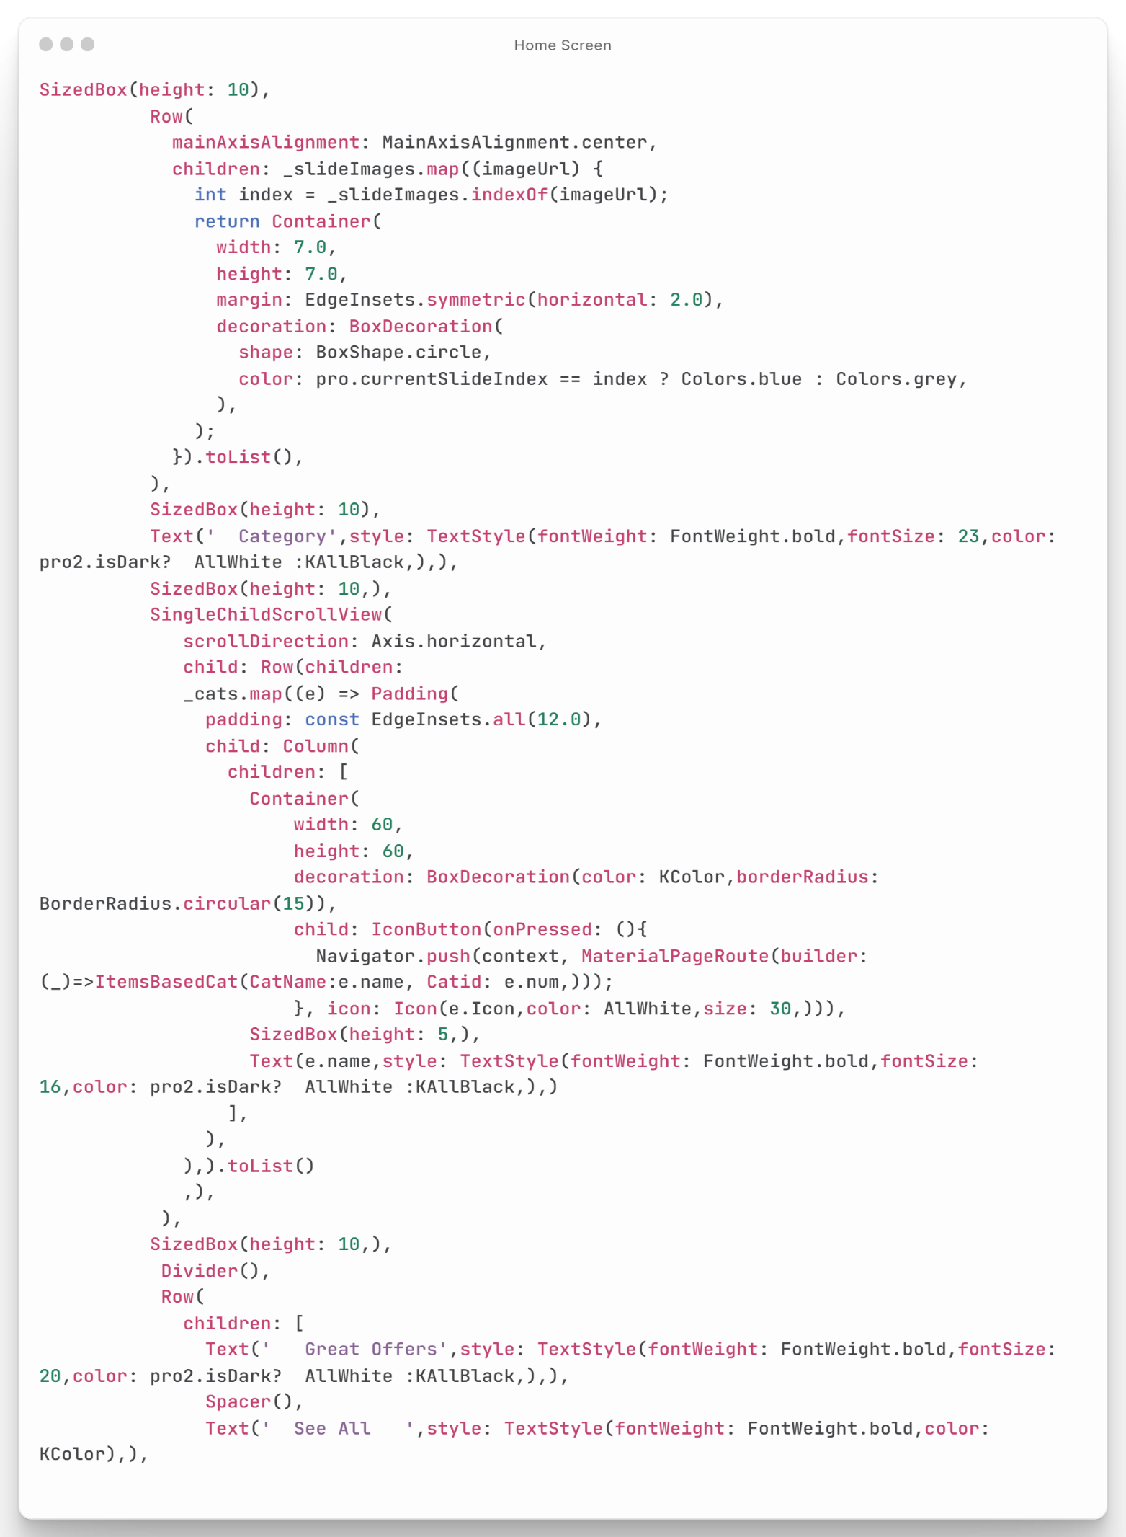

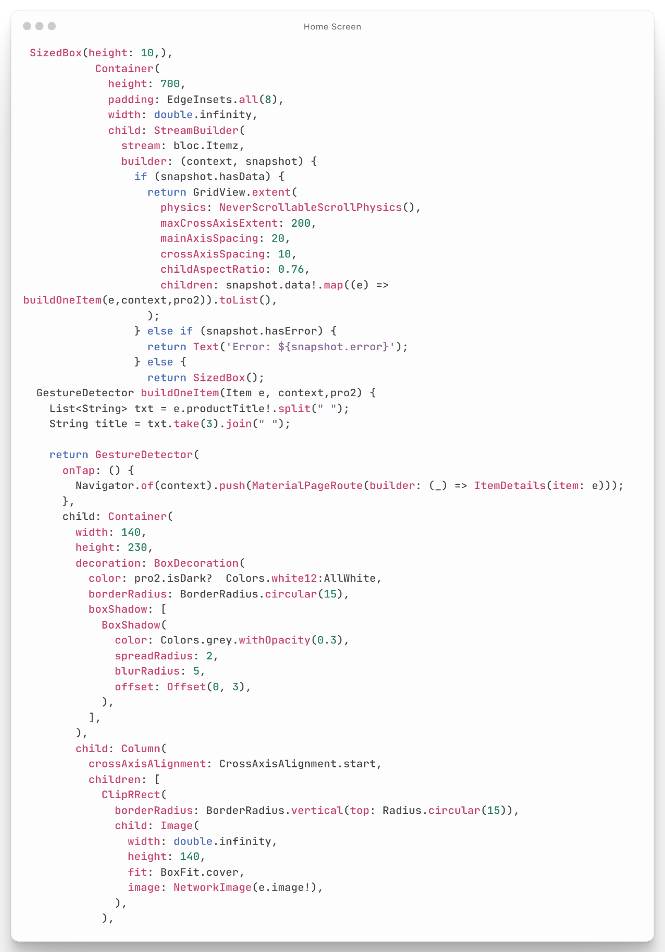

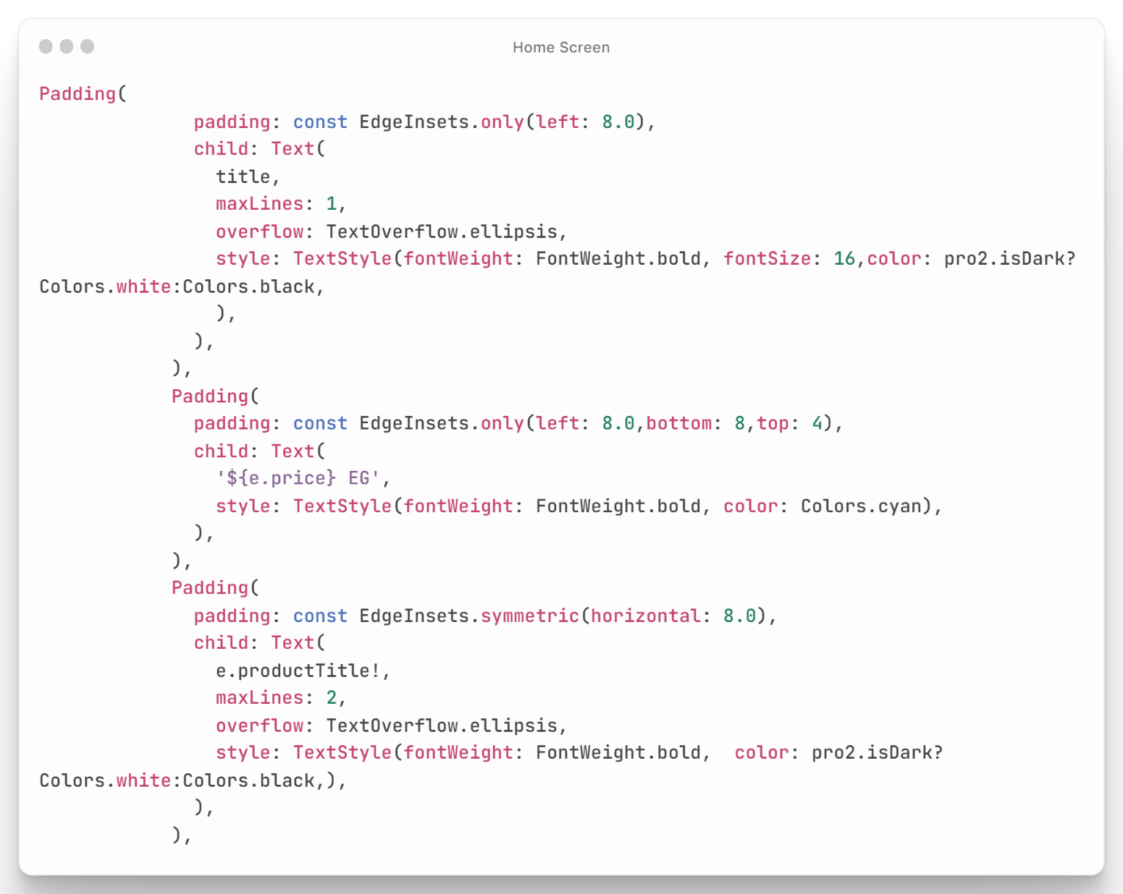

Figure : Home Screen Code

## Item Details Code

This code builds a screen for displaying details of an item in a Flutter application. The screen includes the item's image, title, price, description, and ratings, as well as the ability to add the item to the shopping cart or mark it as a favorite **as shown in Figure (29).**

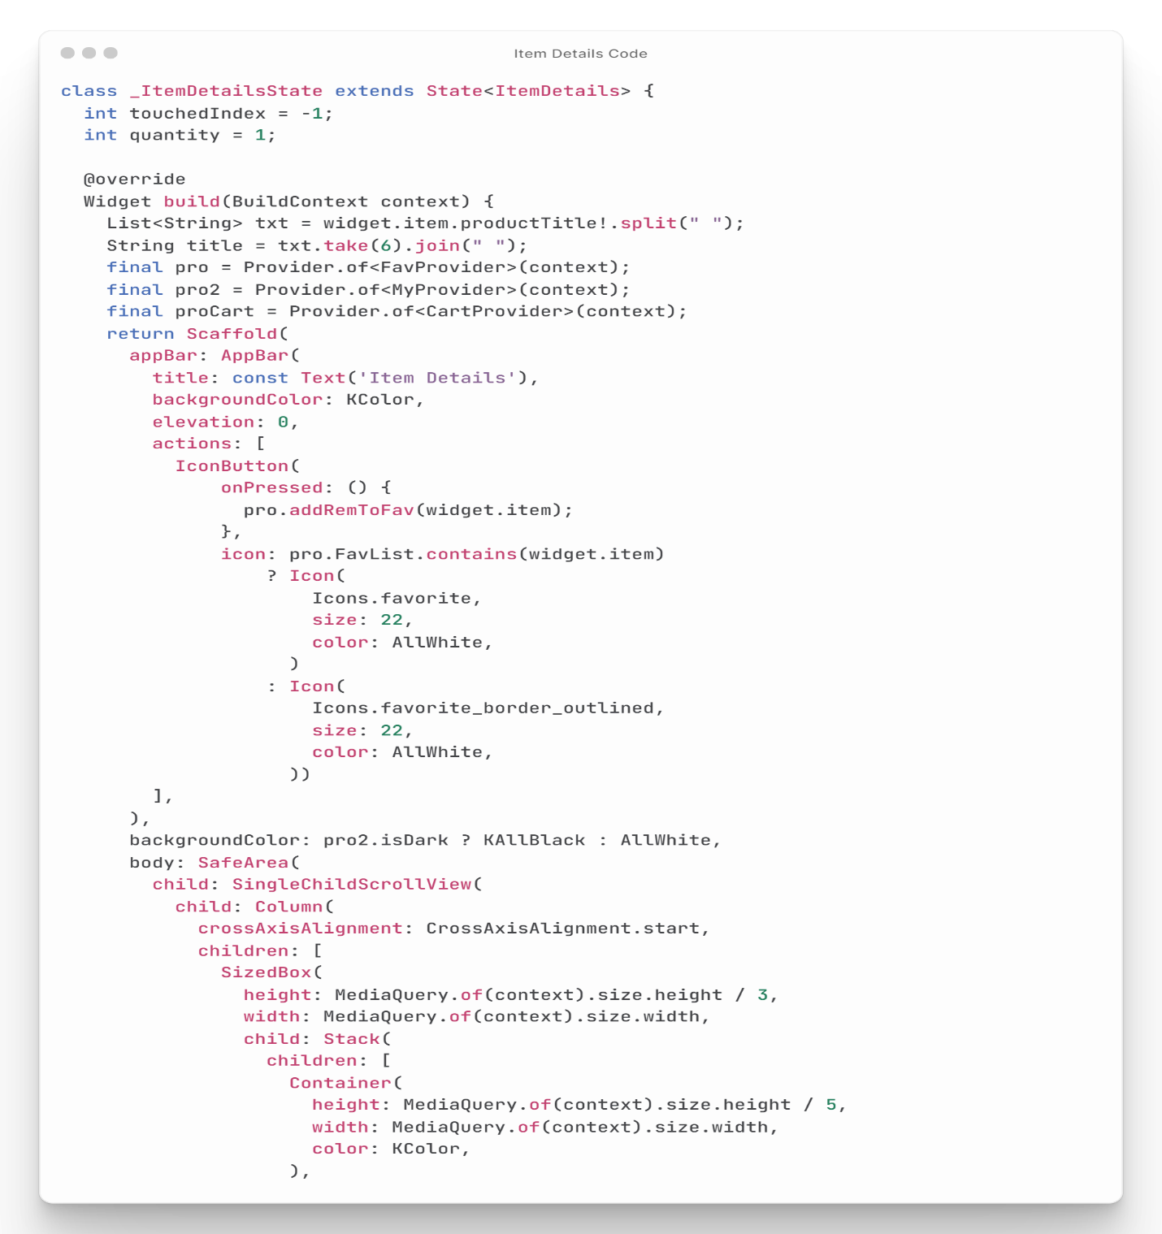

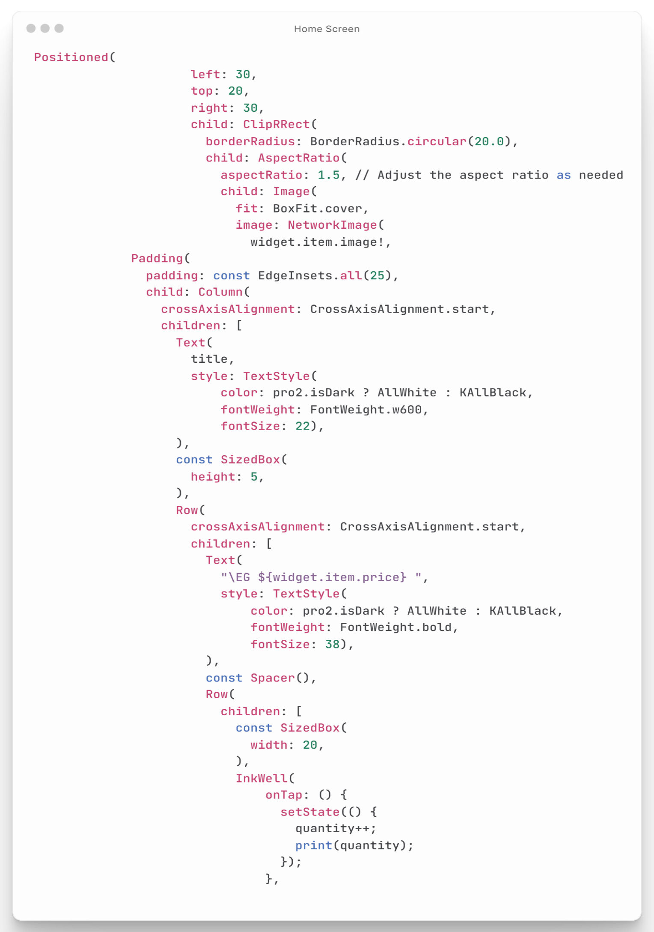

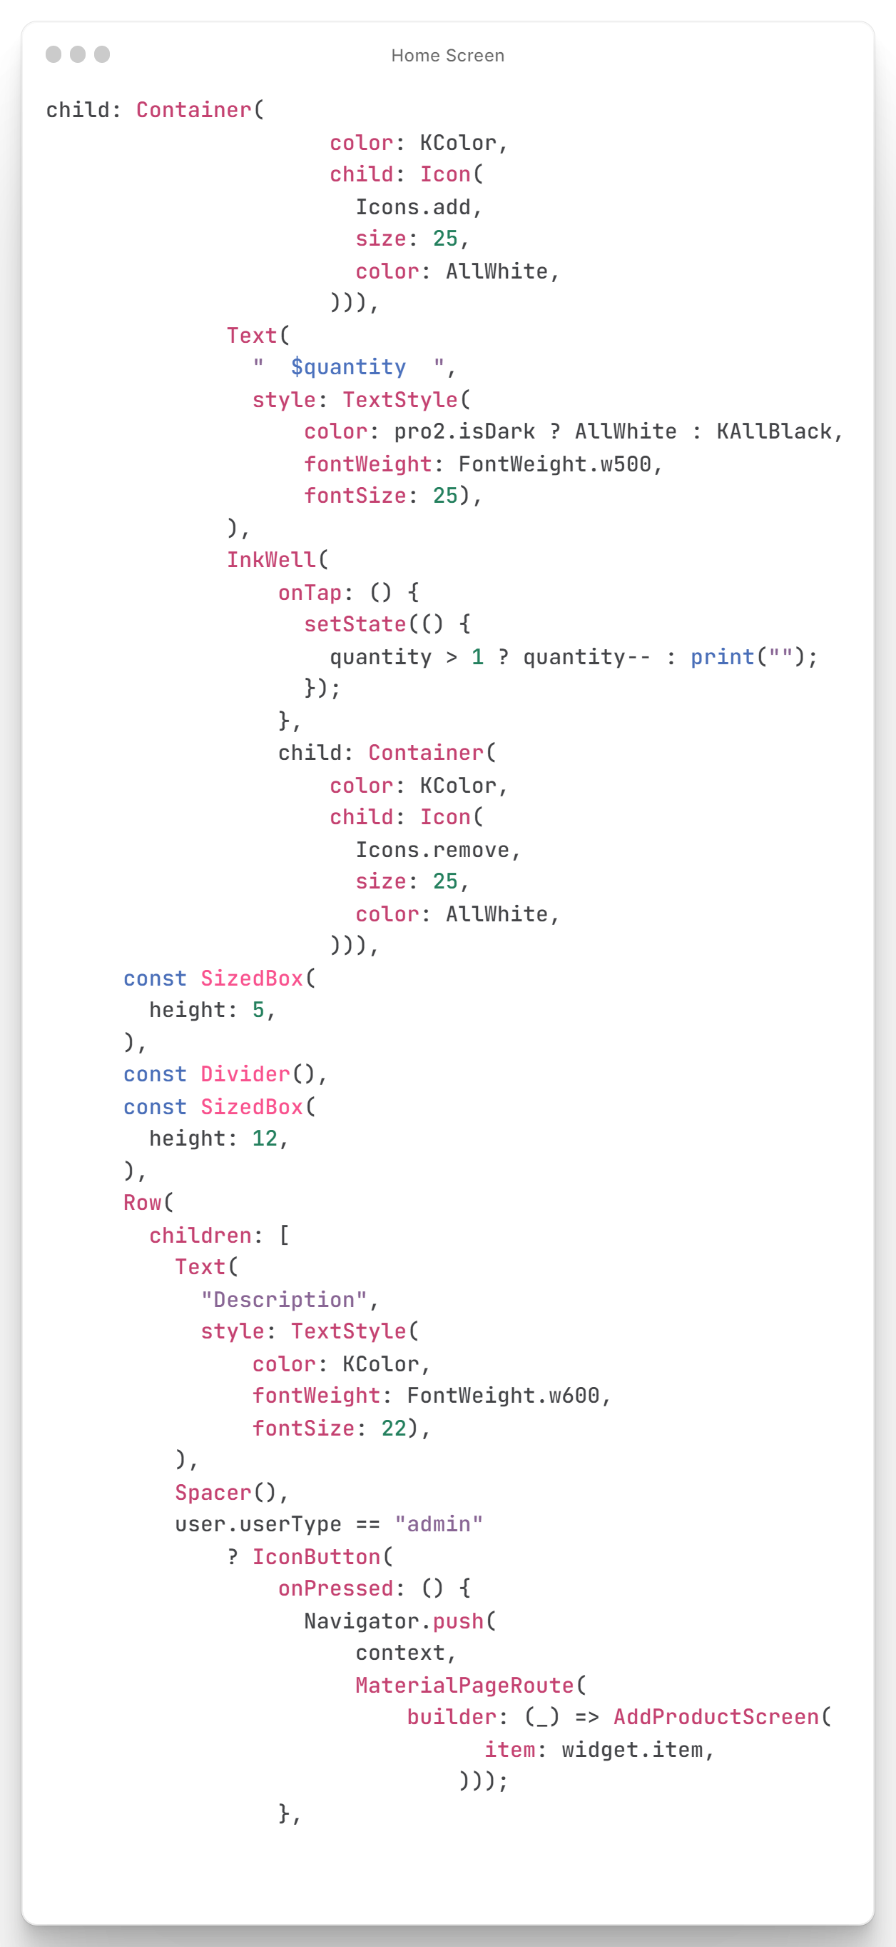

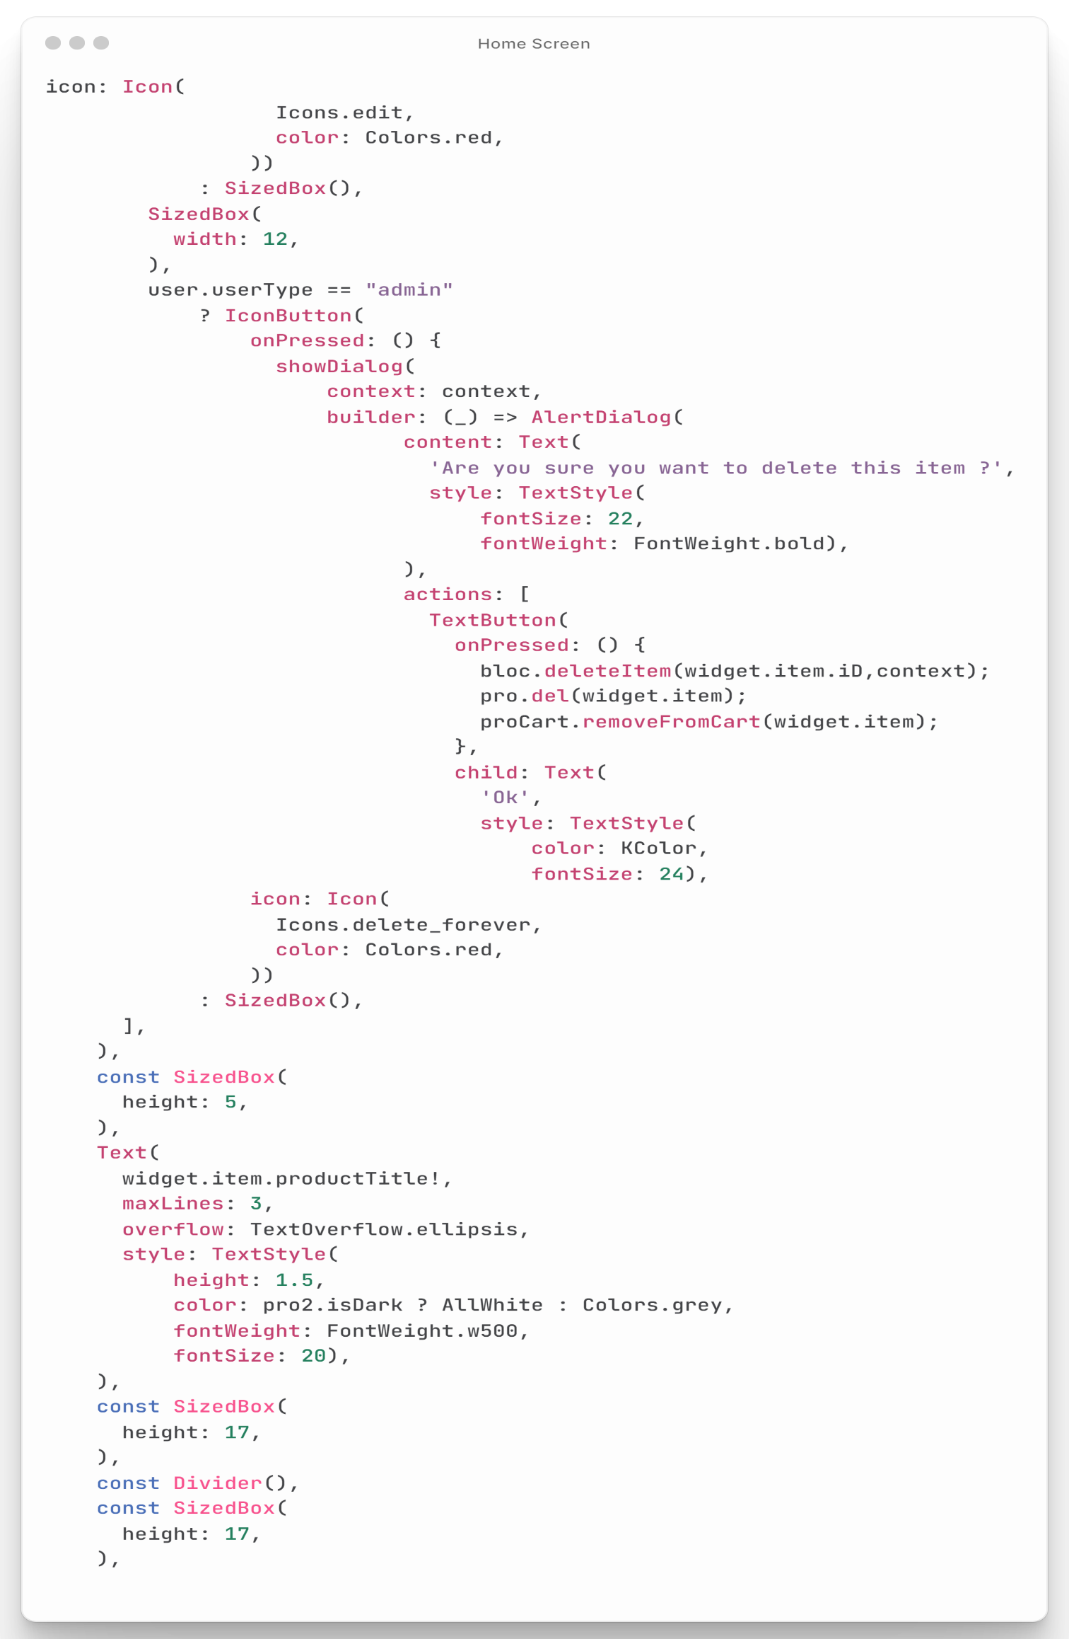

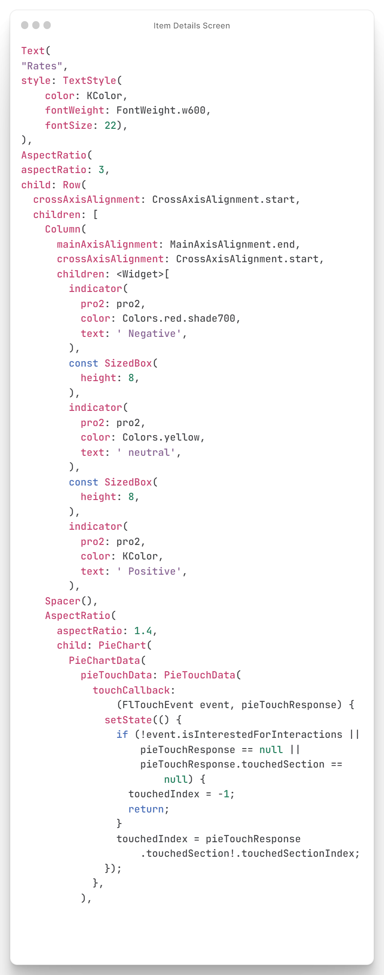

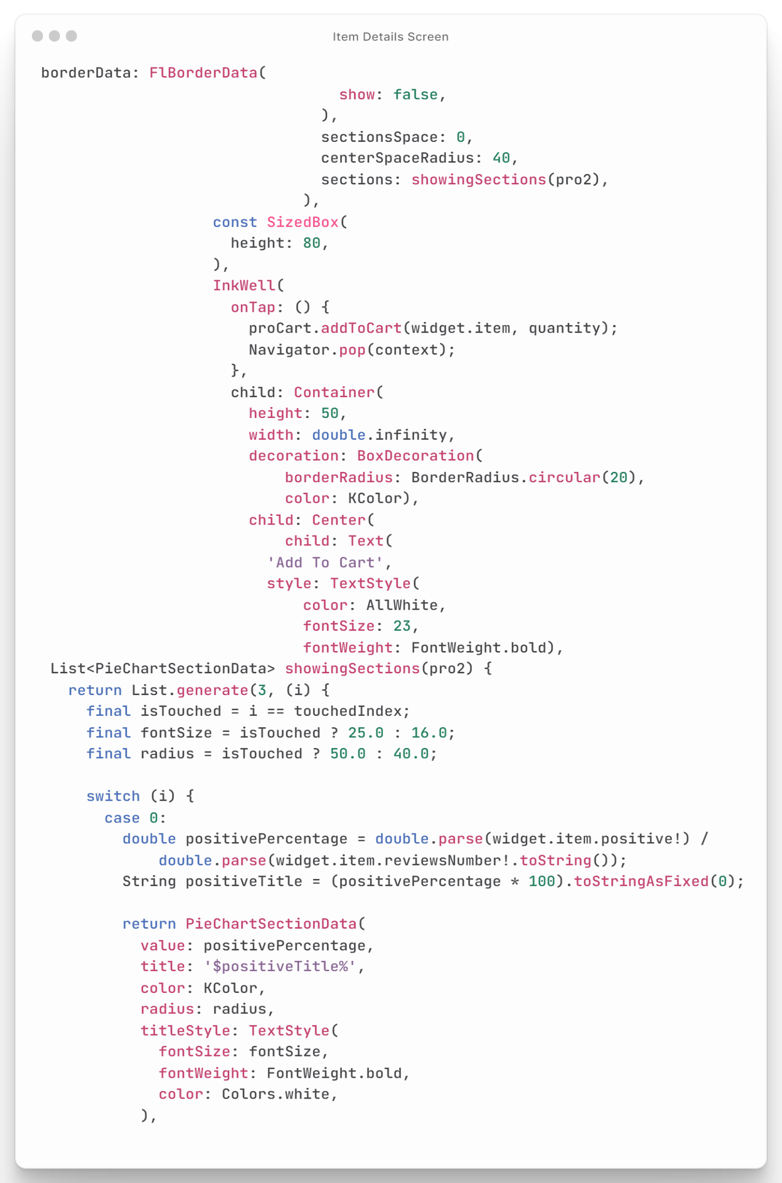

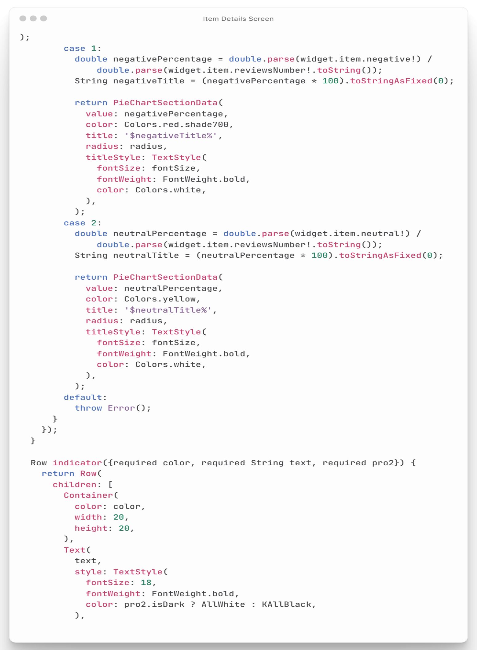

Figure : Item Details Screen Code

## Favorite Code

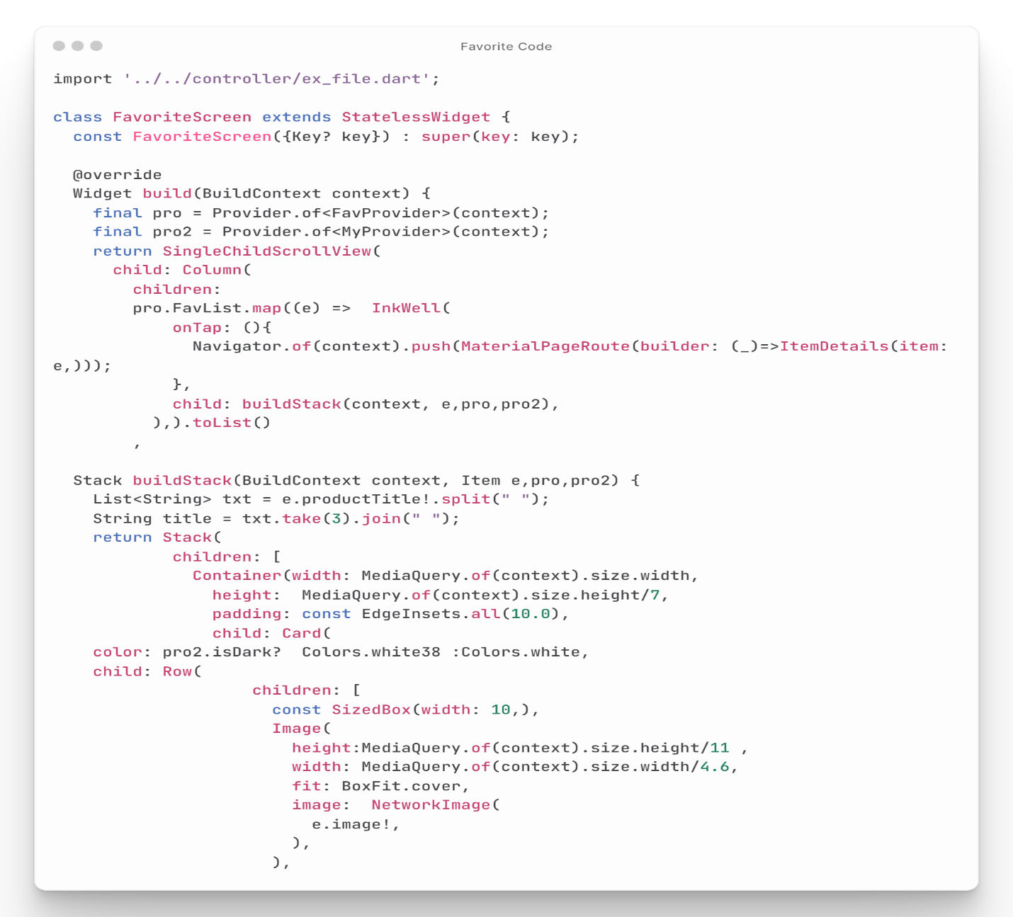This code creates a screen for displaying favorite items in a mobile app. The screen shows a list of items in a card format, containing each item's image, title, description, and price **as shown in figure (30).** Each item is accompanied by a "Favorite" button that users can use to add or remove the item from their favorites list. The screen is scrollable, and the items are generated using a build Stack function. Overall, this code provides a simple and user-friendly screen for displaying favorite items in a mobile app, allowing users to easily manage their favorites list.

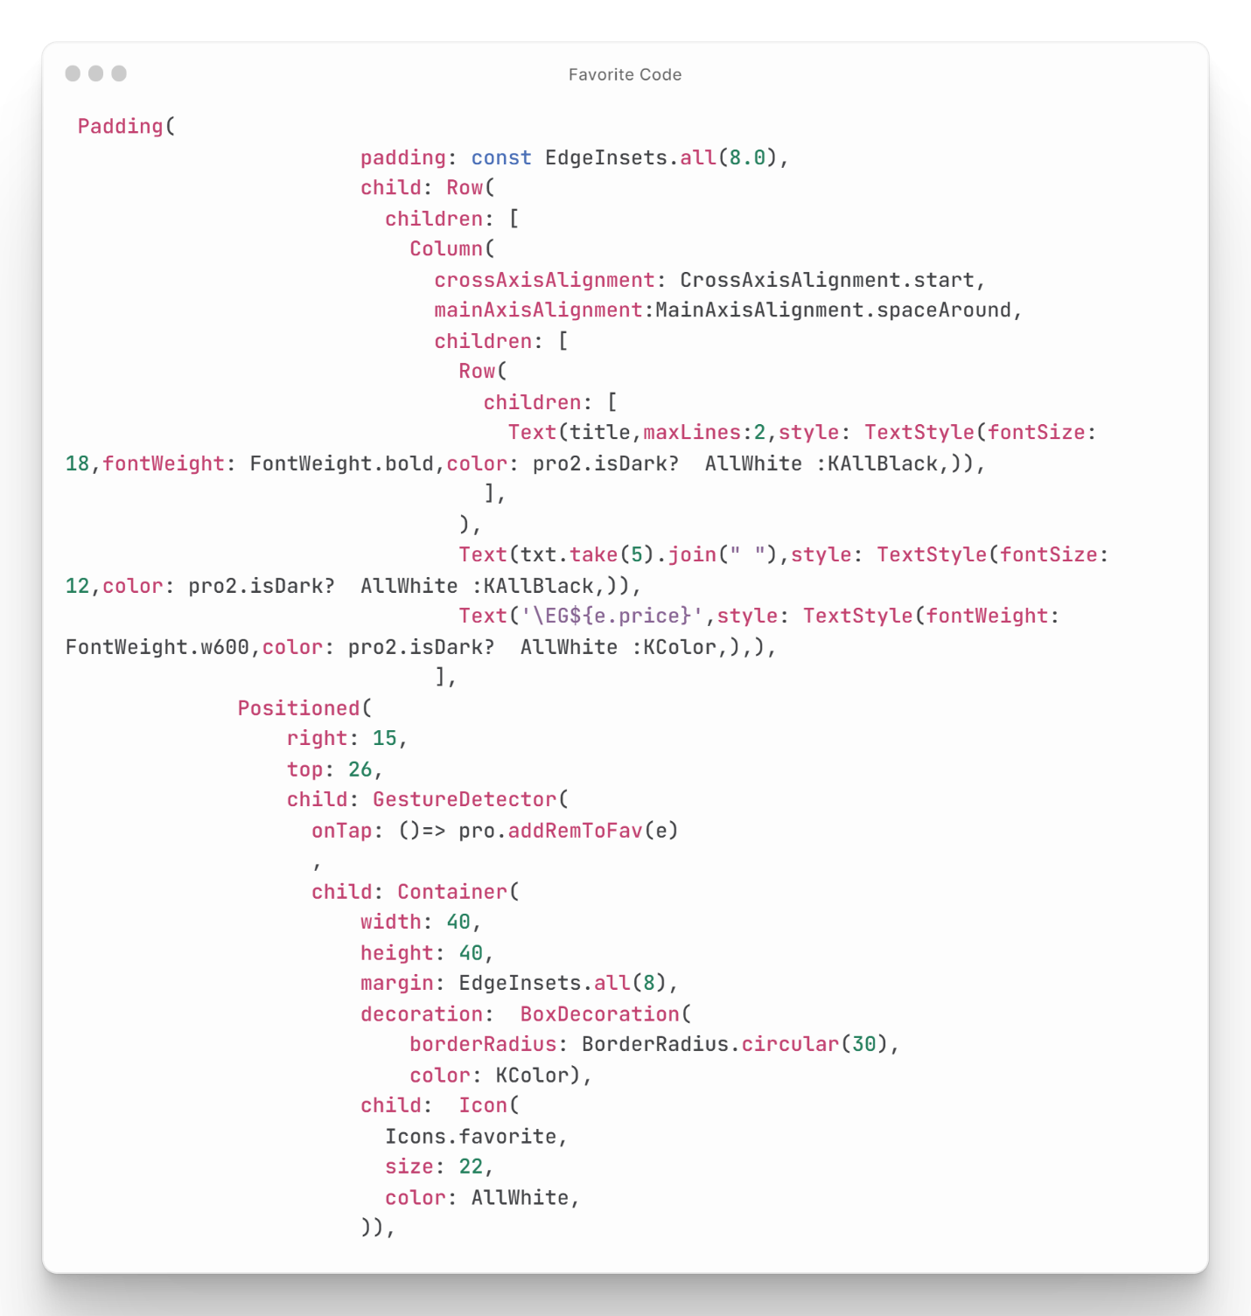

Figure : Favorite Screen Code

## Cart Code

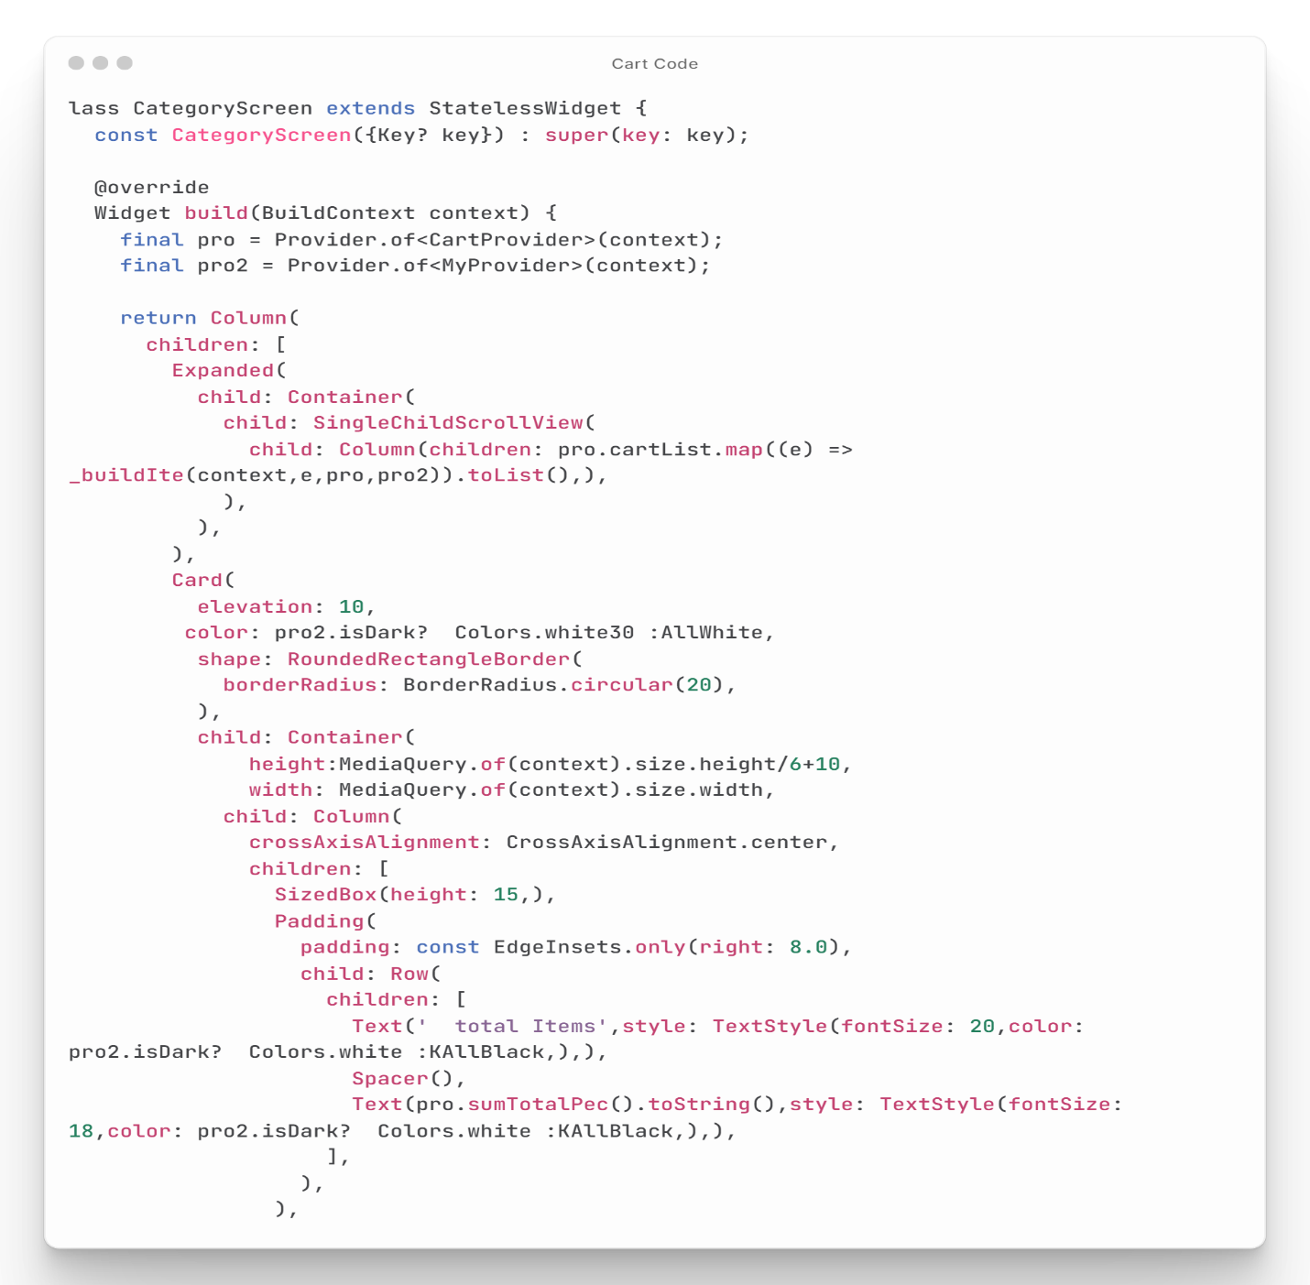This code creates a screen for displaying items in a shopping cart in a mobile app. The screen shows a list of items in a card format, with each item's image, title, category, and price **as shown in Figure (31).** There is also a "Remove" button for each item that allows users to delete the item from their cart. The screen also shows the total number of items and the total price, and there is a "Checkout" button that users can tap to proceed to the checkout process.

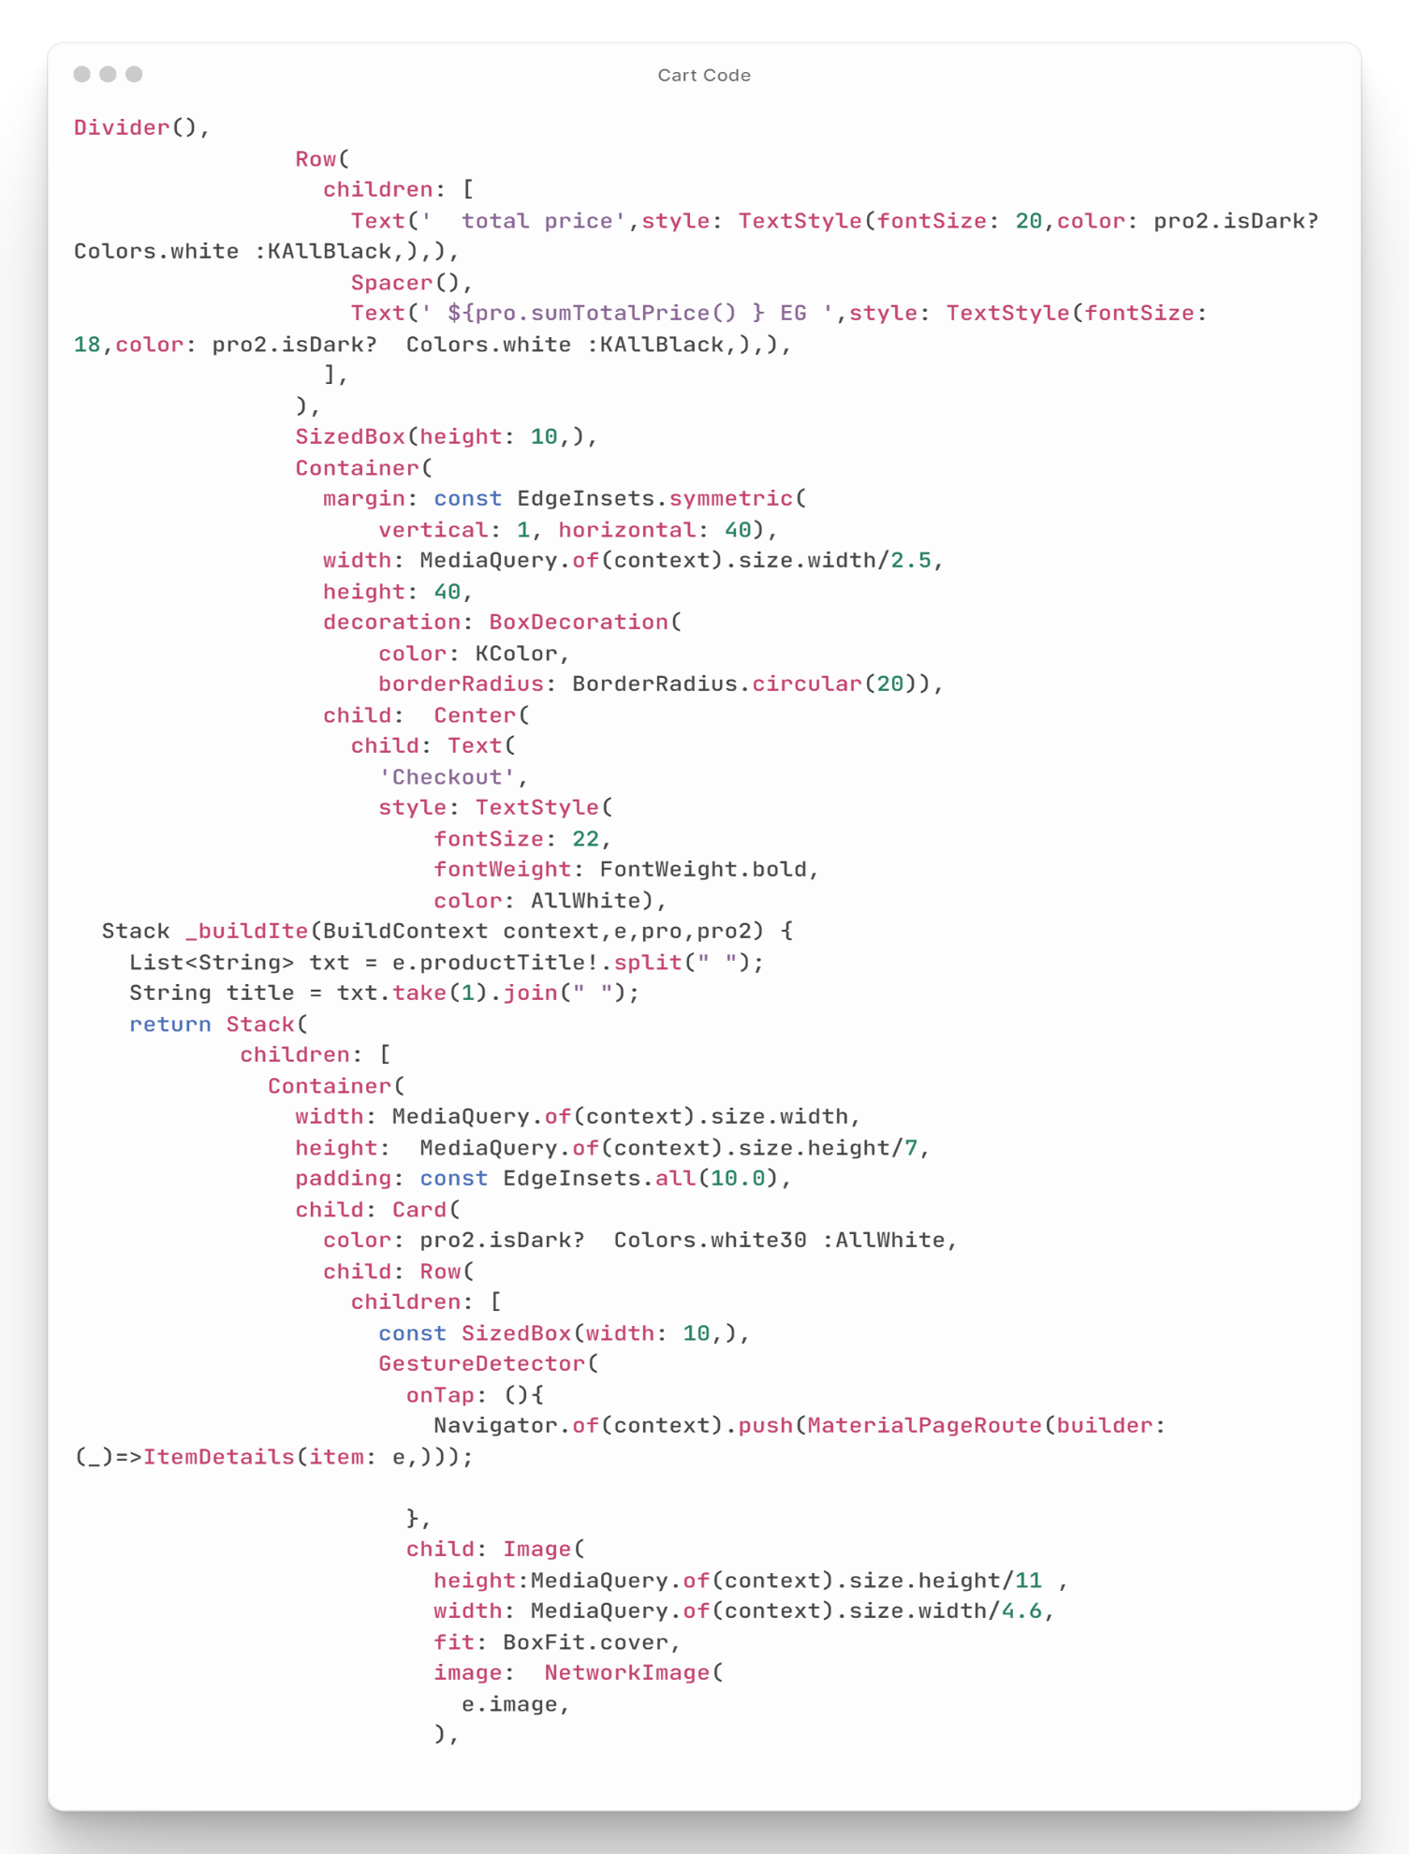

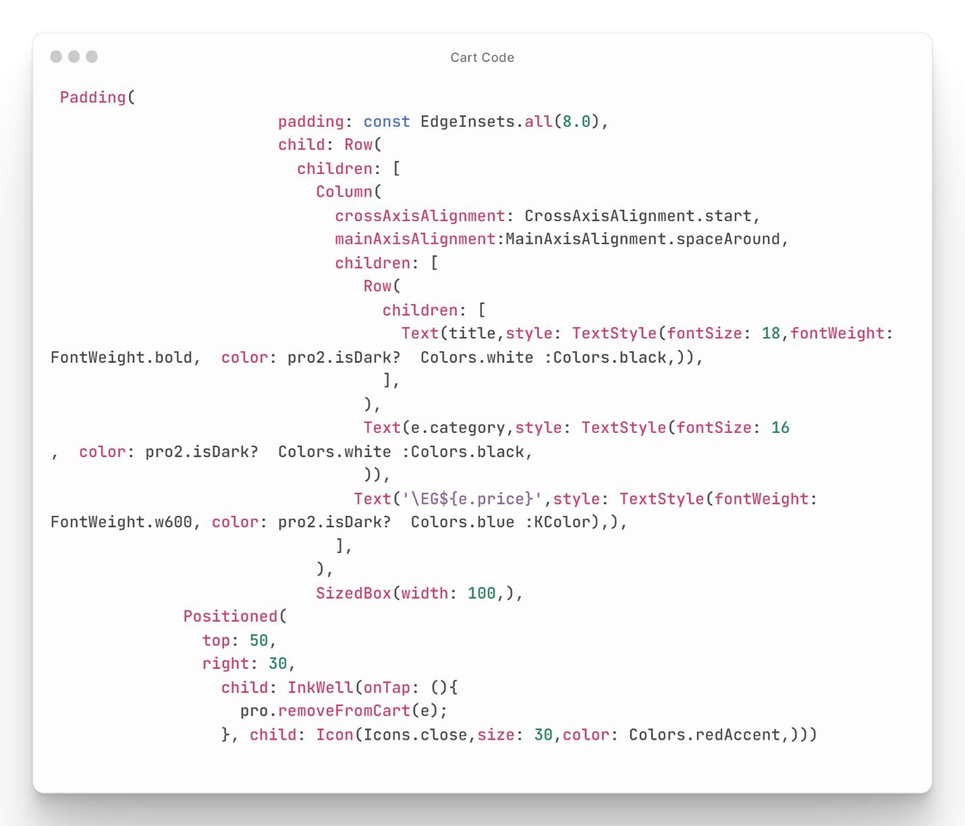

Figure : Cart Screen Code

## Search Code

The presented code is for a search screen in a mobile app that enables users to search for items and view their details **as shown in Figure (32).** The code imports several classes, including the My Provider class, ex_file.dart file, and a custom Item Details widget. The Search Screen widget is a stateless widget that builds a Scaffold with a custom app bar title, search field, and background color. The search field uses a Text Field widget with a Text Editing Controller to filter the list of items based on the user's search query. The ListView.builder widget displays the filtered list of items as List Tile widgets, and when a user taps on an item, the Item Details widget is displayed. Overall, this code provides a simple and intuitive search screen in a mobile app, allowing users to search for items and view their 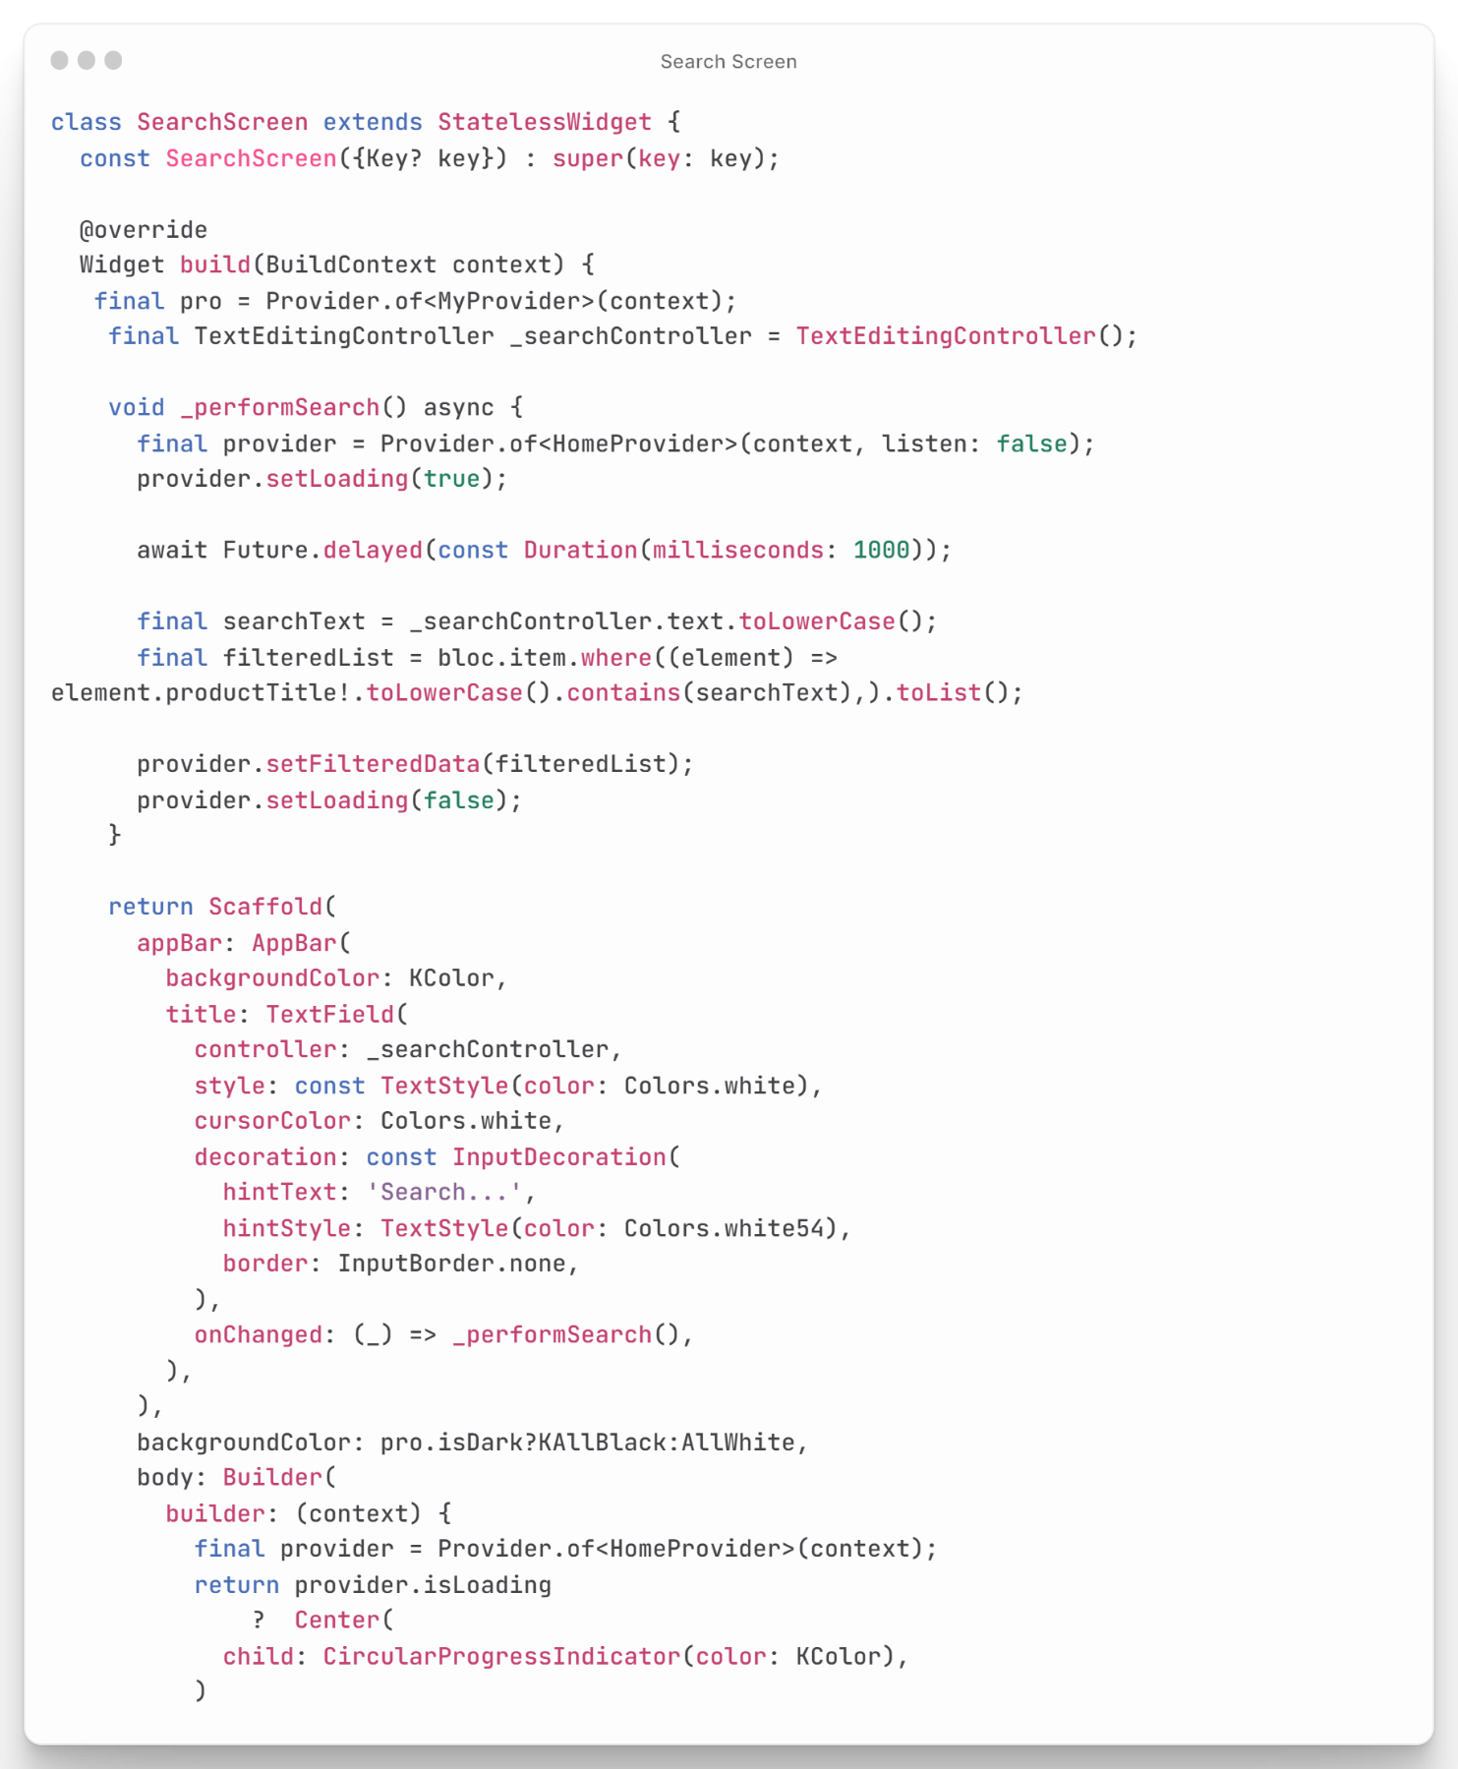details with ease.

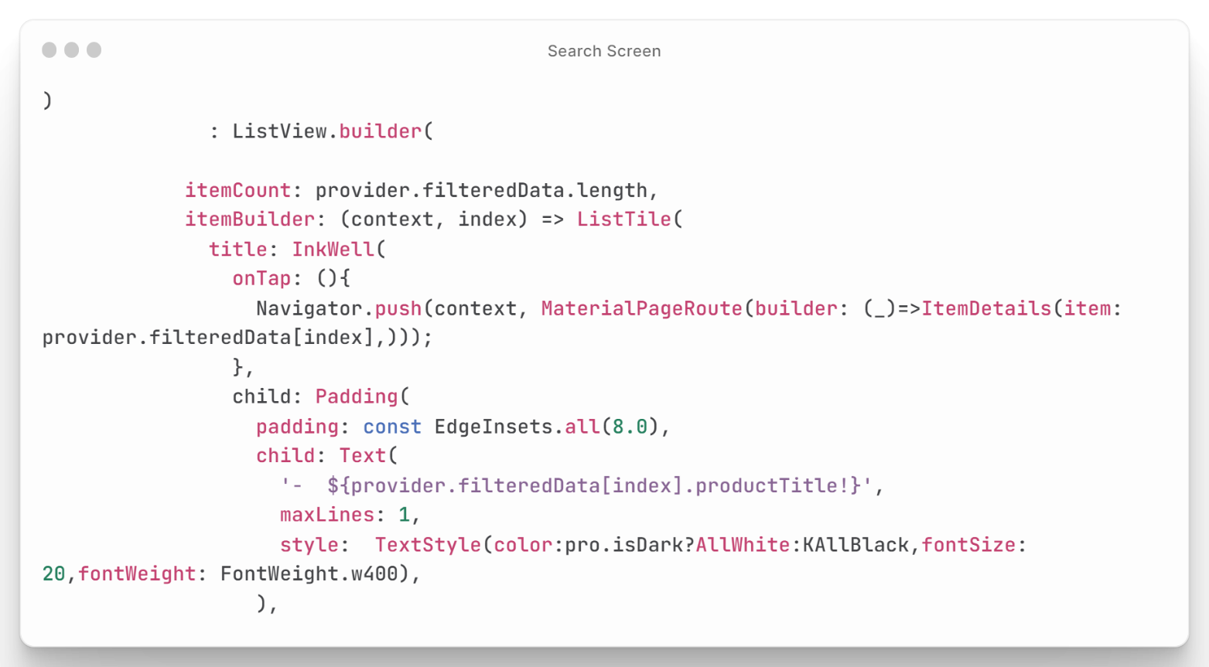

Figure : Search Screen Code

## Categories Screen Code

This is a Flutter widget that displays a list of items based on a selected category. The widget takes in two parameters: Cat Name, which is the name of the selected category, and Cat id, which is the ID of the selected category. The widget displays an App Bar with the Cat Name as the title and a background color that depends on the app's theme. The body of the widget is a list of items that are retrieved from a stream of items using a Stream Builder. For each item, the widget displays an Inkwell widget that shows the item's image, title (truncated to the first three words), and price. When the user taps on an item, they are taken to a screen that displays more details about the item. Overall, this code creates a simple and reusable widget that can help developers quickly implement a list of items based on a selected category in their Flutter app **as shown in Figure (33).**

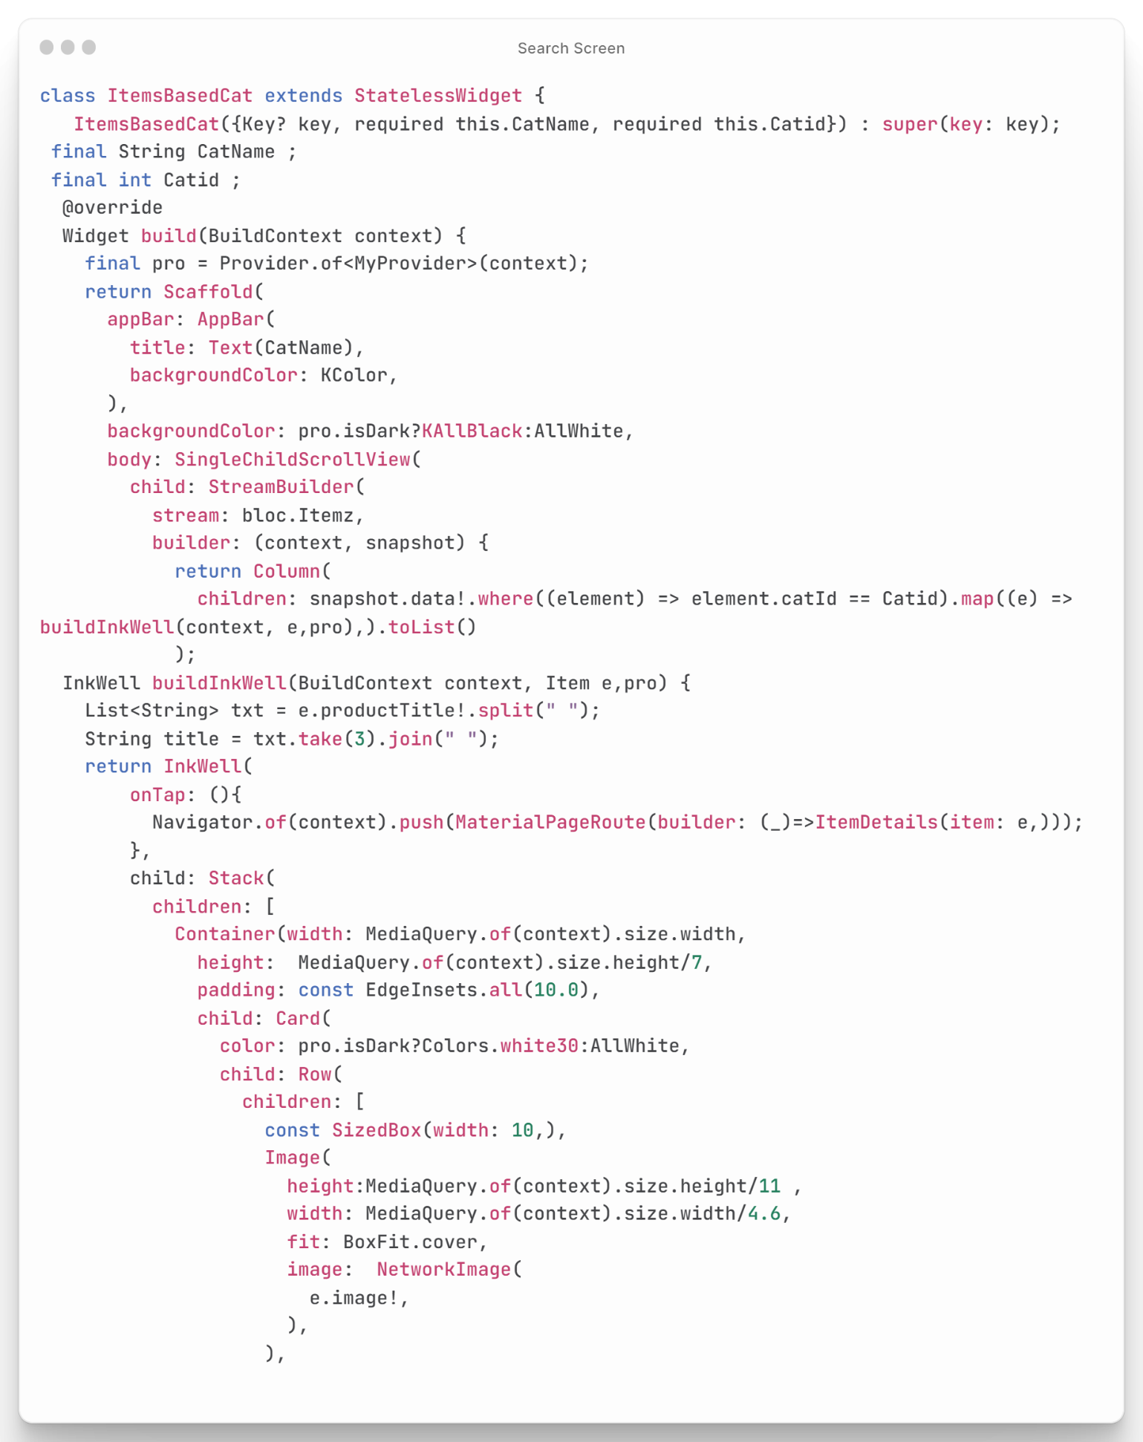

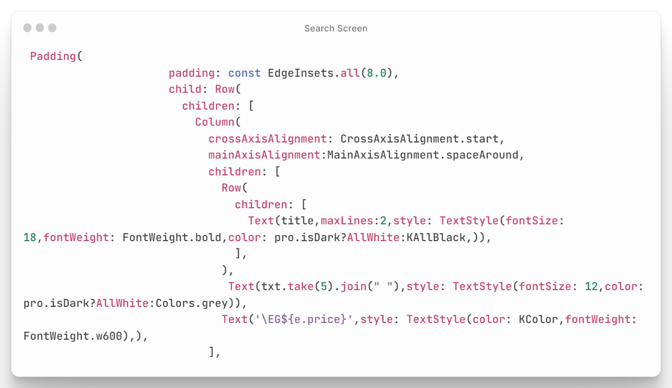

Figure : Categories Screen Code

## Setting (User - Admin) Code

The presented code is for a settings screen in a mobile app that allows users to manage their preferences and settings. The code imports the My Provider class and an ex_file.dart file. The Settings Screen widget is a stateless widget that builds a row with a column of settings cards, with the background color of the screen depending on the app's theme. The screen includes a welcome message, a card for adding a product (if the user is an admin), a card for toggling between light and dark mode, and a card for logging out of the app **as shown in Figure (34).** The cards use a build Card function to display an icon, text, and arrow icon, and take a function parameter that is called when the card is tapped. Overall, this code provides a simple and intuitive settings screen in a mobile app, allowing users to easily manage their preferences and settings such as toggling between light and dark mode, logging out of the app, and adding products (if the user is an admin).

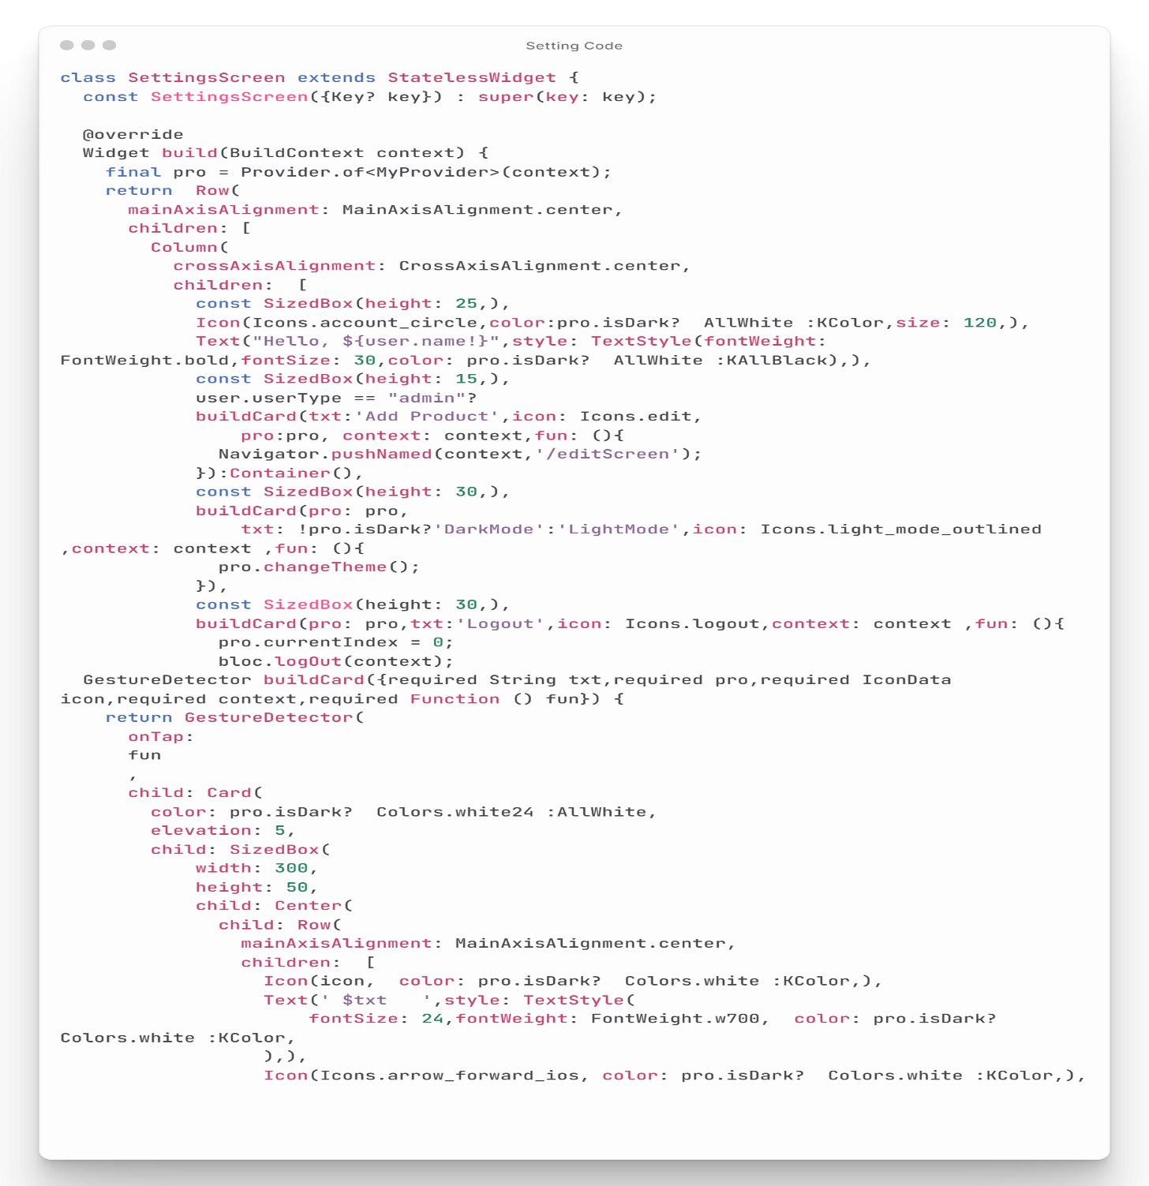

Figure : Setting Screen Code

## Add – Edit Product Screen Code

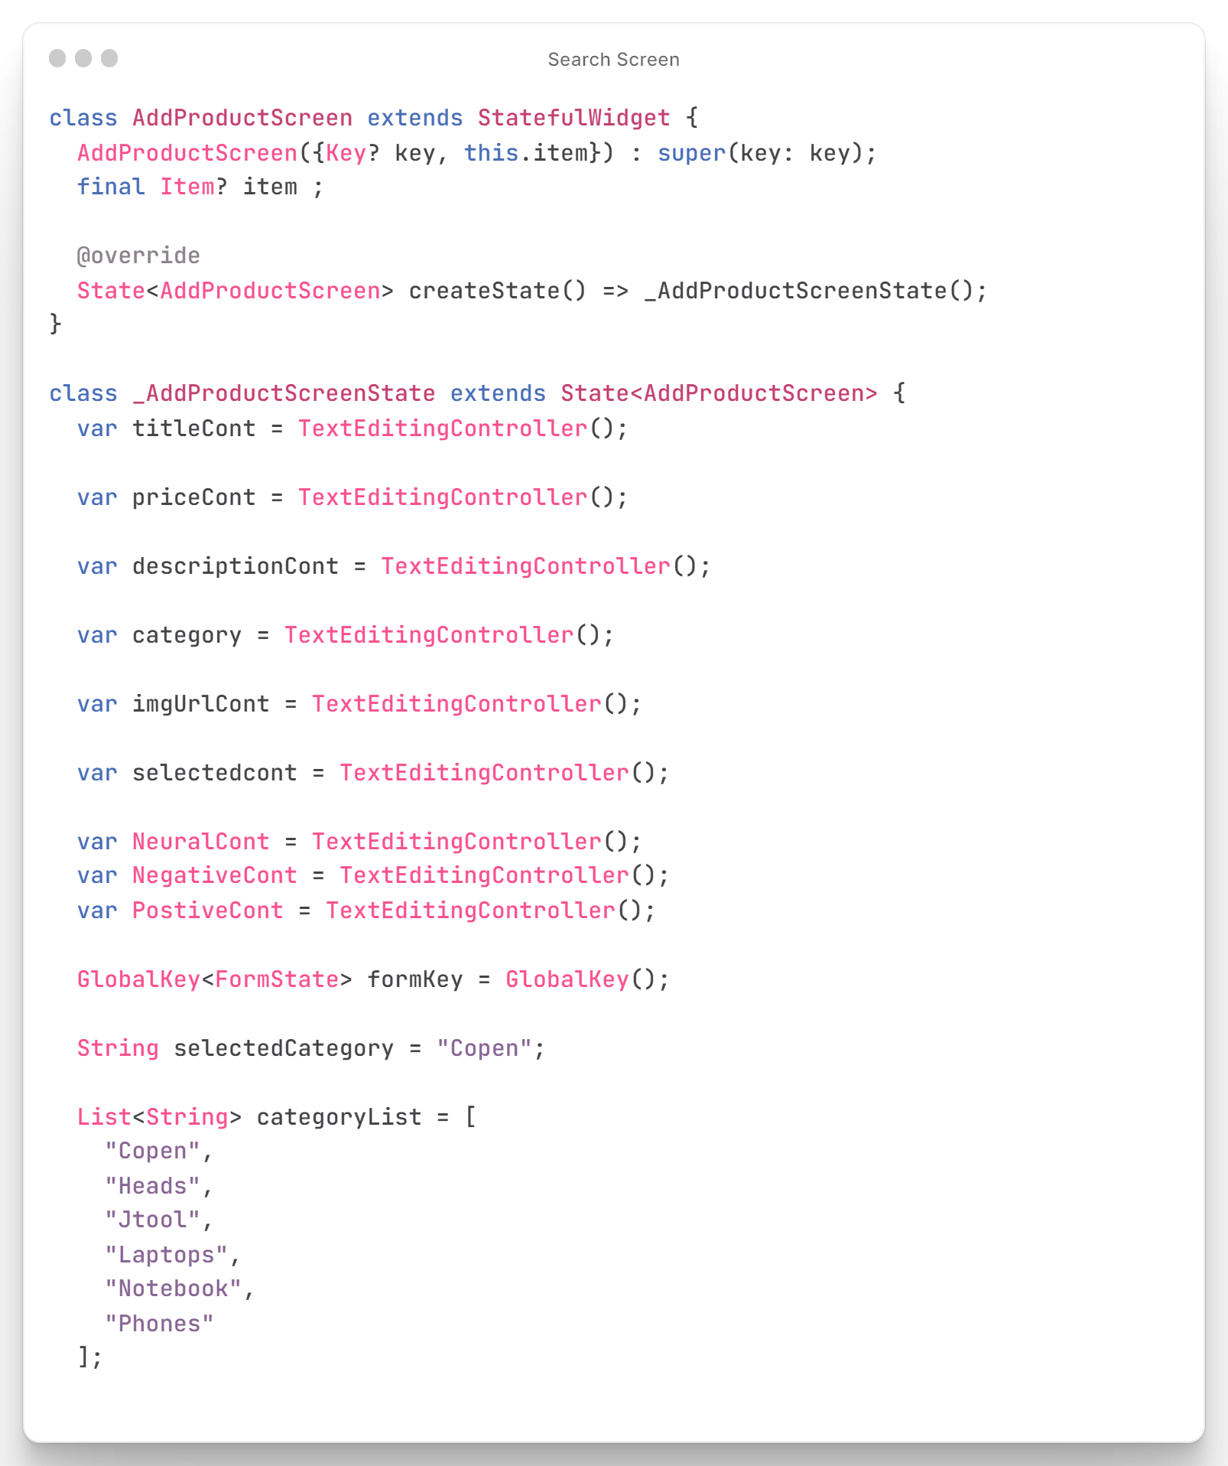This code is for a screen in a mobile app that allows users to add or edit a product. The screen has several text input fields for the product's information, such as its title, price, description, image link, and category. There's also a dropdown menu for selecting the product's category. When the user taps the "Add Product" or "Edit Product" button, the app saves the product's information to the app's database **as shown in Figure (35).**

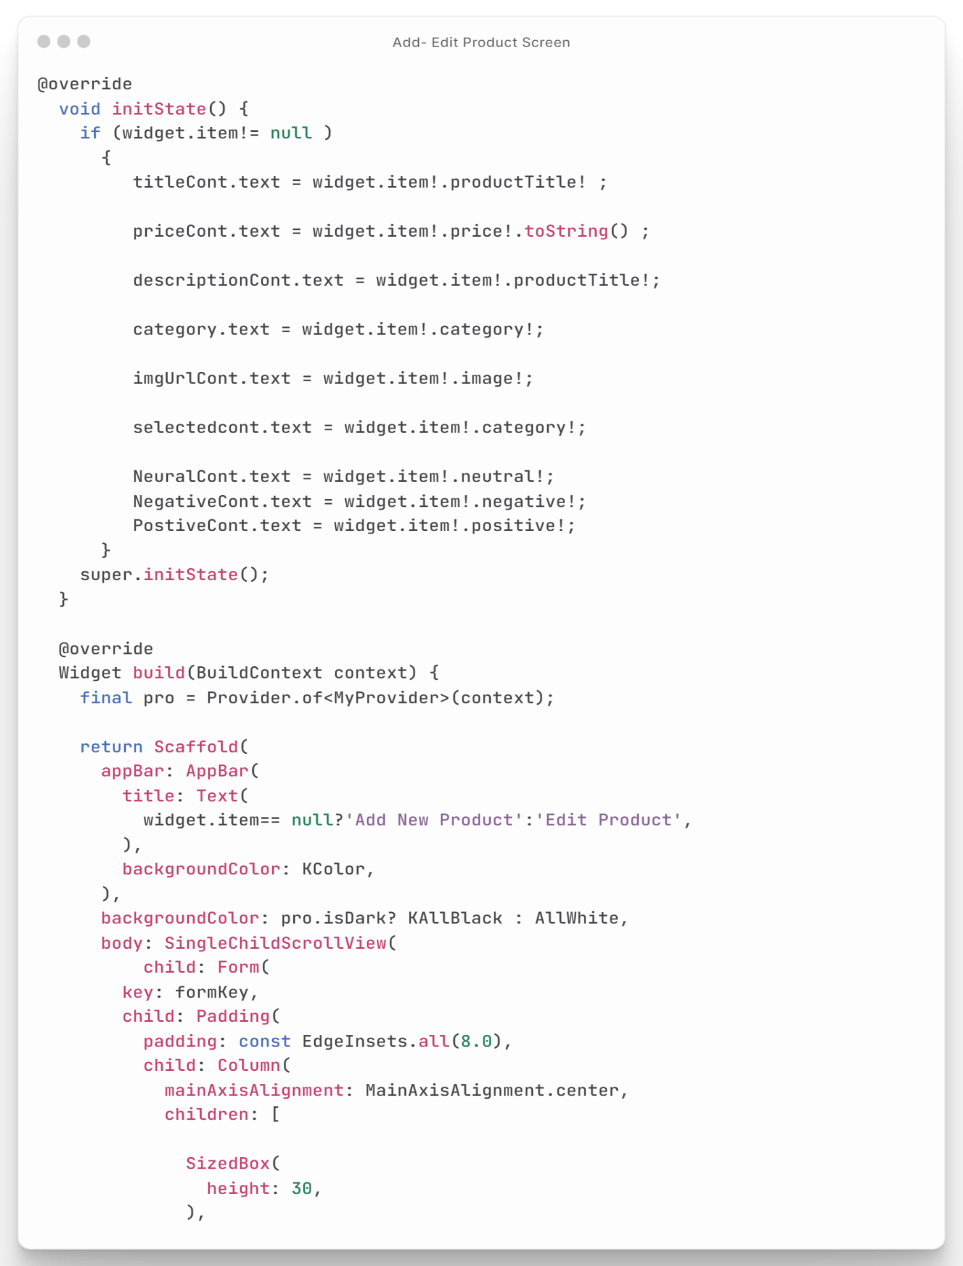

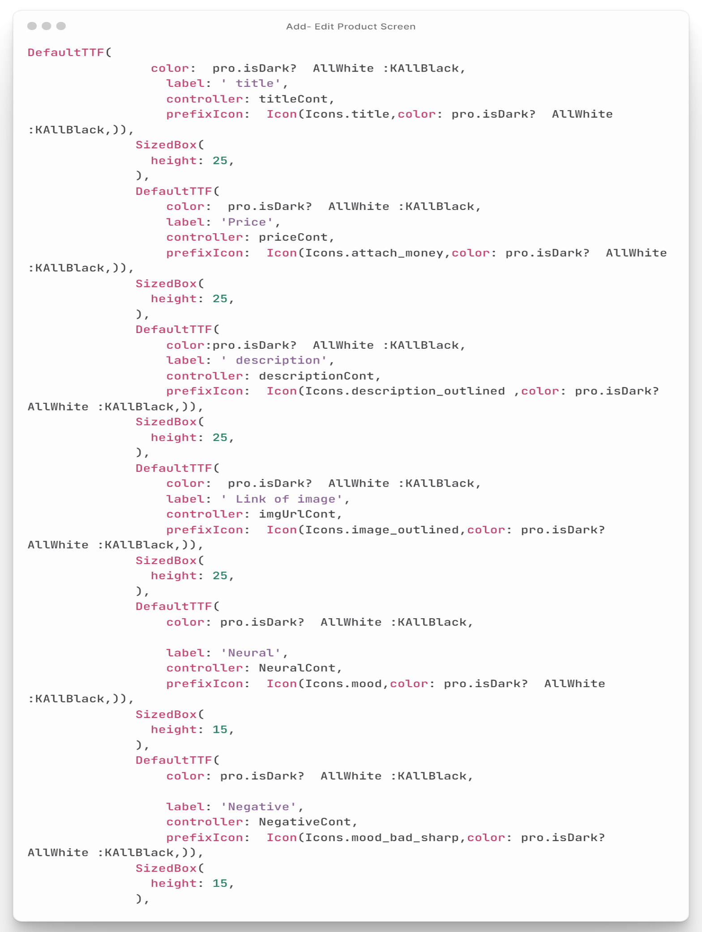

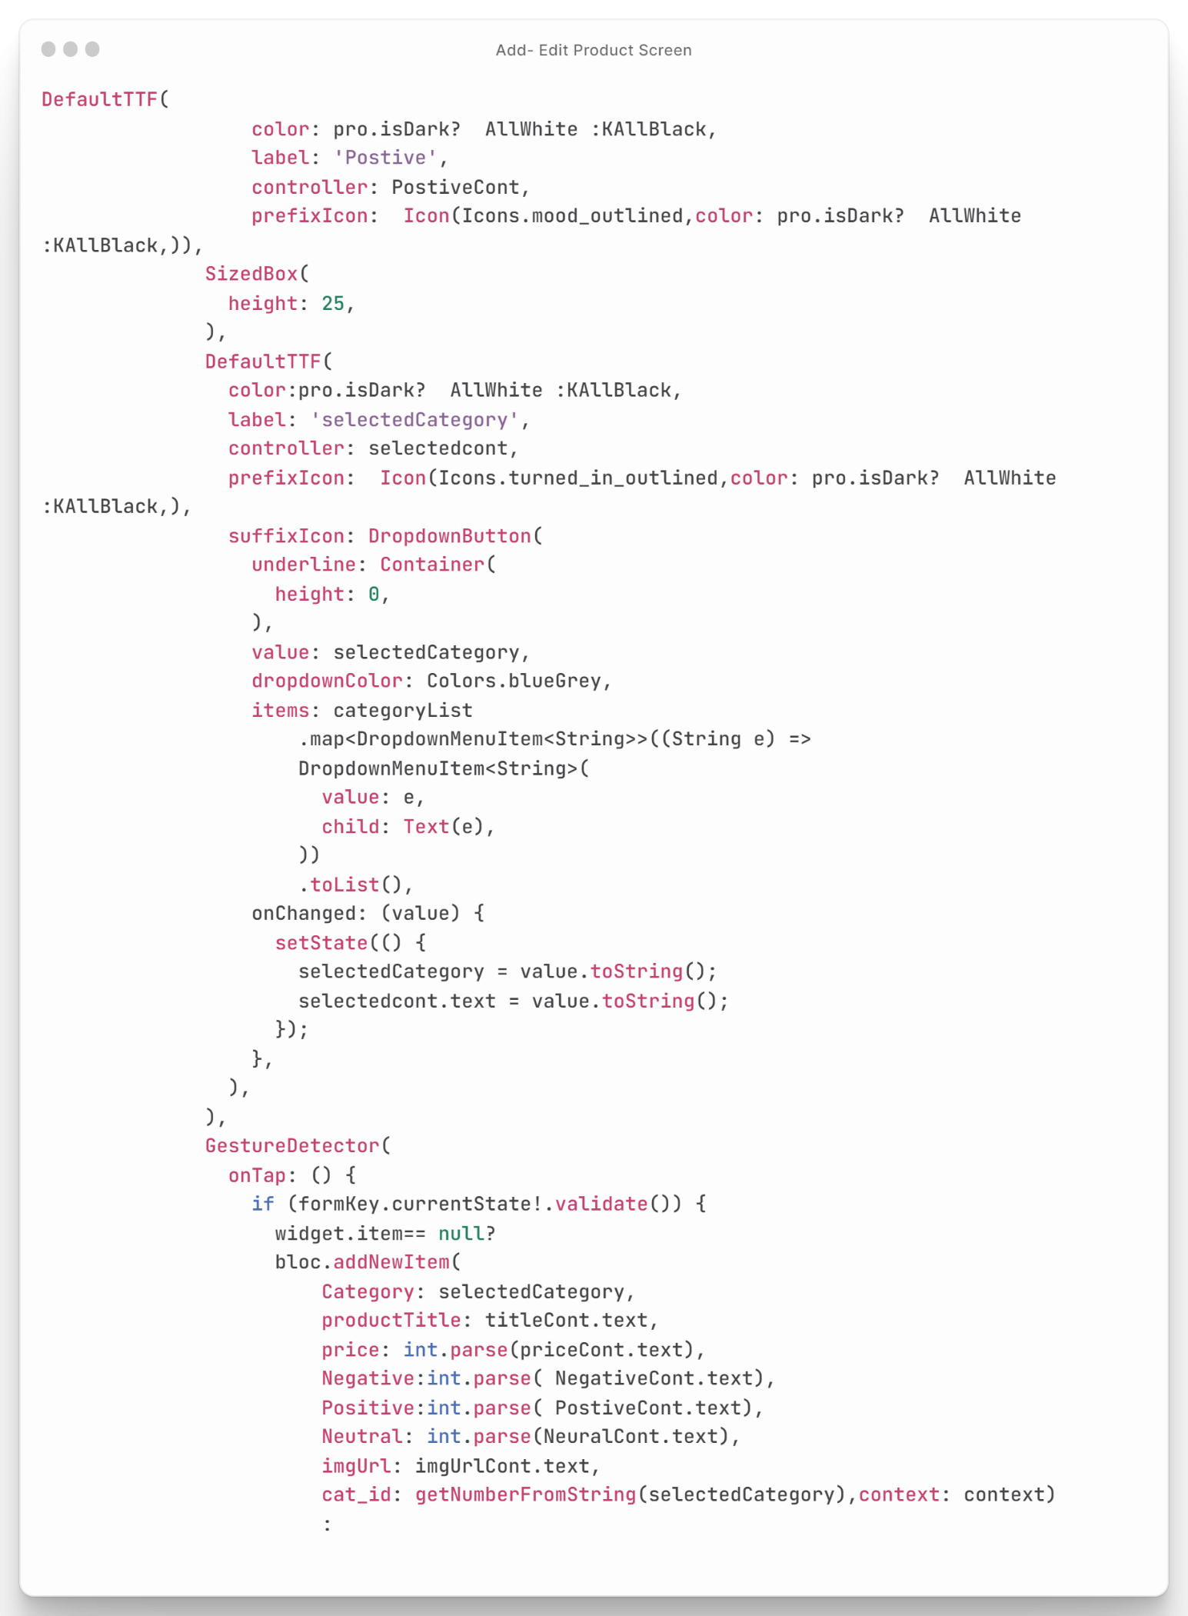

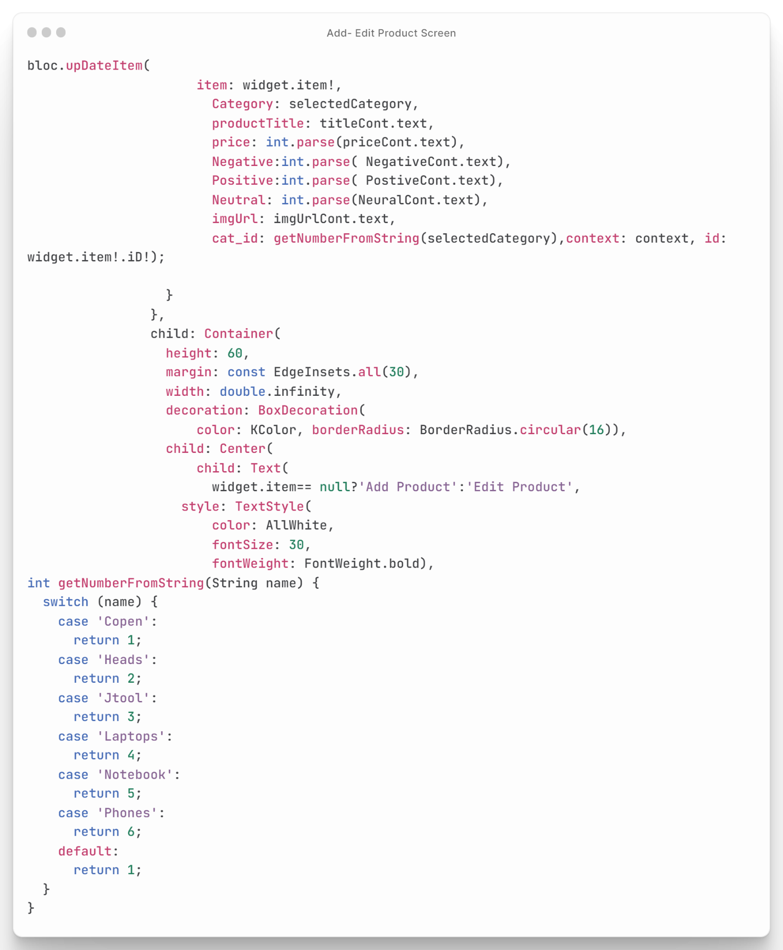

Figure : Add - Edit Product Screen Code

## Database Backend Code

Database: Which designed meet our project requirements to store our products data and the result of prediction process also the user's data and other features like wish-list in addition to the products categories **as shown in Figure (36 & 37).**

Figure : Tables of Database

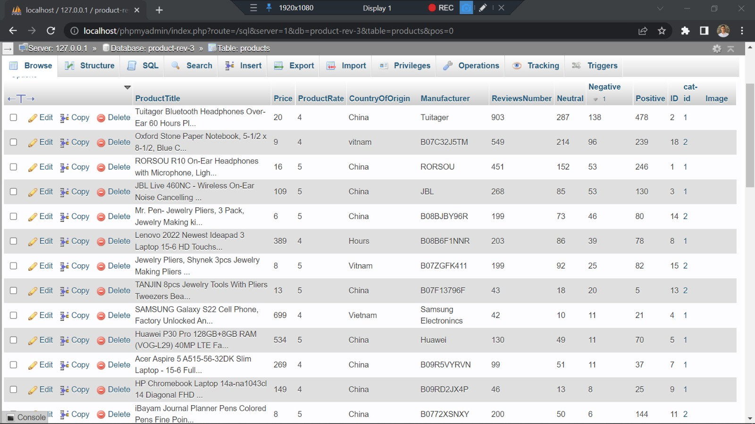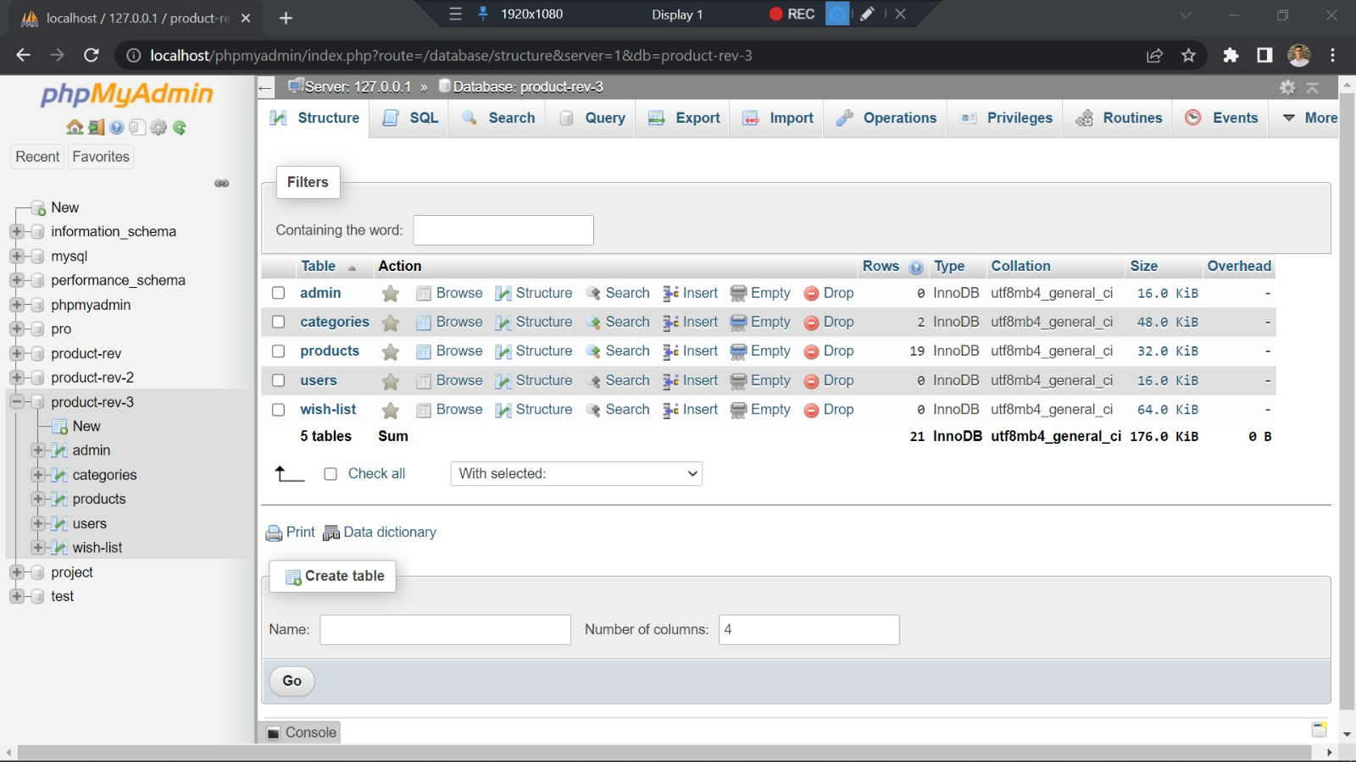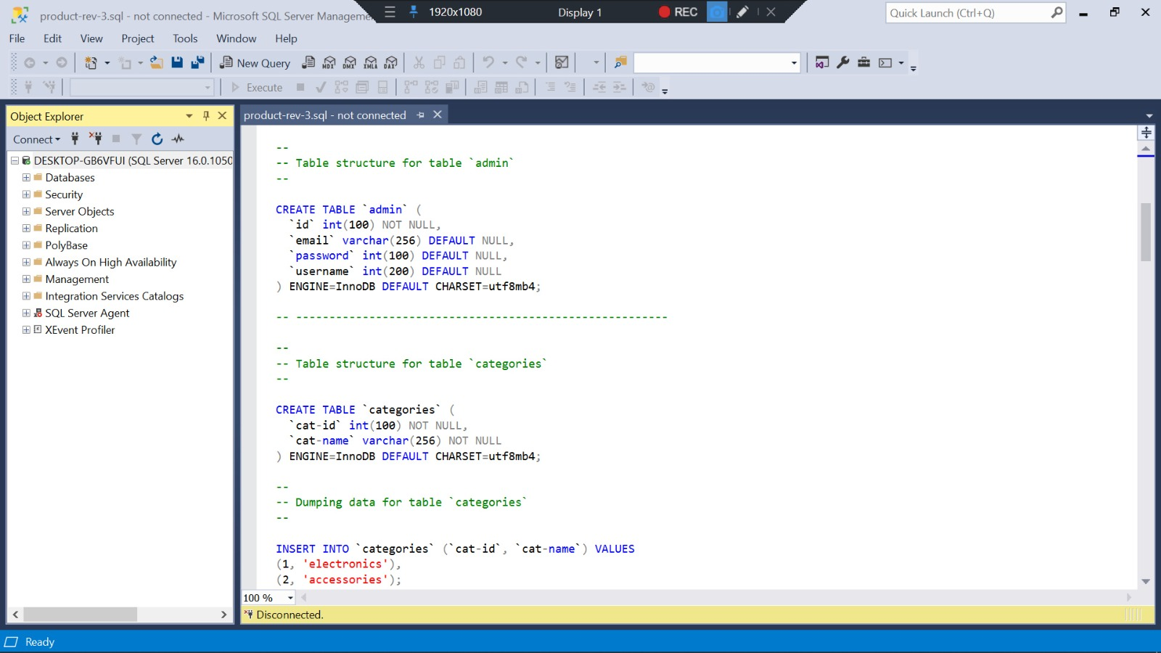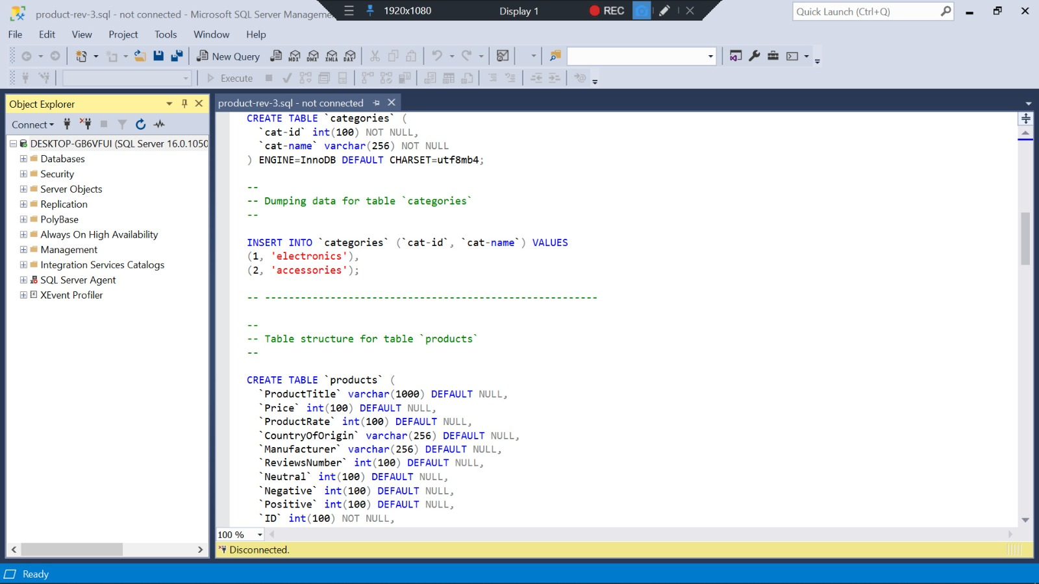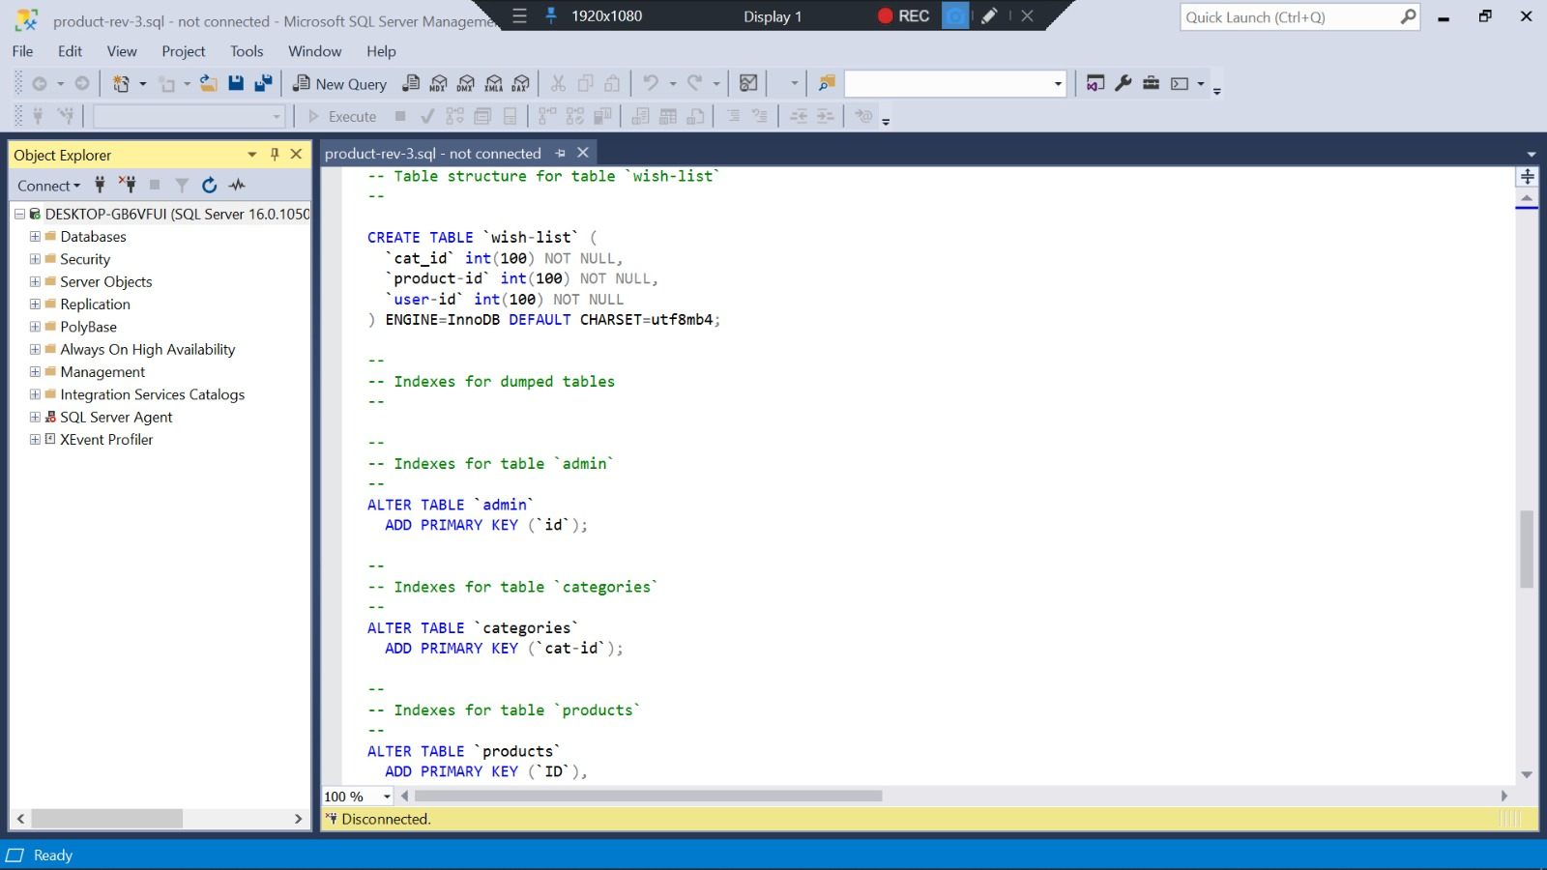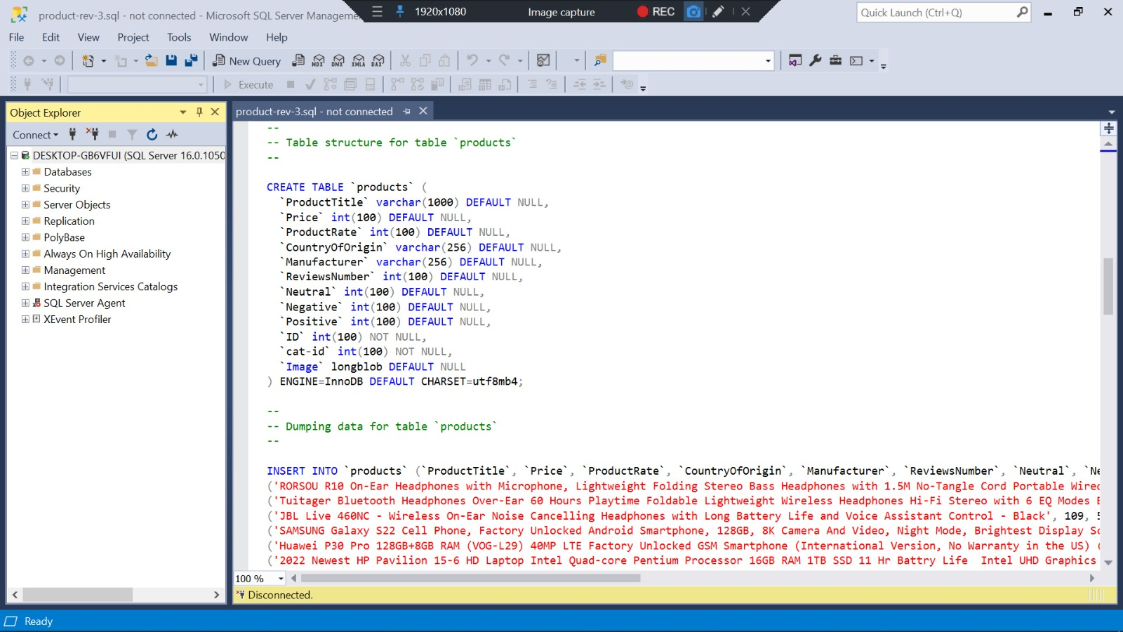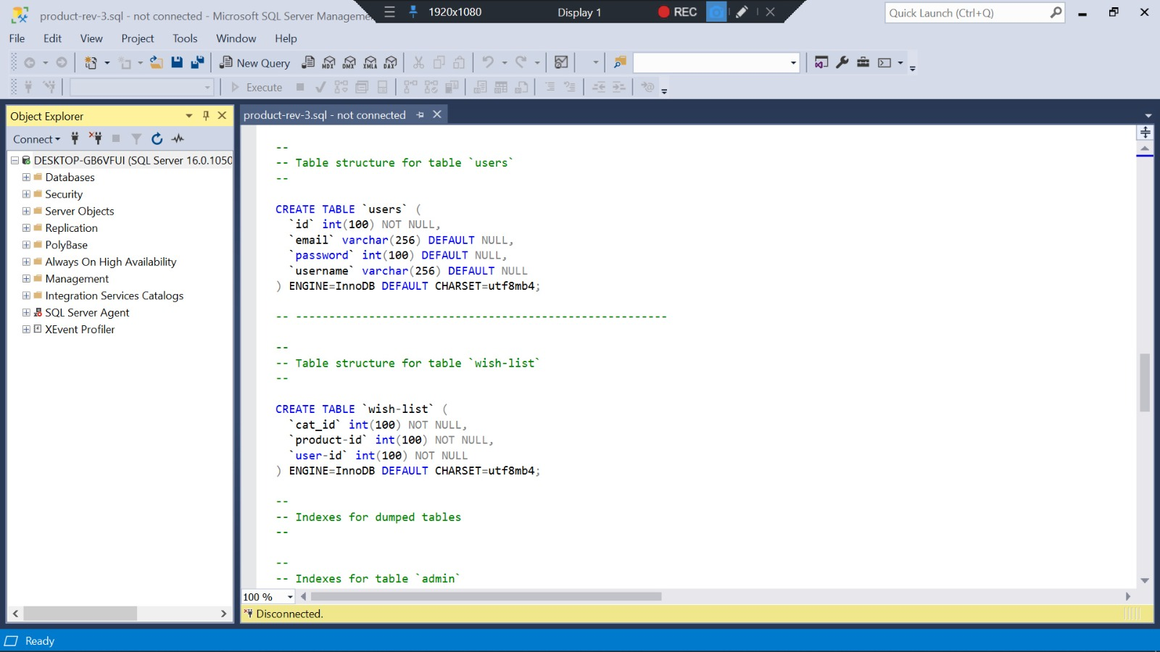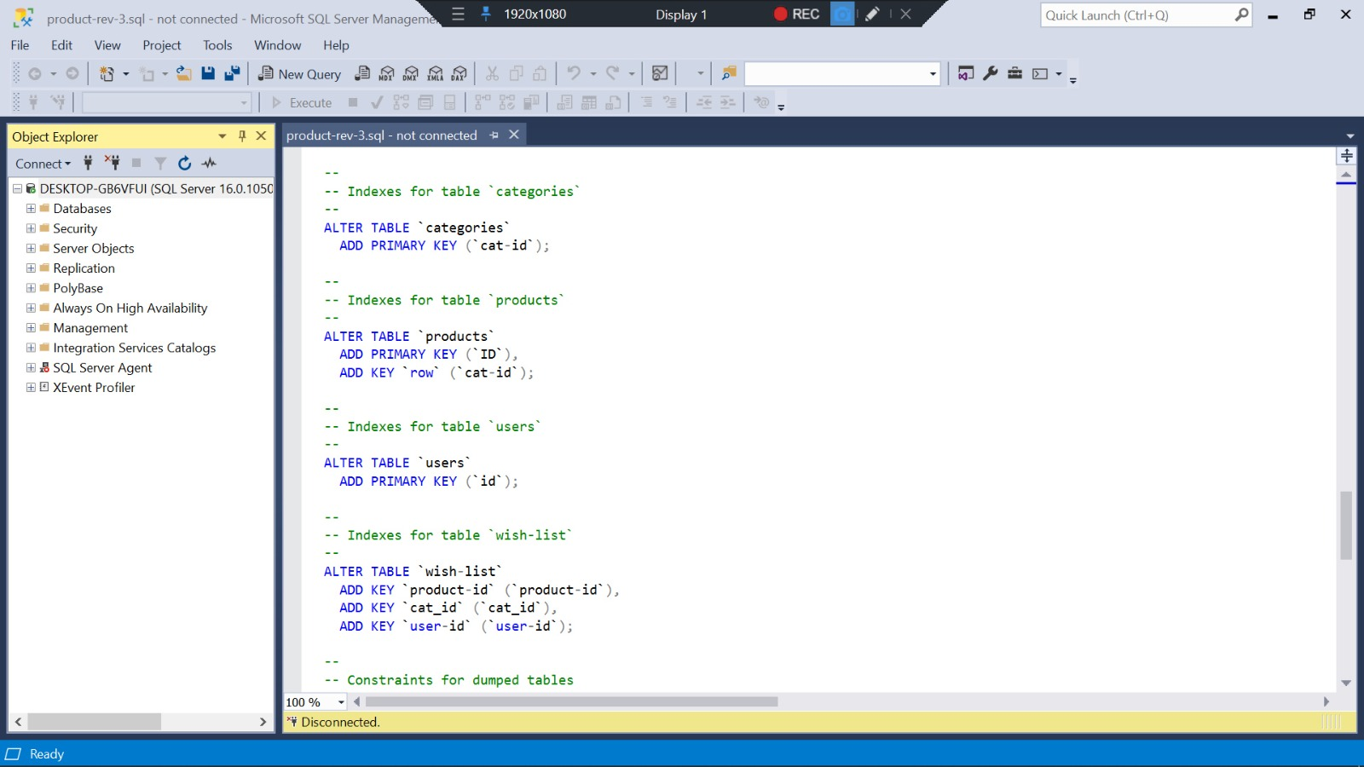

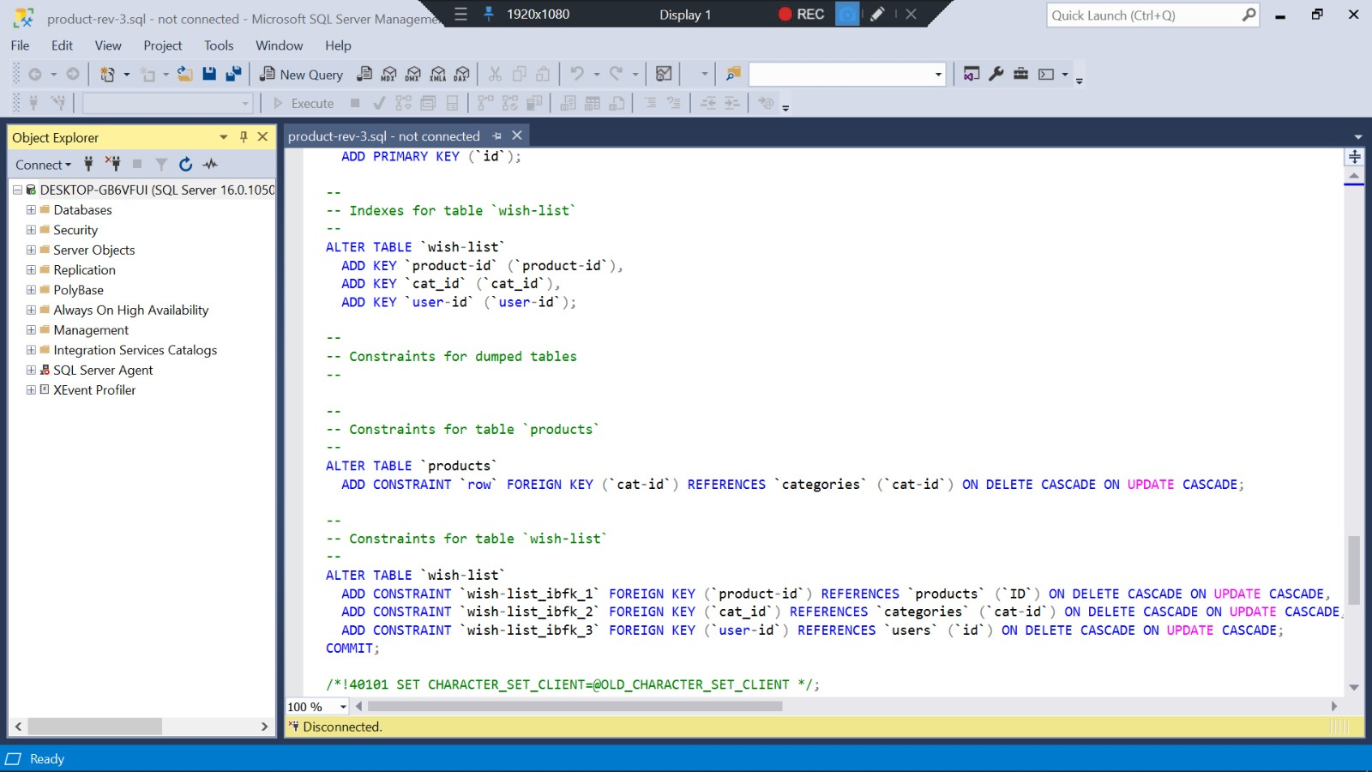

Figure : Database Code

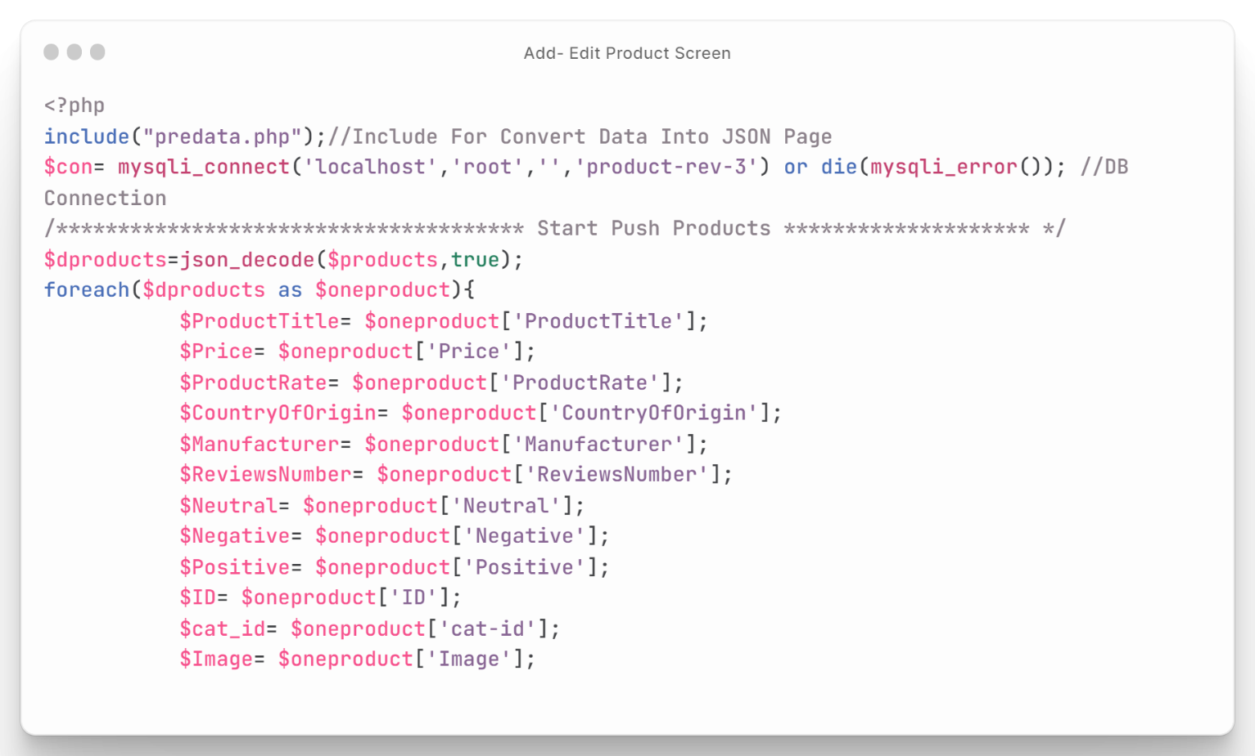We first open the CSV file for reading using the fopen() function. We then use a while loop and the fgetcsv() function to read each line of the file and add the values to an array. Once we have the data in an array, we use the json_encode() function to convert it to JSON format. Finally, we save the JSON data to a file using the file_put_contents() function **as shown in Figure (38).**

Figure : PHP Connection with Database and Push 1

This is a PHP code that is designed to push data from a JSON file into a MySQL database. The code begins by including a PHP file called "predata.php" that contains functions for convert formatting.

Next, the code establishes a connection to a MySQL database using the mysqli_connect() function. It then uses the json_decode() function to convert a JSON string called $products into a PHP array.

The code then uses a foreach loop to iterate over each item in the $dproducts array. For each item, it extracts the relevant data and assigns it to variables. It then constructs an SQL query to insert this data into a MySQL table called "products" using the mysqli_query() function.

Finally, the code checks whether the query was successful using an if statement and echoes a message to indicate whether the data was pushed successfully or not.

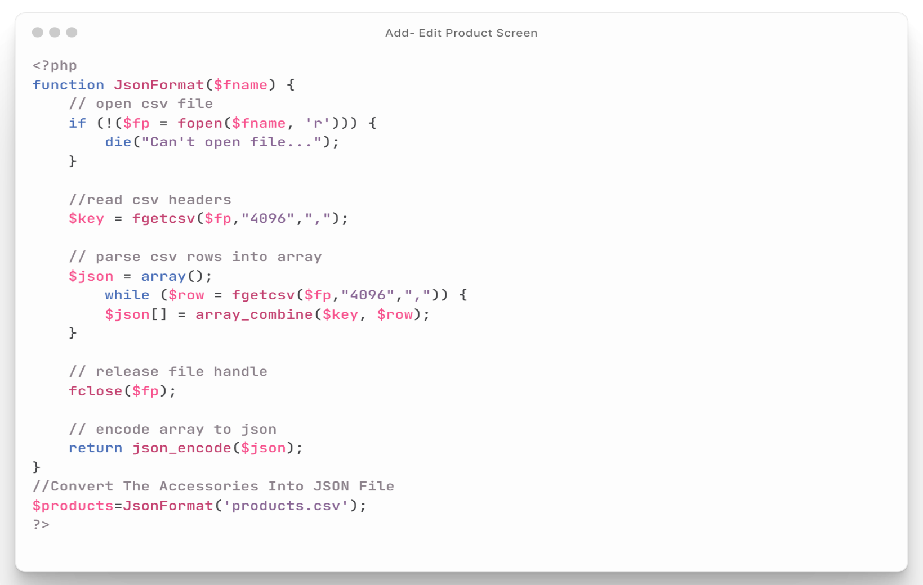Overall, this code is useful for importing data from a JSON file into a MySQL database **as shown in figure (39).**

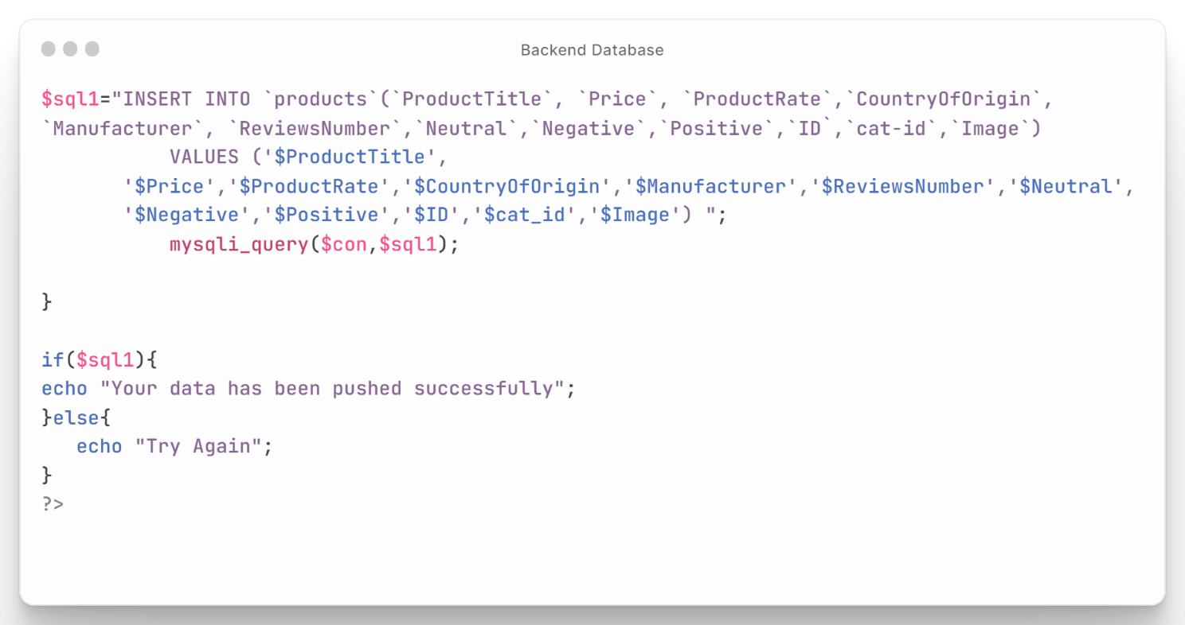

Figure : PHP Connection with Database and Push 2

## API Connection

* ALL Categories: it's request that responsible for getting all categories from database to the application **as shown in figure (40).**

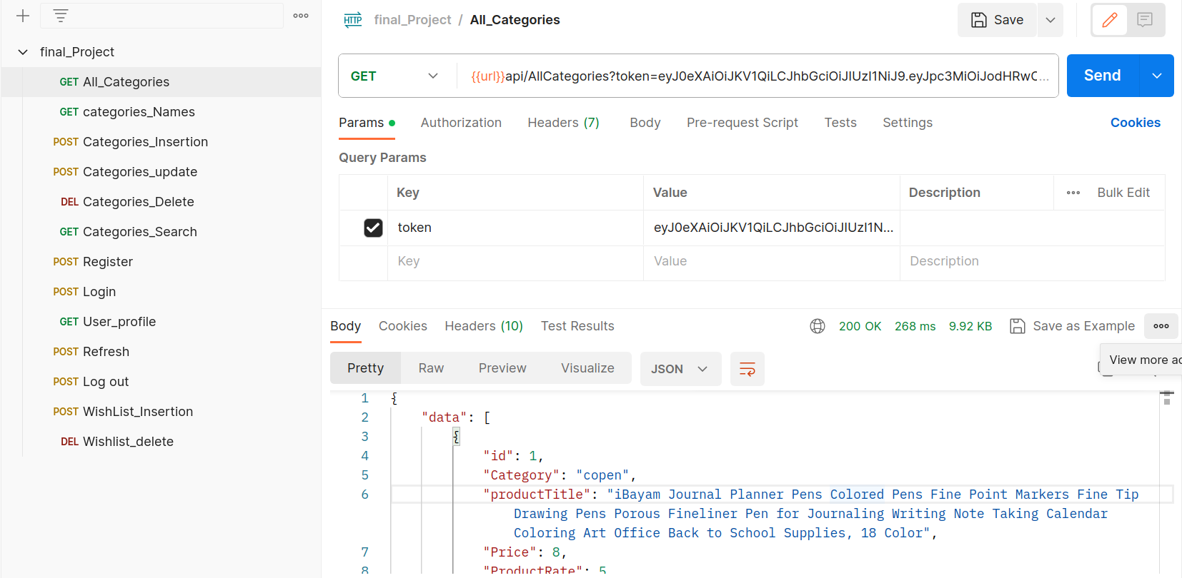

Figure : All Categories

* Categories Names: it's request that responsible for getting Categories names from Database to the application **as shown in figure (41).**

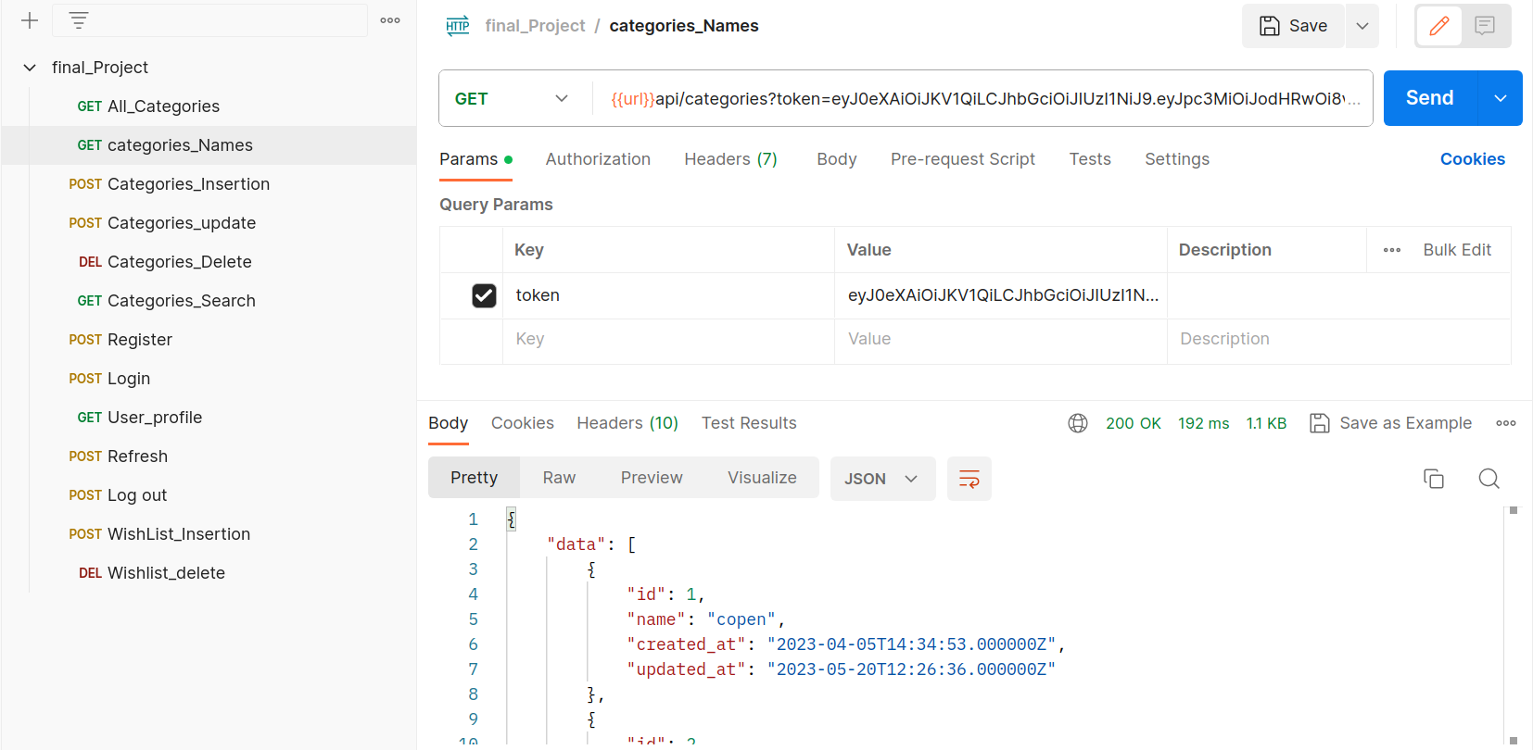

Figure : Categories Names

* 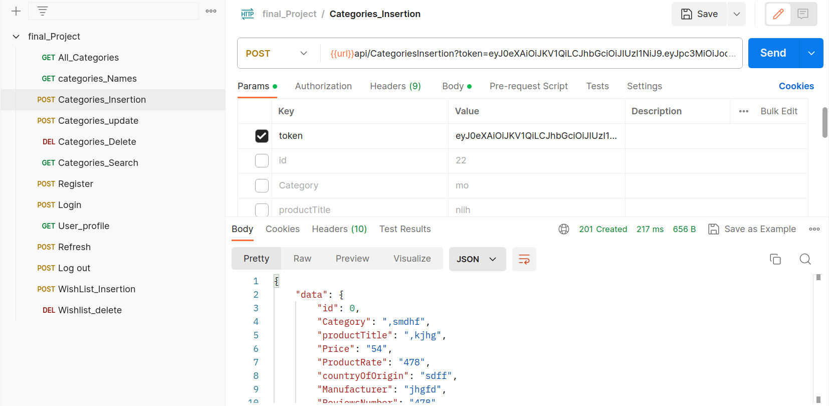Categories Insertion: it's request that responsible for inserting Categories to Database from the application **as shown in figure (42).**

Figure : Categories Insertion

* 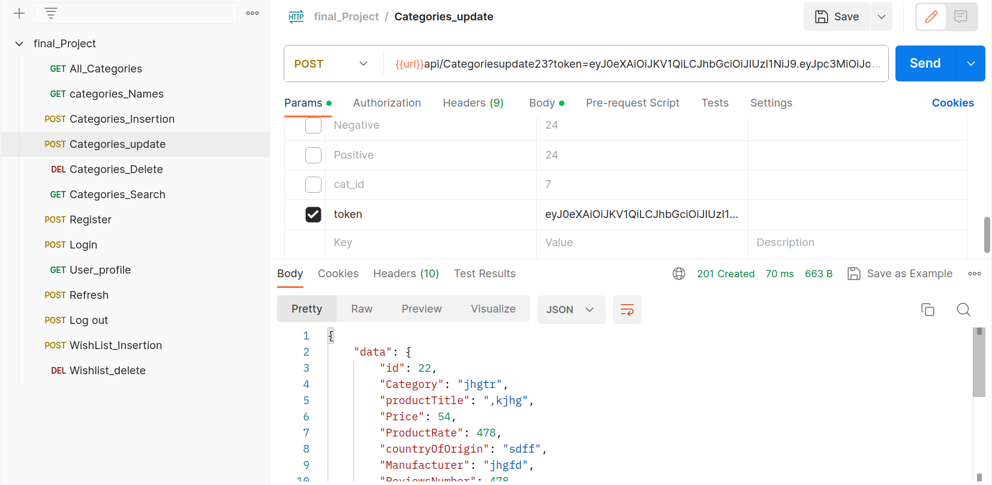Categories Update: it's request that responsible for edit the Categories in the Database from the application **as shown in figure (43).**

Figure : Categories Update

* 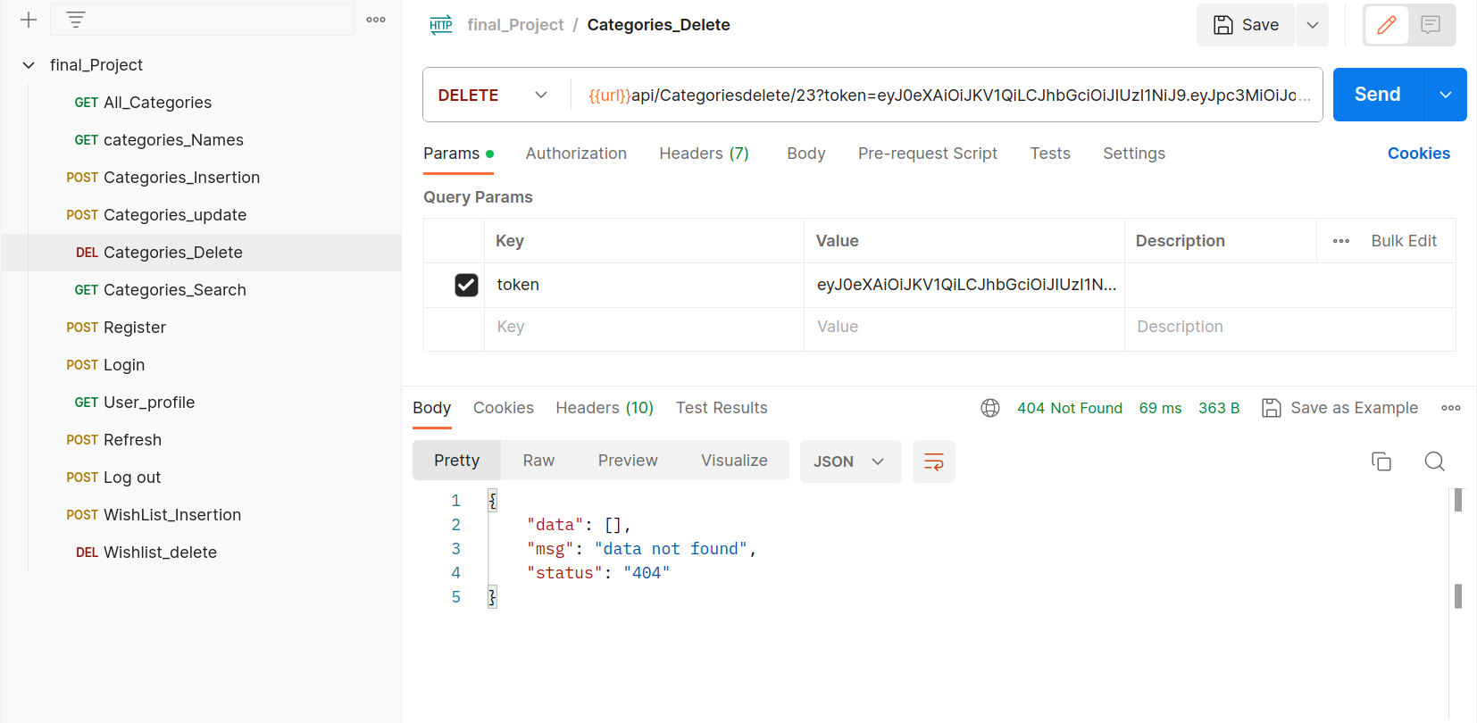Categories delete: it's request that responsible for deleting Categories in the Database by their ID from the application **as shown in figure (44).**

Figure : Categories Delete

* 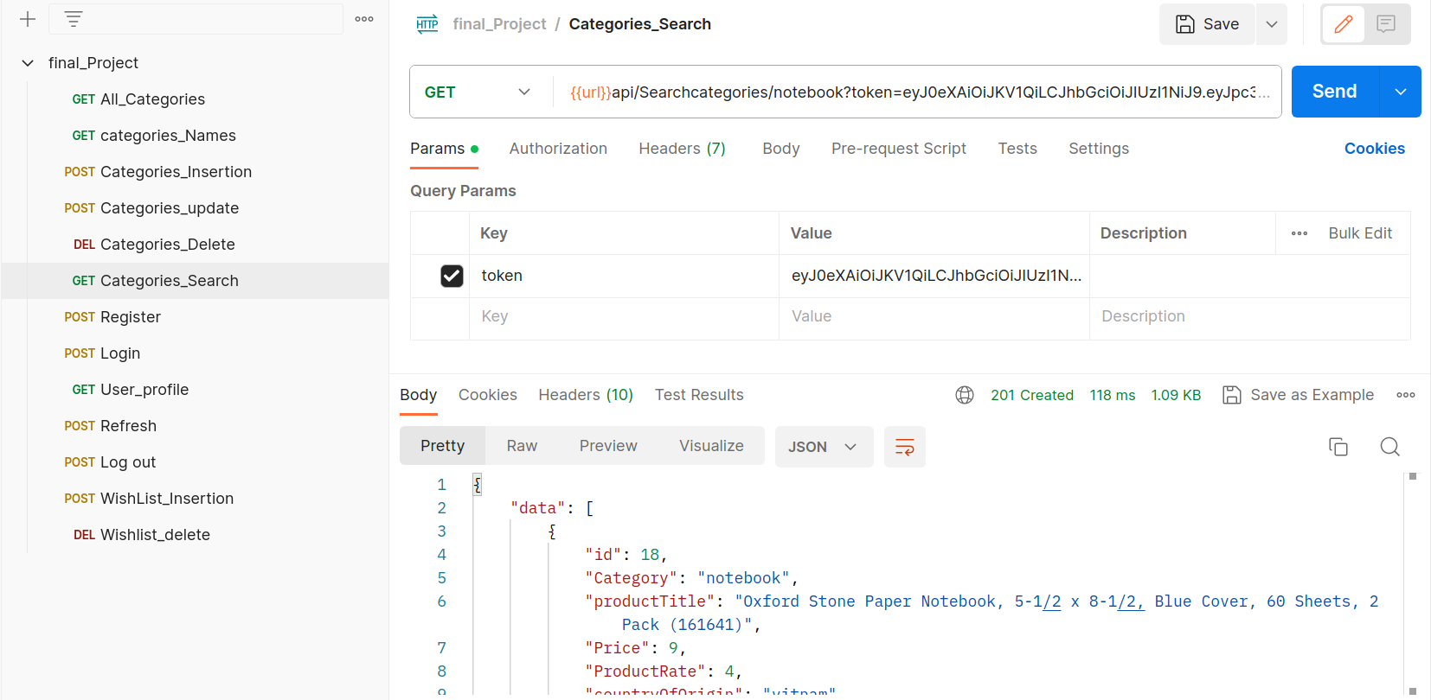Categories search: it's request that responsible for search for Categories in the Database by their name entering by the application **as shown in figure (45).**

Figure : Categories Search

* 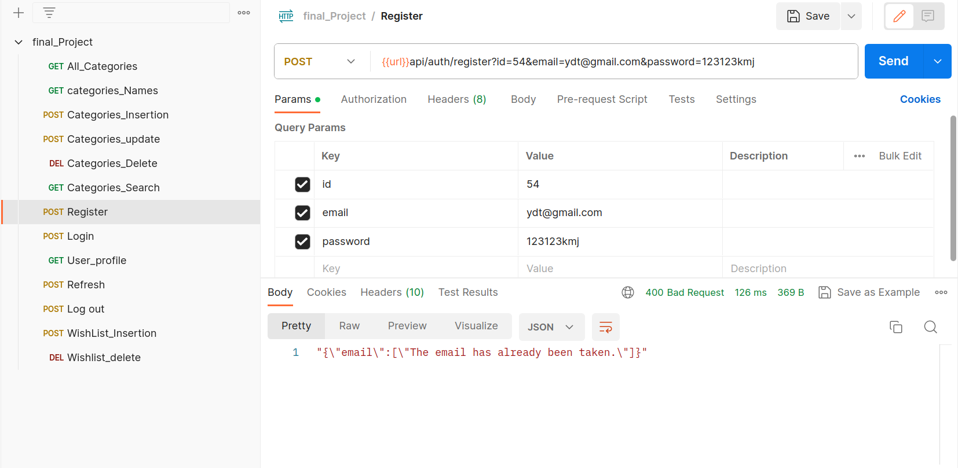Register: it's request that responsible for registering users in the application and saved them in the database for login process **as shown in figure (46).**

Figure : Register

* 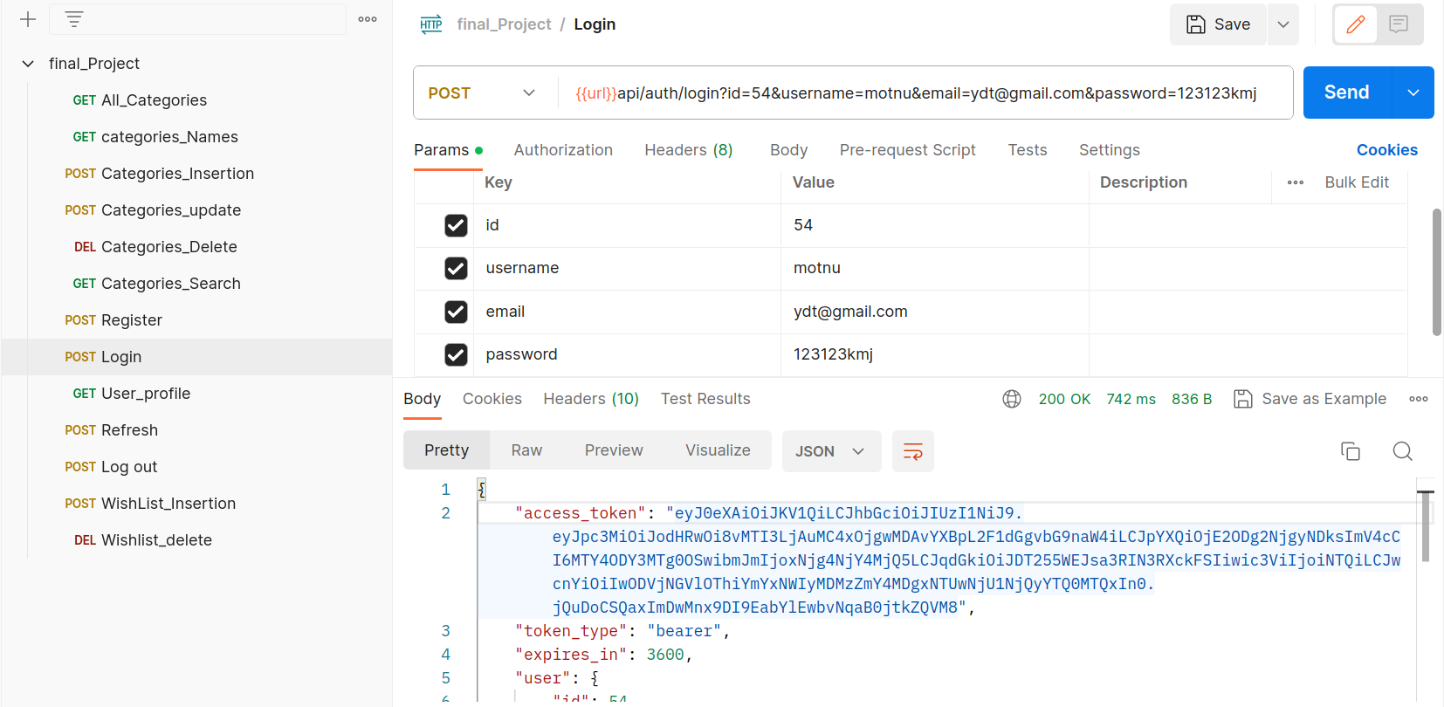login: it's request that responsible for login users to the application by their saved data in the database that made by the register request **as shown in figure (47).**

Figure : Login

* 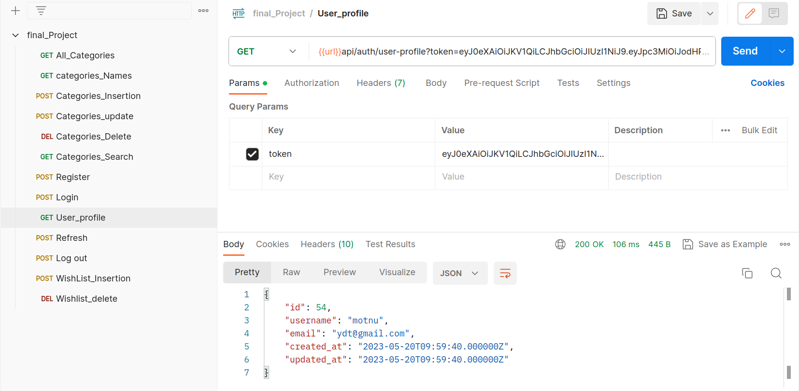User profile: it's request that responsible for the profile of the user in the application **as shown in figure (48).**

Figure : User Profile

* 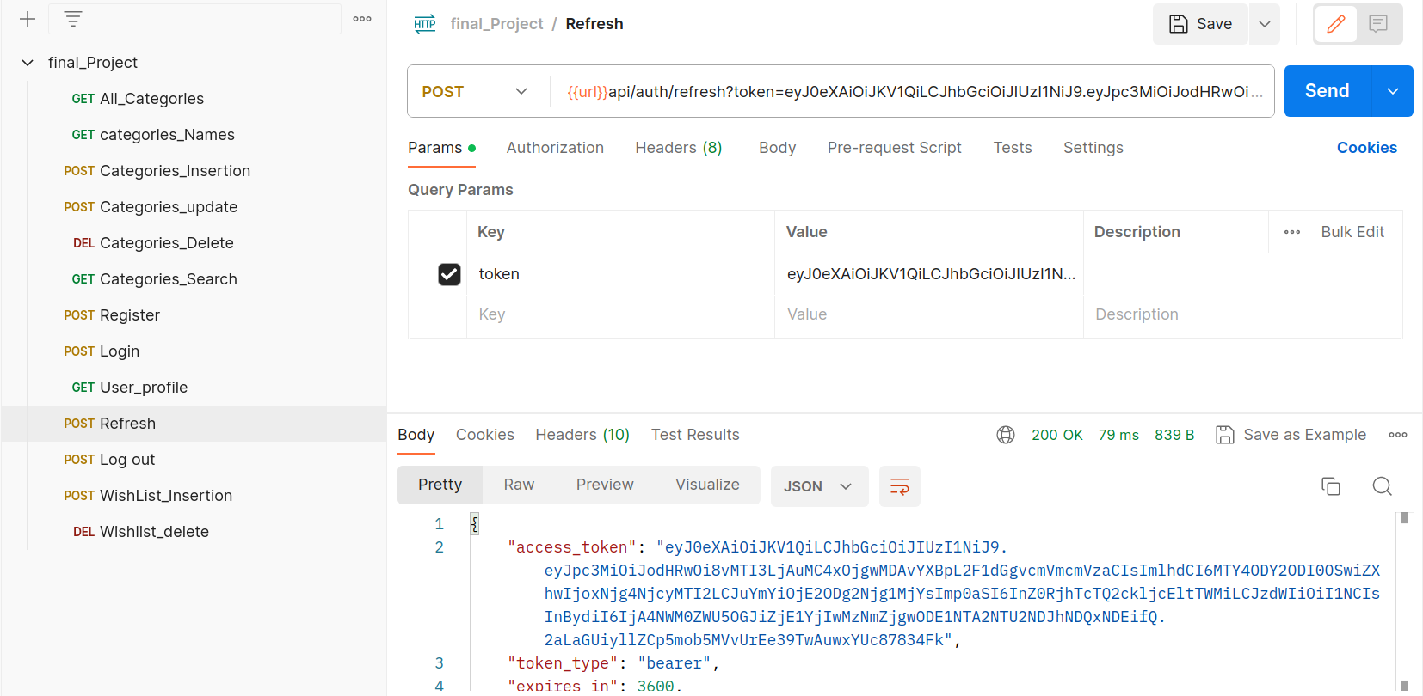Refresh: it's request that responsible for refreshing and update the profile to any new login or logout or any update made in the application **as shown in figure (49).**

Figure : Refresh

* 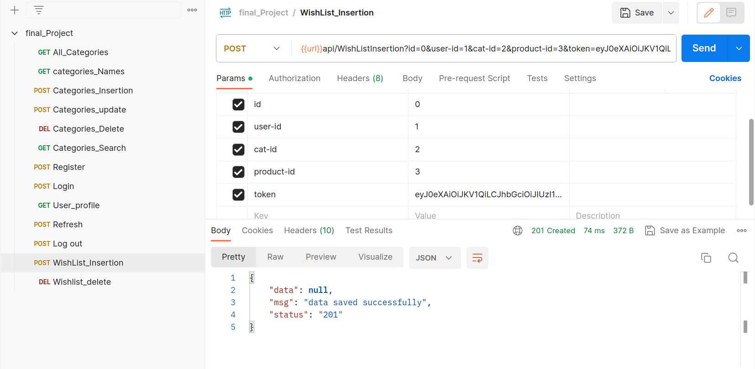Wish list insertion: it's request that responsible for inserting Categories in the wish list part in the application and saved them to the database **as shown in figure (50).**

Figure : Wish List insertion

* 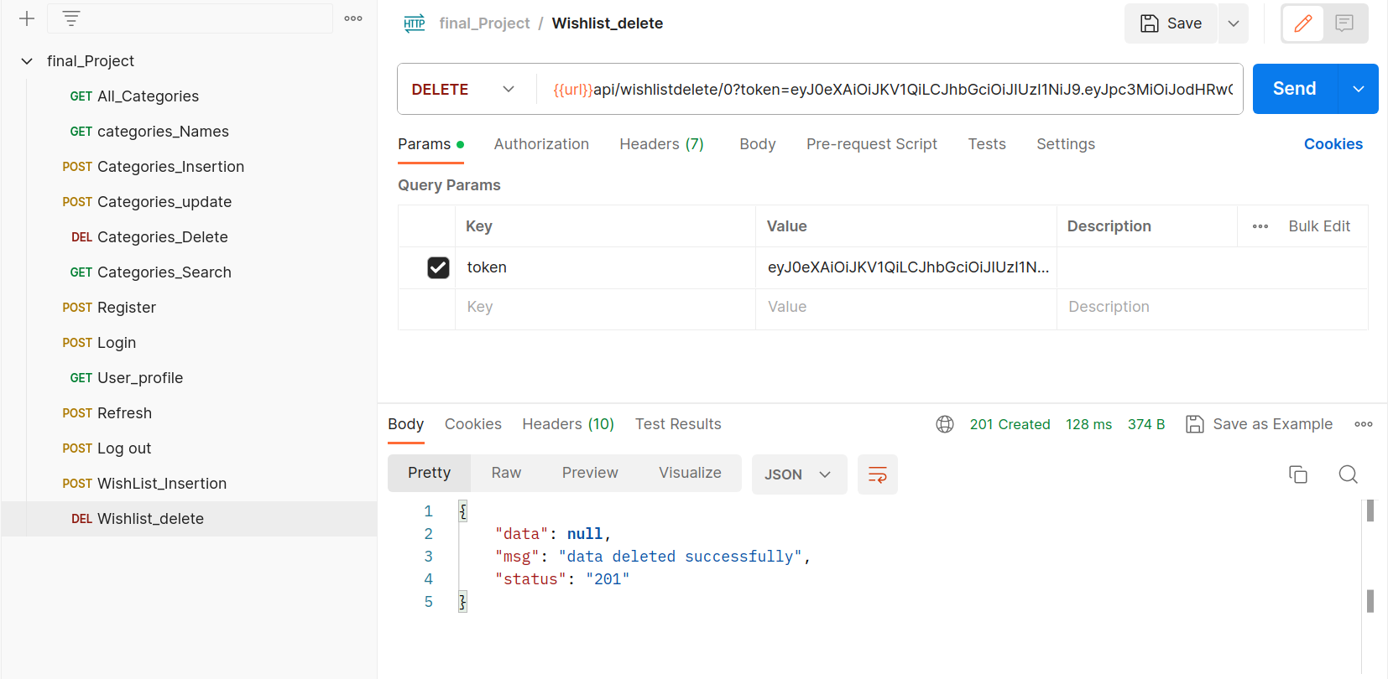Wish lists delete: it's request that responsible for deleting Categories from the wish list part in the application and from database **as shown in figure (51).**

Figure : Wishlist Delete

* 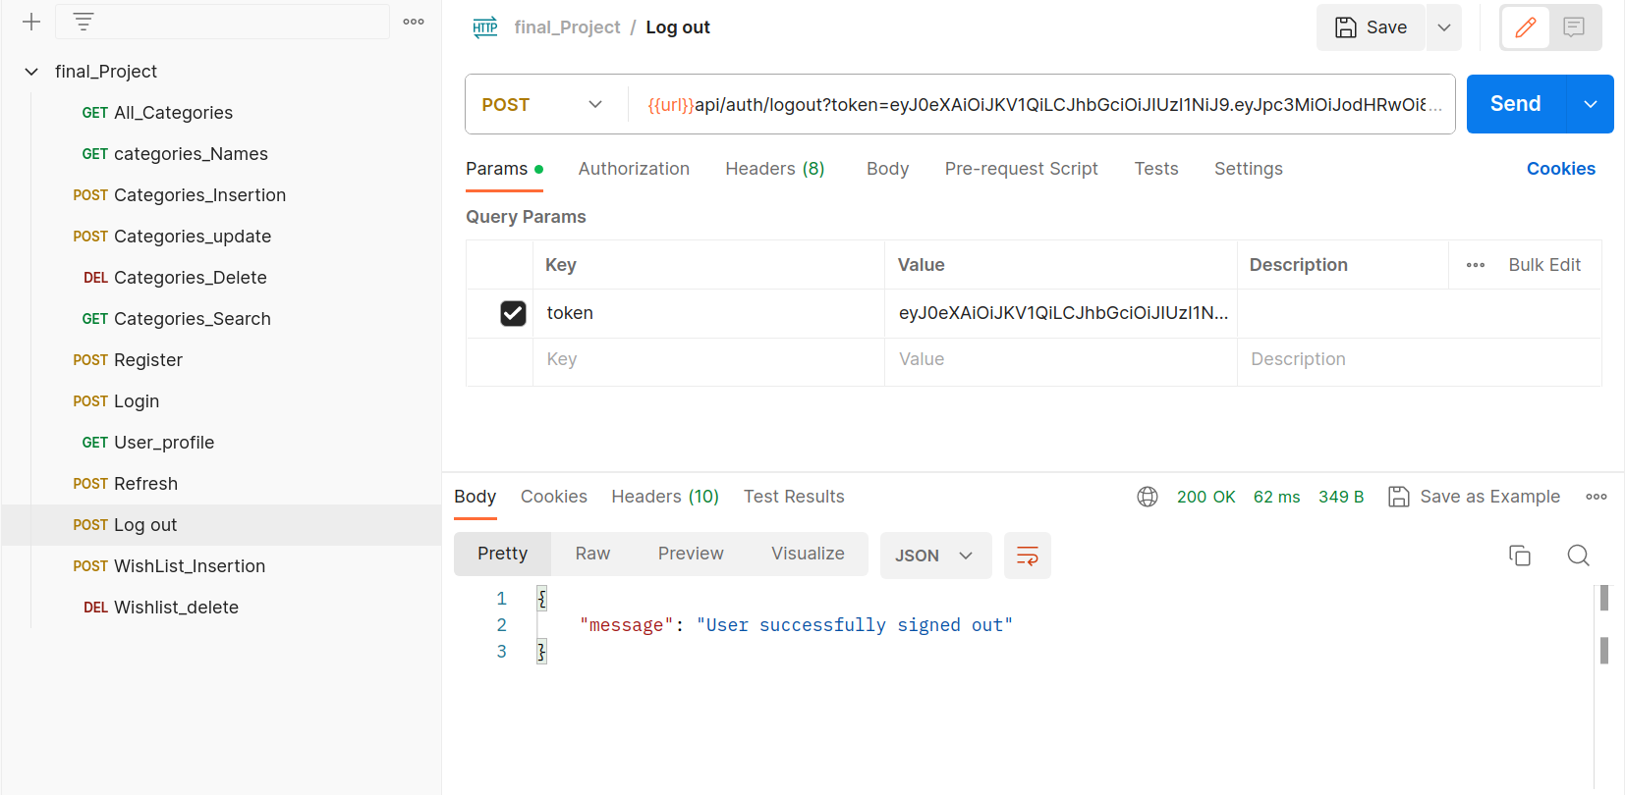log out: it's request that responsible for login out from the application **as shown in figure (52).**

Figure : Log Out

## NLP and Scripting IPYNB

### **Amazone Reviews IPYNB:**

**Notebook Contents**

* Importing The Libraries
* Loading The Data
* Data Inspection
* Preprocessing The Data
* Roberta Model
* Building NLP System
* **Importing The Libraries:**

This code imports several Python libraries that are commonly used in data analysis, natural language processing (NLP), and machine learning projects **as shown in figure (53).**

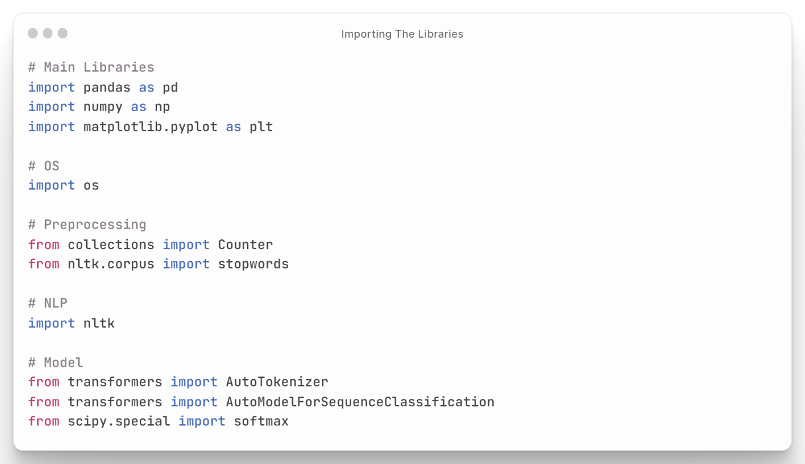

Figure : Importing the Libraries

* **Loading The Data:**

This code reads data from a CSV file called 'headphone1.csv' and stores it in a pandas DataFrame object named df. The pd.read_csv() function is used to read the CSV file and create a pandas DataFrame **as shown in figure (54).**

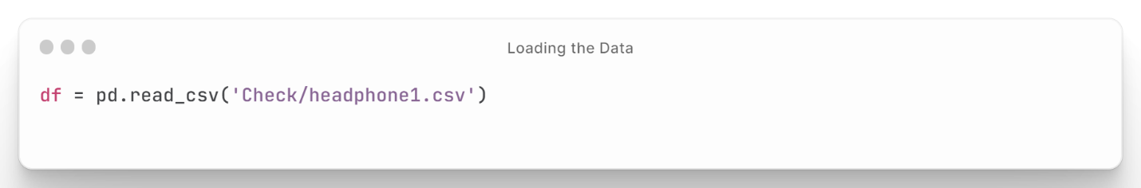

Figure : Loading The Data

* **Data Inspection:**

This code is written in a Jupyter Notebook and performs several data exploration tasks on a pandas Data Frame named df. The first line of code uses the head() function to show the first five rows of the DataFrame. The second line uses the shape attribute to display the dimensions of the Data Frame, which in this case is (451, 8), indicating that there are 451 rows and 8 columns. The third line uses the info() function to display information about the Data Frame, including the data types of each column and the memory usage. The next two lines of code show the first 20 review titles and a review body, respectively, by accessing the Review Title and Review Body columns of the Data Frame using the indexing operator. Overall, this code provides a quick and easy way to explore the structure and contents of a pandas Data Frame using Jupyter Notebook **as shown in Figure (55).**

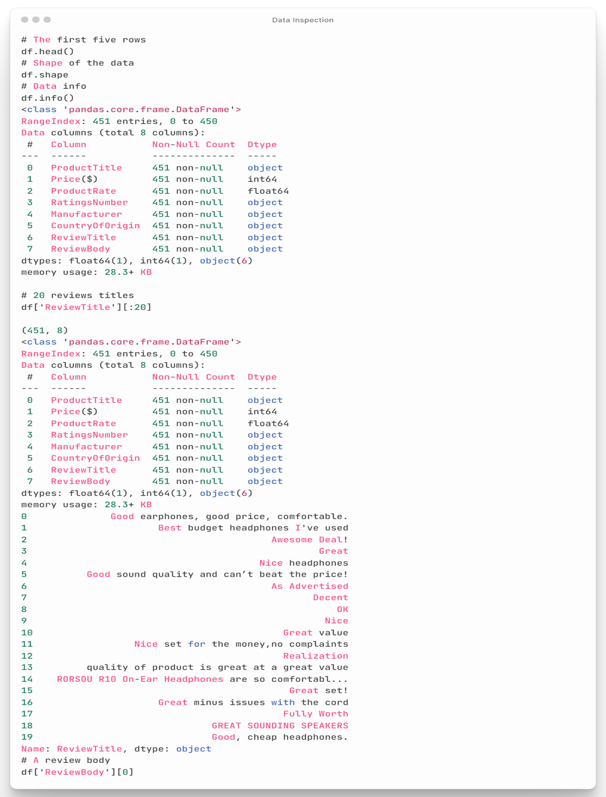

Figure : Data Inspection

* **Preprocessing The Data:**

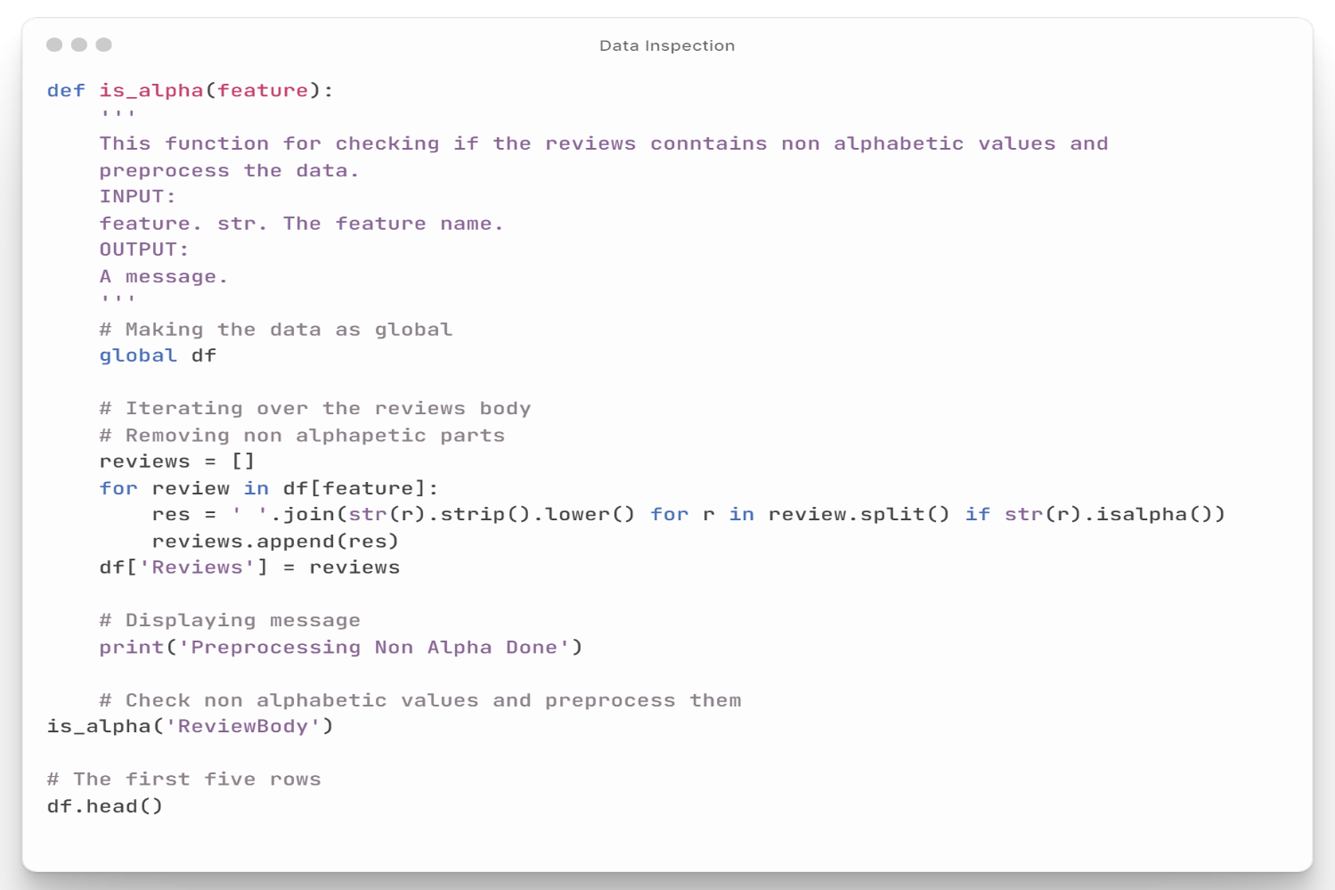This code defines two functions in a Jupyter Notebook. The first function is_alpha(feature), takes a feature name as an argument and checks if the reviews in that feature contain non-alphabetic characters. If non-alphabetic characters are found, the function preprocesses the reviews by removing those characters and converting all text to lowercase. The function then adds a new column named 'Reviews' to the Data Frame with the preprocessed reviews. The second function, most_freq_words(feature,length), takes a feature name and a length as arguments, and returns the most frequent words in the reviews for that feature, up to a certain length. The function concatenates all reviews for the given feature into a single string, then uses the Counter function to count the frequency of each word and returns the length most common words. Overall, these functions are useful for preprocessing and analyzing text data in the Data Frame and can be used to gain insights into the most common words or phrases in the reviews **as shown in figure (56).**

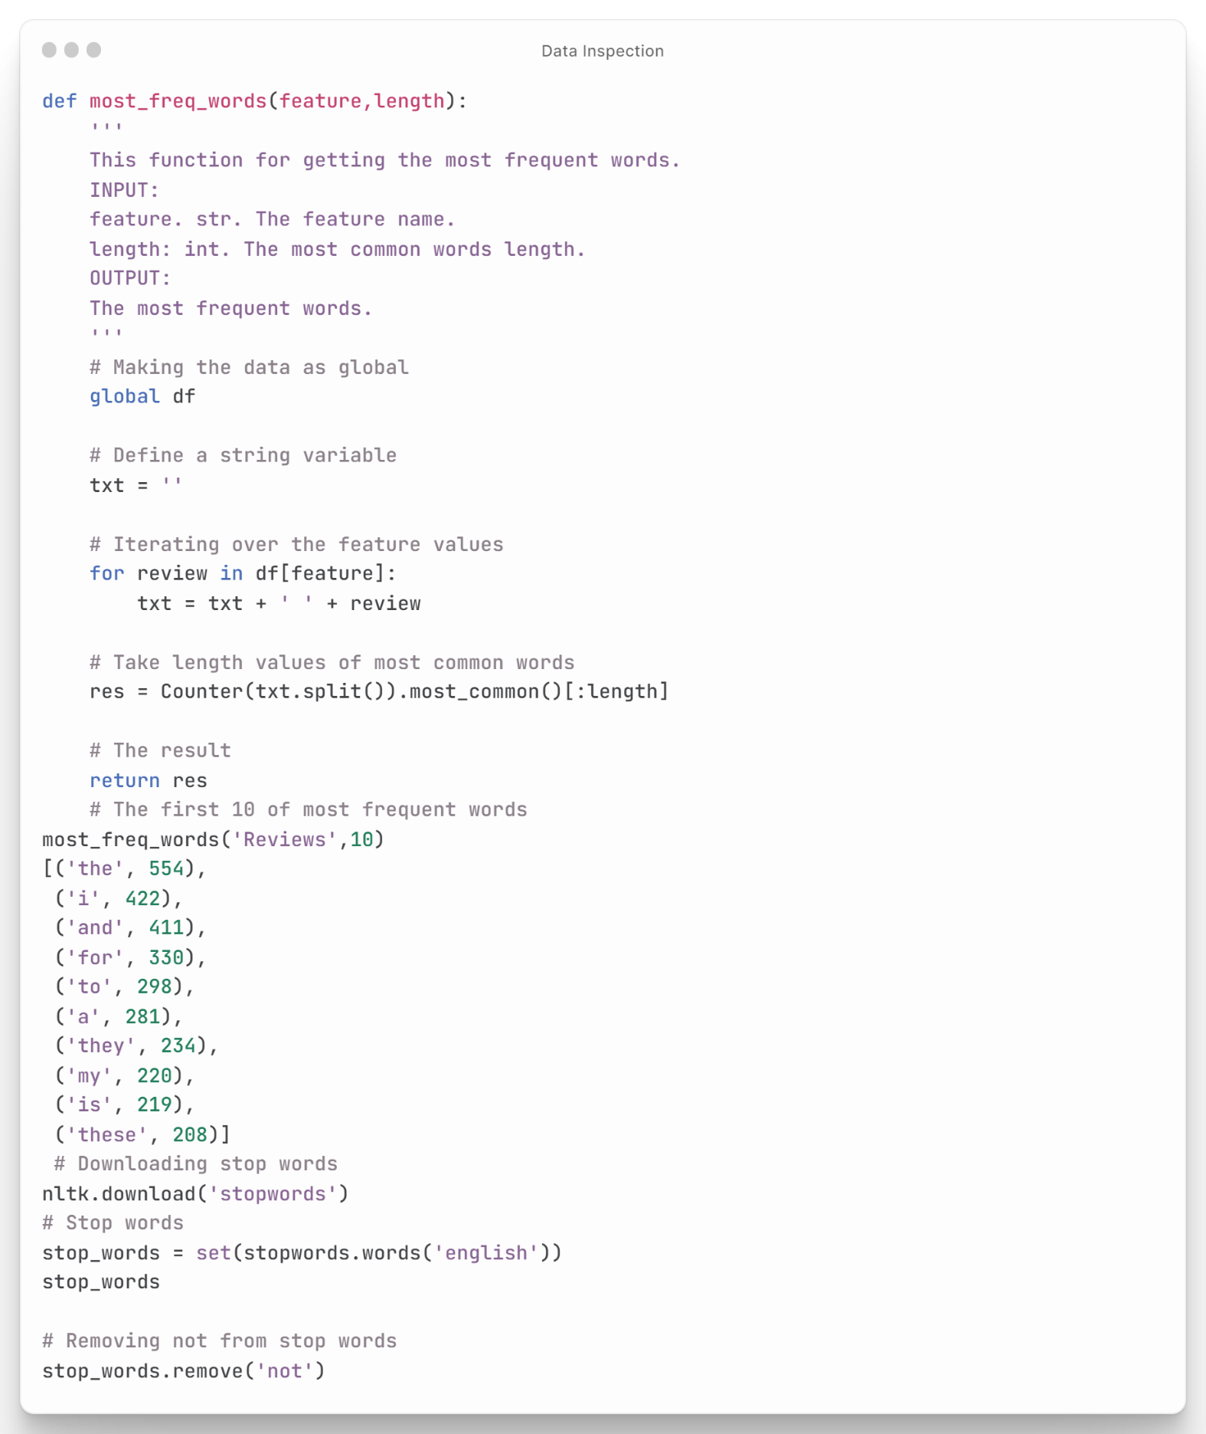

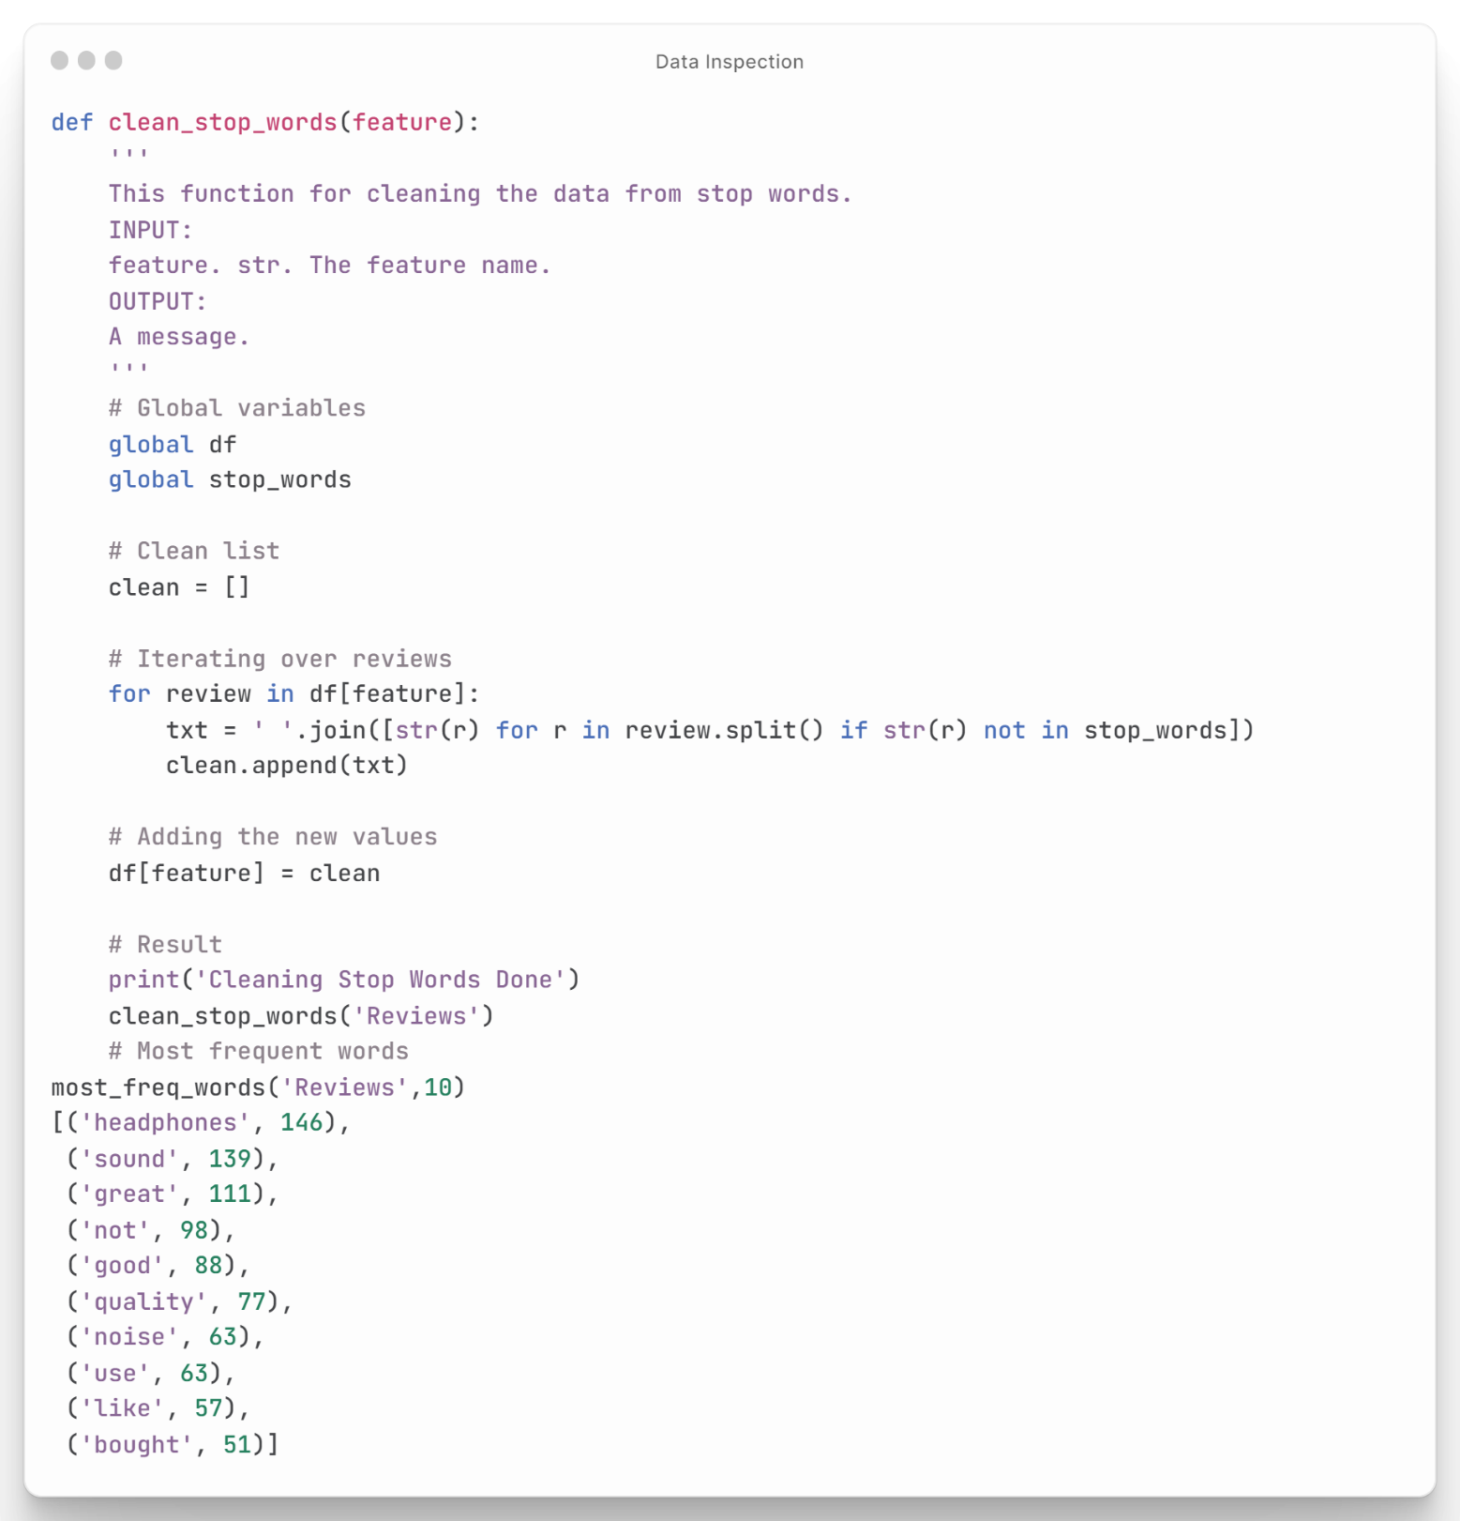

Figure : Preprocessing The Data

* **Roberta Model:**

This code is a continuation of the previous code and is used to classify the sentiment of a single review using the pre-trained Twitter-RoBERTa model for sentiment analysis. The first three lines of code are the same as in the previous code and set the task, model task, and tokenizer variables. The next two lines use the Auto Model for Sequence Classification class to get the pre-trained model for sentiment analysis. The code then encodes a single review using the tokenizer and passes it to the model to get the model's output scores. The SoftMax function is applied to the output scores to convert them into probability distributions. The code then finds the index of the maximum score and maps it to a sentiment label ('Negative', 'Neutral', or 'Positive') based on the index value. Finally, the code creates a dictionary containing the sentiment scores for each label and prints it. Overall, this code demonstrates how to use a pre-trained model to classify the sentiment of a single review in Python **as shown in figure (57).**

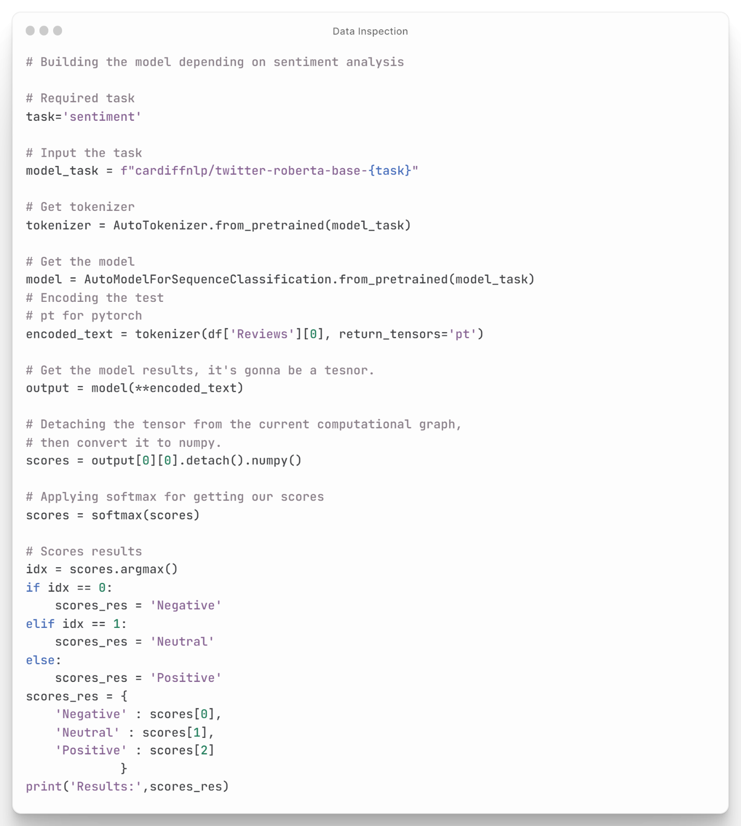

Figure : Roberta Model

* **Building NLP System**

This code defines a function named pred(review) that takes a review as input, encodes it using the pre-trained Twitter-RoBERTa tokenizer, passes it to the pre-trained model for sentiment analysis, and returns the predicted sentiment label ('Negative', 'Neutral', or 'Positive'). The code then sets the data_folder variable to the path of the directory containing the data files to be processed. The code uses the os library to list the categories in the data_folder directory, and iterates over each category, and then each element in each category, and then each data set for each element. For each data set, the code loads the data into a pandas Data Frame, drops any rows with missing values, preprocesses the review text using the is_alpha and clean_stop_words functions defined earlier, applies the pred function to each review in the 'Reviews' column of the Data Frame, adds a new 'Prediction' column to the Data Frame with the predicted sentiment labels, and saves the Data Frame to a new CSV file in a 'Final Data' directory. Overall, this code demonstrates how to use pre-trained models for sentiment analysis to process and analyze text data in multiple files using Python **as shown in figure (58).**

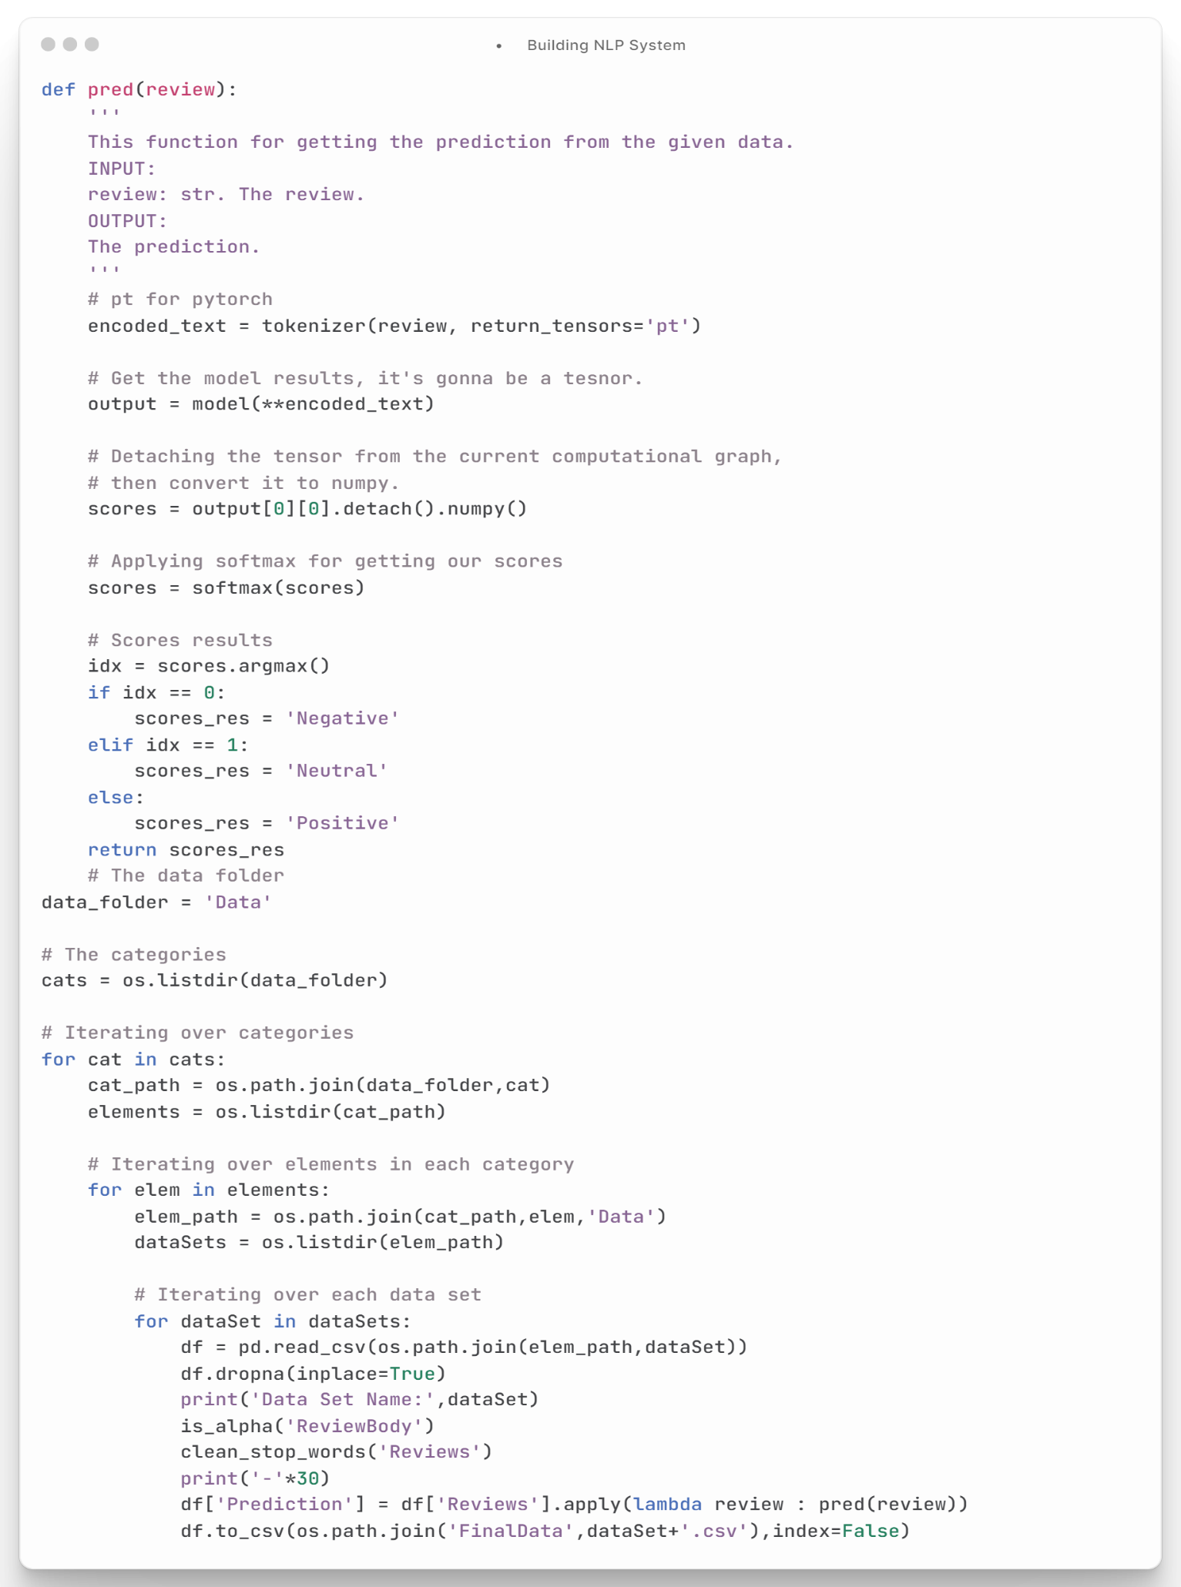

Figure : Building NLP System

### **Scraping IPYNB:**

**Notebook Contents**

* Importing The Dependencies
* Required Functions
* System Interface
* **Importing The Dependencies:**

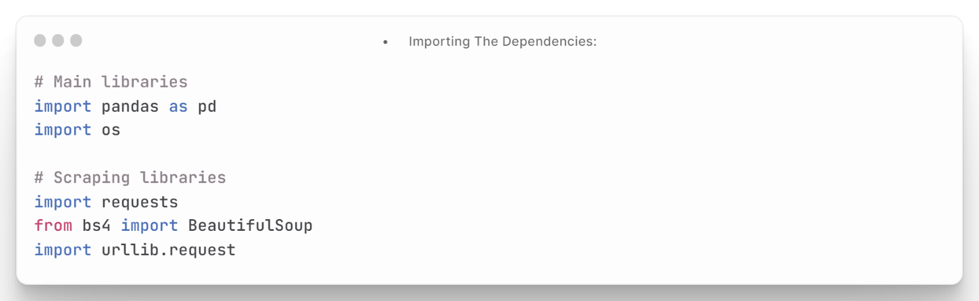This code imports the required libraries for web scraping and data analysis in Python **as shown in figure (59).**

Figure : Importing the Dependencies

* **Required Functions:**

This code defines several functions for web scraping data from Amazon product pages. The get_soup(url) function takes a URL as input, sends an HTTP request to the URL with appropriate headers, and returns the parsed HTML content as a BeautifulSoup object. The get_main_data(soup) function extracts the main product data from the given soup, such as product title, price, rating, manufacturer, and country of origin. The get_reviews_data(soup) function extracts the reviews data from the given soup, such as review titles and review bodies, by iterating over all the reviews in the current page. The get_image(soup, path) function extracts the product image URL from the given soup and saves the image to the specified directory. The main() function is the main entry point for the program, where it takes the user input for the product URL, number of reviews pages, and product category, and then calls the appropriate functions to scrape the data and save it to a CSV file and an image file. Overall, this code demonstrates how to use web scraping techniques to extract data from Amazon product pages using Python **as shown in figure (60).**

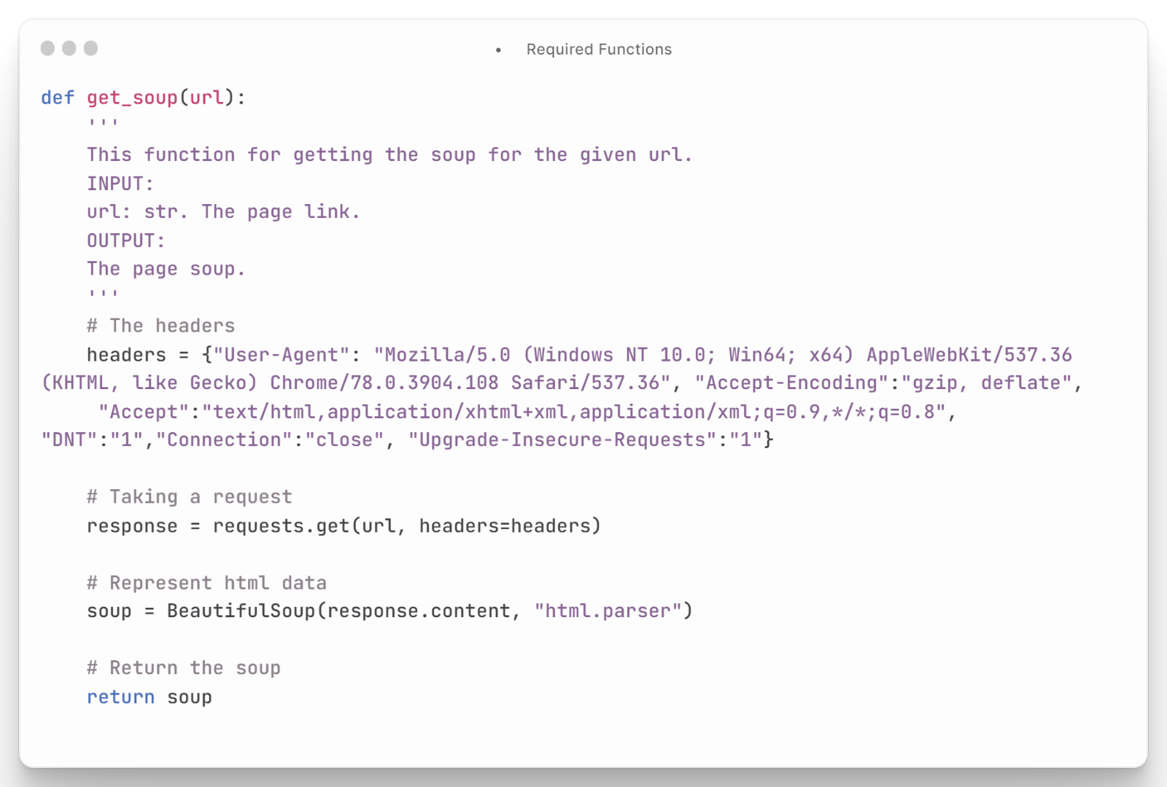

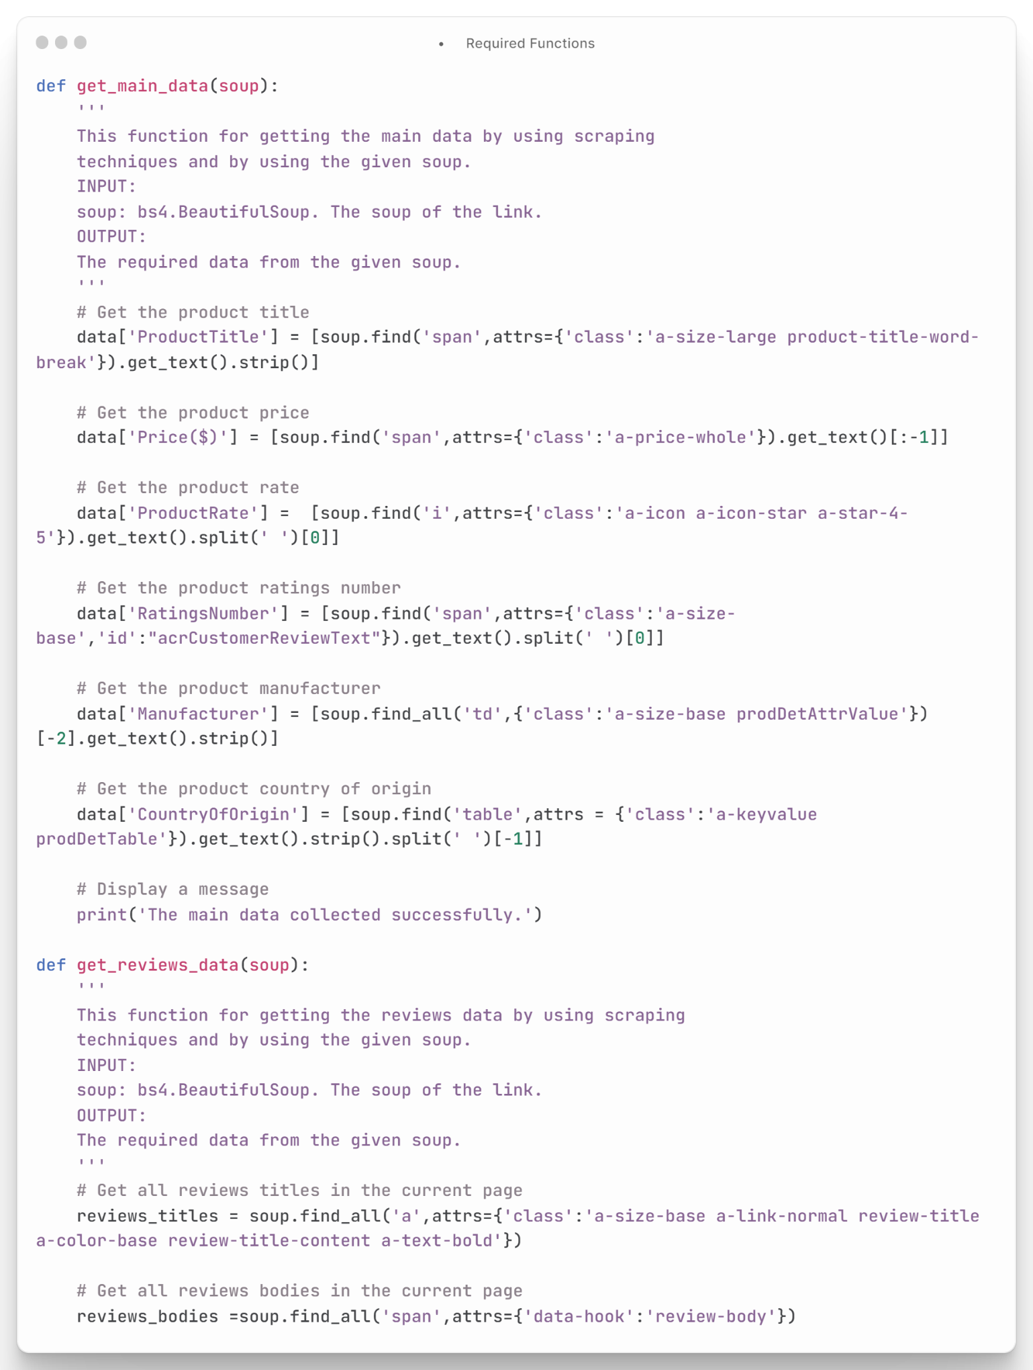

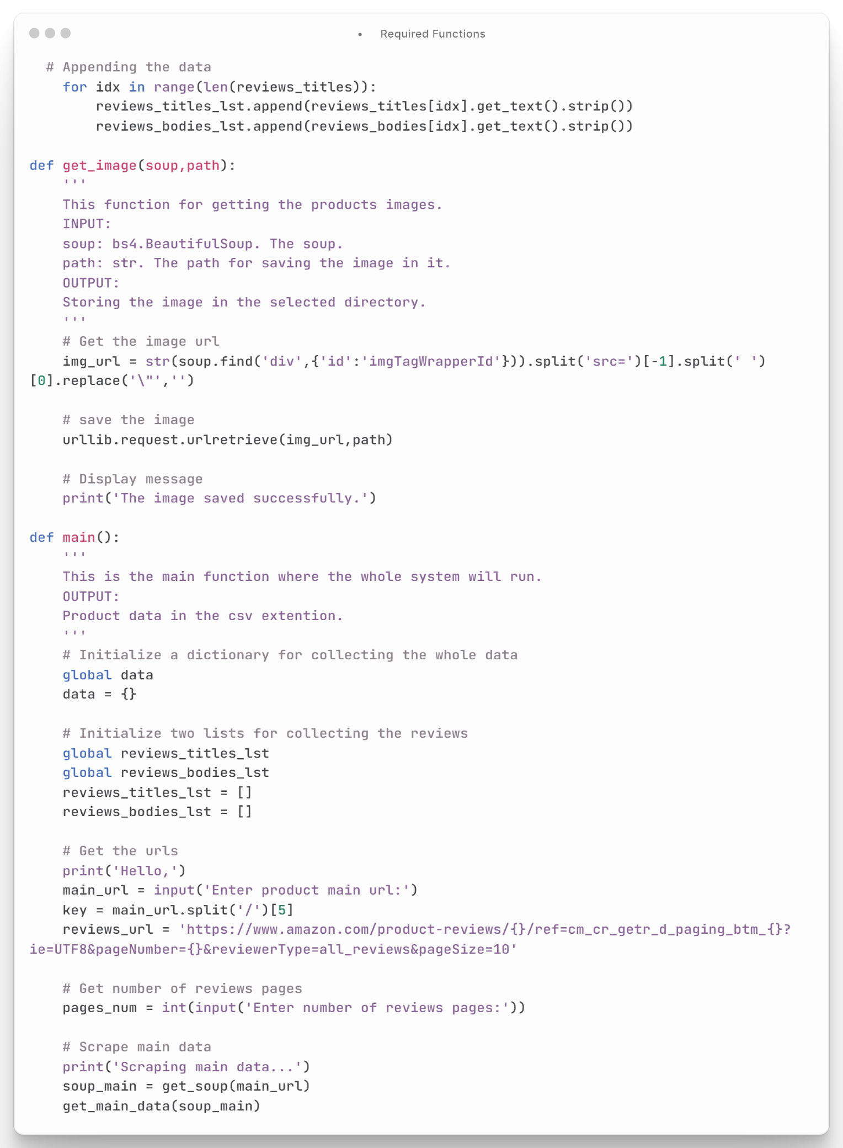

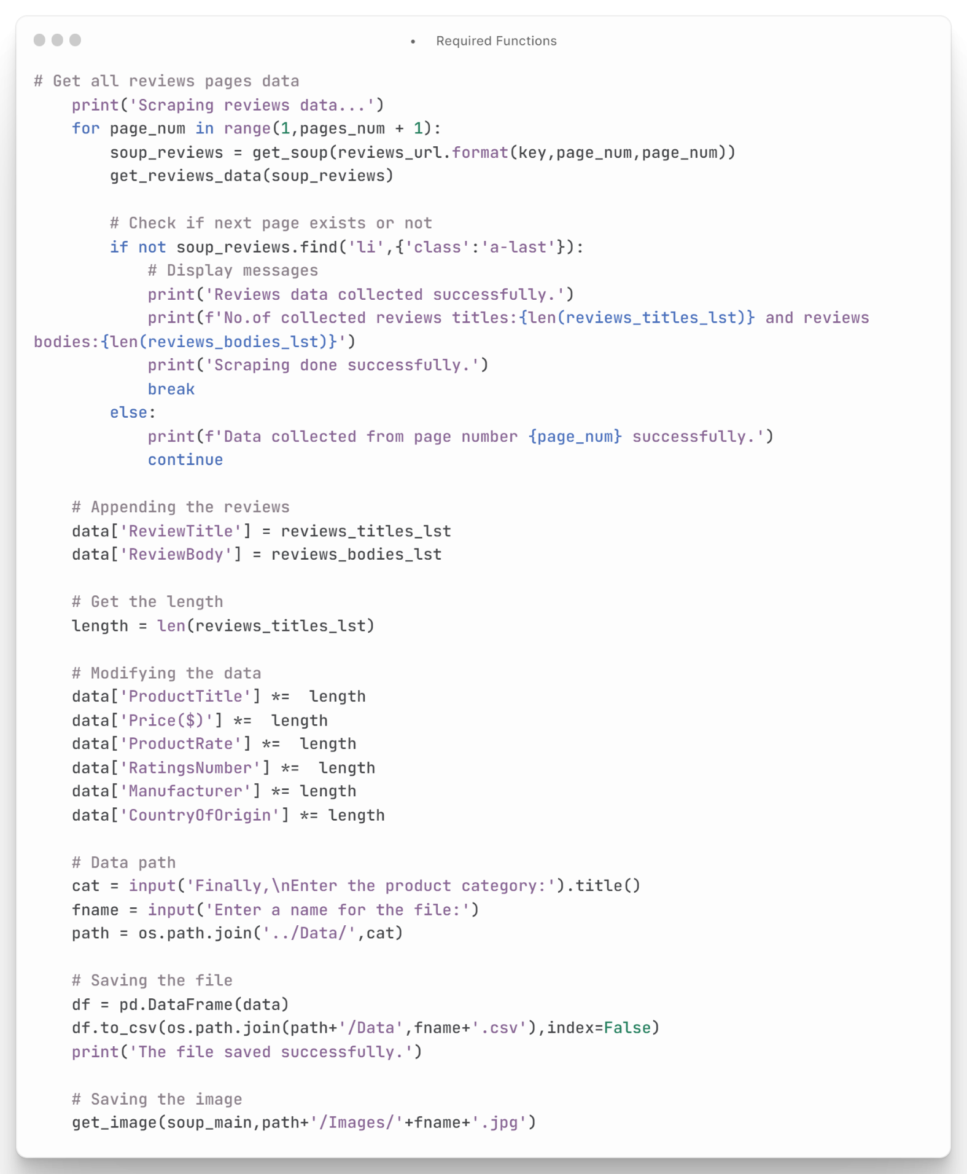

Figure : Required Functions

* **System Interface:**

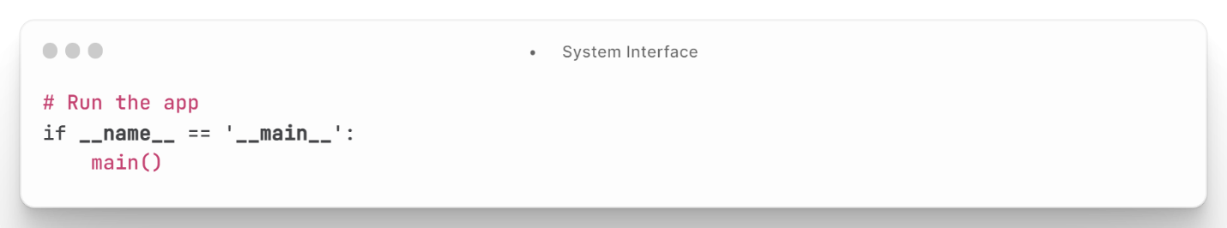This code runs the main() function when the Python script is executed directly, instead of being imported as a module. The __name__ == '__main__' condition checks if the script is being run as the main program, and not imported as a module. If the condition is True, the main() function is called to execute the main program logic. This code is commonly used in Python scripts to allow the script to be used both as a standalone program and as a module that can be imported into other scripts **as shown in figure (61).**

Figure : System Interface

* This project was submitted to the High Institute of Computer Science & Information Systems, in partial fulfilment of the requirements for the degree of Bachelor of Computers and Information.
* According to the instructions of High Institute of Computer Science & Information Systems, the project has uploaded to the GitHub:

https://github.com/MohammedOsama1/PRD

# References

1. Ye, Q., Cheng, Z. (June), & Fang, B. (2013). Learning from other buyers: The effect of purchase history records in online marketplaces. Decision Support Systems, 56, 502–512. https://doi.org/10.1016/j.dss.2012.11.007

<https://www.sciencedirect.com/science/article/abs/pii/S0167923612003399>

1. Katawetawaraks, C., & Wang, C. (2013, October 31). Online shopper behavior: Influences of online shopping decision. SSRN. <https://papers.ssrn.com/sol3/papers.cfm?abstract_id=2345198>
2. Chen, T., Samaranayake, P., Cen, X., Qi, M., & Lan, Y.-C. (2022a, May 2). The impact of online reviews on consumers’ purchasing decisions: Evidence from an eye-tracking study. Frontiers. https://www.frontiersin.org/articles/10.3389/fpsyg.2022.865702/full
3. Mo , Z., Li, an-F., & Fan, Yp. (2015, March 8). Effect of online reviews on Consumer Purchase Behavior. Journal of Service Science and Management. https://www.scirp.org/html/13-9201791_57521.htm
4. Karimi, S., Papamichail, K. N., & Holland, C. P. (2015). The effect of prior knowledge and decision-making style on the online purchase decision-making process: A typology of consumer shopping behaviour. Decision Support Systems, 77, 137–147. https://doi.org/10.1016/j.dss.2015.06.004
5. Li, X., Zhao, X., Xu, W. (Ato), & Pu, W. (2020). Measuring ease of use of mobile applications in e-commerce retailing from the perspective of consumer online shopping behaviour patterns. Journal of Retailing and Consumer Services, 55, 102093. https://doi.org/10.1016/j.jretconser.2020.102093
6. Wang, Z., & Sun, Y. (2018, May 9). design the registration and login function of APP. Journal of Software Engineering and Applications. https://www.scirp.org/journal/paperinformation.aspx?paperid=84810
7. Kuzmin, N., Ignatiev, K., & Grafov, D. (1970, January 1). Experience of developing a mobile application using flutter. SpringerLink. https://link.springer.com/chapter/10.1007/978-981-15-1465-4_56
8. University, J. G. N., Gunawan, J., University, N., University, A. P. N., Pradeep, A., University, D. C. N., Choffnes, D., University, W. H. N., Hartzog, W., University, C. W. N., Wilson, C., Inc., A., & Metrics, O. M. A. (2021, October 1). A comparative study of dark patterns across web and mobile modalities. Proceedings of the ACM on Human-Computer Interaction. <https://dl.acm.org/doi/10.1145/3479521>
9. Guan, Z., & Li, A. (2020, October). The_Problem_Solver_A_Mobile

_Platform_to_Mediate_Teenager_Family_Relationship_using_Dart_and_Machine_Learning [https://www.researchgate.net/publication/365025548_ 10.5121/csit.2022.121825](https://www.researchgate.net/publication/365025548_%2010.5121/csit.2022.121825)

**ملخص المشروع**

في الفترة الاخيرة اصبح يعاني الكثير من الناس من صعوبة اختيار أفضل المنتجات عند التسوق عبر الإنترنت، حيث يواجهون تحديات عديدة في اختيار المنتج الذي يلبي احتياجاتهم. فمن بين هذه التحديات هو الاعتماد على الصور والوصف الموجودة على الموقع الإلكتروني دون أن يكون لديهم فرصة للتعرف على المنتج بشكل فعلي، مما يجعلهم غير قادرين على التمييز بين المنتجات المختلفة. وبالإضافة إلى ذلك، فإن وجود العديد من المتاجر عبر الإنترنت يجعل من الصعب على المستخدمين اختيار أفضل المتاجر التي تقدم منتجات عالية الجودة وتوفر خدمة عملاء ممتازة. ولذلك، فإن البحث عن المنتجات المناسبة يتطلب جهداً ووقتاً كبيرين، ويتطلب الاعتماد على تقييمات المنتجات وآراء المستخدمين السابقين لمساعدتهم في اتخاذ القرار الصحيح.

في مشروعنا يدور حل هذه المشكلة حيث يوفر خدمات تقييم المنتجات وتوفير المعلومات حول المتاجر المختلفة، بما يساعد المستخدمين على اتخاذ القرار الصحيح عند الشراء عبر الإنترنت. وتشمل خدماتنا أيضًا توفير معلومات حول الأسعار و تقييمات العملاء الذين بالفعل تم شراء المنتجات من قبل ويعتمد حلنا علي برنامج يعتمد علي خورزمات لجلب اراء العملاء من موقع الشهير امازون للتسوق (سوق)، وذلك بالاعتماد على أساليب الذكاء الاصطناعي وتحليل البيانات. وبهذا الشكل، يمكننا تقديم خدمات متميزة وفعالة للمستخدمين، مما يساعدهم على اختيار المنتجات التي تلبي احتياجاتهم بأفضل طريقة ممكنة.